Saif
Human Ranger
Level 1
Unaligned
Strength 14 (+2)  Constitution 12 (+1)  Dexterity 18 (+4)  Intelligence 11 (+0)  Wisdom 13 (+1)  Charisma 10 (+0) | Height: 6' 1"  Weight: 195 lb  Skin:  Eyes:  Hair:
Maximum Hit Points: 24
Bloodied: 12
Surge Value: 6
Surges / Day: 7 [includes constitution modifier]
Size: Medium
Speed: 6 squares
Vision: Normal
Initiative: | 1d20 +4 | = + 4 [dexterity]
Base Strength Attack: | 1d20 +2 | = + 2 [strength]
Base Dexterity Attack: | 1d20 +4 | = + 4 [dexterity]
Base Constitution Attack: | 1d20 +1 | = + 1 [constitution]
Base Intelligence Attack: | 1d20 +0 | = + 0 [intelligence]
Base Wisdom Attack: | 1d20 +1 | = + 1 [wisdom]
Base Charisma Attack: | 1d20 +0 | = + 0 [charisma]

Armor Class: | 14 | = 10 + 4 [dexterity]
Fortitude Defense: | 14 | = 10 + 1 [Human] + 1 [ranger] + 2 [strength]
Reflex Defense: | 16 | = 10 + 1 [Human] + 1 [ranger] + 4 [dexterity]
Will Defense: | 12 | = 10 + 1 [Human] + 1 [wisdom]
If your campaign uses the fixed-enhancement bonus system [PH2/Dark Sun], level 1 characters get +0 on attack/damage (0d6 extra damage on a critical hit) and +0 on all defenses. These bonuses do not stack with magic items.
Armor: None ("cloth")
Shield: None
Attacks:
Unarmed Melee: +2 [base strength attack] vs AC; damage 1[W]=1d4+2 [strength bonus]
Careful Attack [melee] [see online revision] +2^{w} [base strength attack] vs AC
Careful Attack [ranged] [see online revision] +4^{w} [base dexterity attack] vs AC
Nimble Strike +4^{w} [base dexterity attack] vs AC
Evasive Strike (melee) +2^{w} [base strength attack] vs AC
Evasive Strike (ranged) +4^{w} [base dexterity attack] vs AC
Split the Tree +4^{w} [base dexterity attack] vs AC
^{w} Weapon-based power. Apply adjustments for proficiency, situation, feats, magic, etc.
Base Saving throw: d20 +1 [human perseverence] vs 10
Encumberance 4e  Normal Load: Heavy Load: Maximum Drag Load 140 lb. 280 lb. 700 lb. | Encumberance 3.5  Light load: Medium load: Heavy load: Lift over head: Lift off ground: Push or drag: 58 lb. or less 59-116 lb. 117-175 lb. 175 lb. 350 lb. 875 lb.

Languages: | Tamwar
Rituals Known:
Skills:
Acrobatics: | +9 | = 4 [dexterity] +5 [class training]
Arcana: | +0 | = 0 [intelligence]
Athletics: | +2 | = 2 [strength]
Bluff: | +0 | = 0 [charisma]
Diplomacy: | +0 | = 0 [charisma]
Dungeoneering: | +1 | = 1 [wisdom]
Endurance: | +6 | = 1 [constitution] +5 [class training]
Heal: | +6 | = 1 [wisdom] +5 [class training]
History: | +0 | = 0 [intelligence]
Insight: | +1 | = 1 [wisdom]
Intimidate: | +0 | = 0 [charisma]
Nature: | +8 | = 1 [wisdom] +5 [class training] + 2 [background]
Perception: | +6 | = 1 [wisdom] +5 [class training]
Religion: | +0 | = 0 [intelligence]
Stealth: | +9 | = 4 [dexterity] +5 [class training]
Streetwise: | +0 | = 0 [charisma]
Thievery: | +4 | = 4 [dexterity]
Feats:
- Lethal Hunter: The extra damage dice from your Hunter’s Quarry class feature increase from d6s to d8s.
- Human Perseverance: +1 feat bonus to saving throws.

At-Will:
Melee Basic Attack: By weapon, damage 1[W]+2 [strength bonus] [standard action]
Ranged Basic Attack: By weapon, damage 1[W]+4 [dexterity bonus] [standard action]
Bull Rush: +2 [base strength attack] vs fortitude [standard action]
Grab: +2 [base strength attack] vs reflex [standard action]
Move grabbed target: +2 [base strength attack] vs fortitude [standard action]
Escape: +9 [acrobatics] vs reflex / +2 [athletics] vs fortitude [move action]
Hunter's Quarry [Ranger][minor action]: See class features
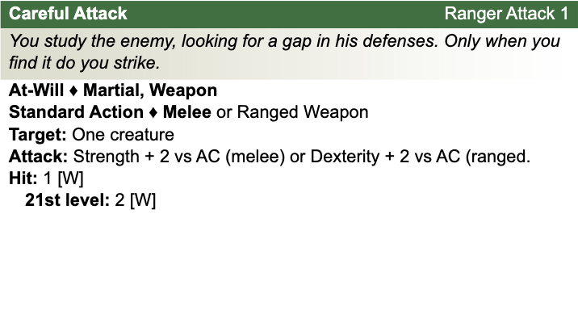
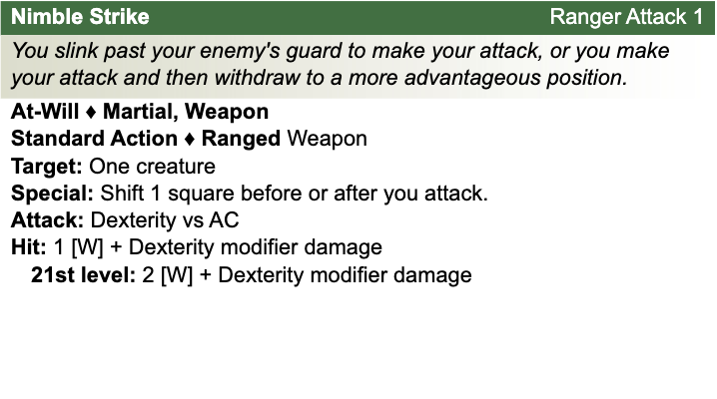
Other Standard Actions: | Administer a potion; Aid another [revised: skill check vs. 10+level/2, success helps +2, failure hurts -1]; Charge [+1 to basic melee attack or bull rush]; Coup de grace; Equip / stow shield; Ready an action; Total defense; Sustain standard action; Some skills during combat (i.e., Acrobatics -- fast escape; Bluff, Heal -- first aid (use second wind DC10, stabilize the dying DC15, grant a saving throw DC15), Intimidate, Thievery depending on circumstances);
Other Move Actions: | Crawl; Run [speed 8]; Stand up; Shift; Squeeze; Walk; may include some skills during combat (i.e., Acrobatics, Athletics); half of a Double Move (if taken in place of a standard action)
Other Minor Actions: | Draw / sheathe weapon; Drink a potion; Drop prone; Load a crossbow; Open / close a door; Pick up an item; Retrieve / stow an item; Perception -- active (as per revision), Sustain minor action; Some skills during combat (i.e., Insight)
Other Immediate Actions: | Readied action
Other Opportunity Actions: | Opportunity attack
Other Free Actions: | Drop held items; End a grab; Talk
Other Non-Actions: | Delay; Endurance checks; Insight to counter Bluff; Knowledge checks; Perception -- passive
Short rest: | Healing surges as available
Five minutes: | Normal escape from restraints (Acrobatics)
One hour: | Forage; Streetwise check

Encounter Powers:
Spend an Action Point [free action, not in surprise round]
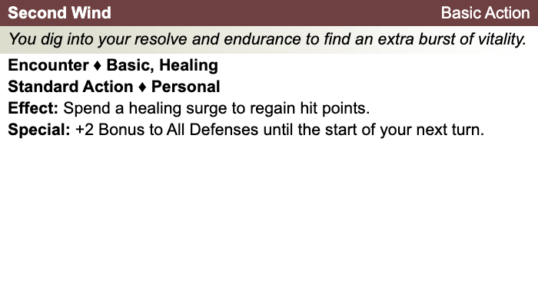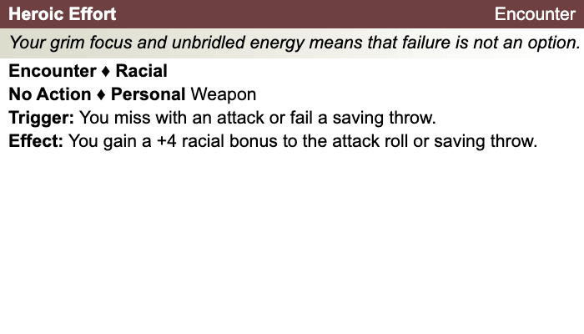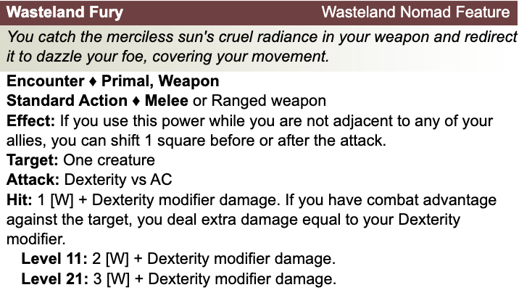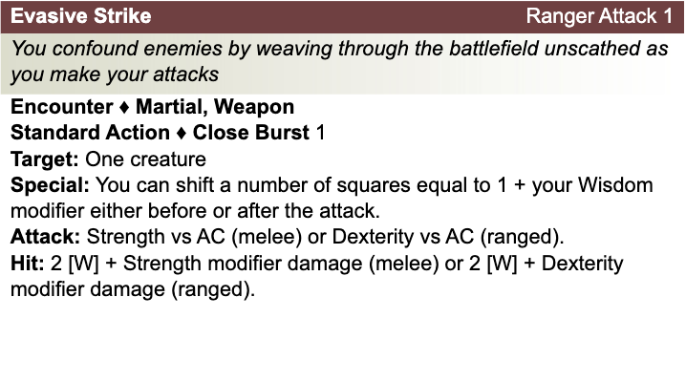

Daily Powers:
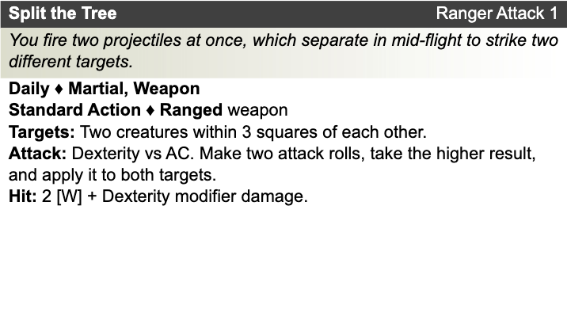
Human
- One bonus feat at 1st level (already included)
- One bonus skill from the skill class list (already included)
- +1 to fortitude, reflex, and will defenses
Ranger
- Prime Shot: If none of your allies are nearer to your target than you are, you receive a +1 bonus to ranged attack rolls against that target.
- Archer Fighting Style: +2 bonus to AC against opportunity attacks.
- Hunter's Quarry: Designate enemy nearest you as your quarry; once per round, deal +1d6 damage to quarry
Theme: Wasteland Nomad [Dark Sun]
- See source book for information
Saif's Equipment: Bandages, Rags
Magic items:
Weapon:
Weapon:
Weapon:
Weapon:
Armor:
Shield:
Arms:
Feet:
Hands:
Head:
Neck:
Ring:
Ring:
Waist:
Resistances:
Action Point Tally:
Daily Item Powers Per Day: Heroic Tier Milestones: / / /
Death Saving Throw Failures:
More about Saif:

Level 2
Unaligned
Strength 14 (+2)  Constitution 12 (+1)  Dexterity 18 (+4)  Intelligence 11 (+0)  Wisdom 13 (+1)  Charisma 10 (+0) | Height: 6' 1"  Weight: 195 lb  Skin:  Eyes:  Hair:
Maximum Hit Points: 29
Bloodied: 14
Surge Value: 7
Surges / Day: 7 [includes constitution modifier]
Size: Medium
Speed: 6 squares
Vision: Normal
Initiative: | 1d20 +6 | = 1 [half level] + 4 [dexterity]
Base Strength Attack: | 1d20 +4 | = + 1 [half level] + 2 [strength] + 1 (fixed enhancement bonus)
Base Dexterity Attack: | 1d20 +6 | = + 1 [half level] + 4 [dexterity] + 1 (fixed enhancement bonus)
Base Constitution Attack: | 1d20 +3 | = + 1 [half level] + 1 [constitution] + 1 (fixed enhancement bonus)
Base Intelligence Attack: | 1d20 +2 | = + 1 [half level] + 0 [intelligence] + 1 (fixed enhancement bonus)
Base Wisdom Attack: | 1d20 +3 | = + 1 [half level] + 1 [wisdom] + 1 (fixed enhancement bonus)
Base Charisma Attack: | 1d20 +2 | = + 1 [half level] + 0 [charisma] + 1 (fixed enhancement bonus)

Armor Class: | 15 | = 10 + 1 [half level] + 4 [dexterity]
Fortitude Defense: | 15 | = 10 + 1 [half level] + 1 [Human] + 1 [ranger] + 2 [strength]
Reflex Defense: | 17 | = 10 + 1 [half level] + 1 [Human] + 1 [ranger] + 4 [dexterity]
Will Defense: | 13 | = 10 + 1 [half level] + 1 [Human] + 1 [wisdom]
If your campaign uses the fixed-enhancement bonus system [PH2/Dark Sun], level 2 characters get +1 on attack/damage (1d6 extra damage on a critical hit) and +0 on all defenses. These bonuses do not stack with magic items.
Armor: None ("cloth")
Shield: None
Attacks:
Unarmed Melee: +3 [base strength attack] vs AC; damage 1[W]=1d4+2 [strength bonus]
Wasteland Fury +5^{w} [best ability vs AC]
Careful Attack [melee] [see online revision] +3^{w} [base strength attack] vs AC
Careful Attack [ranged] [see online revision] +5^{w} [base dexterity attack] vs AC
Nimble Strike +5^{w} [base dexterity attack] vs AC
Evasive Strike (melee) +3^{w} [base strength attack] vs AC
Evasive Strike (ranged) +5^{w} [base dexterity attack] vs AC
Split the Tree +5^{w} [base dexterity attack] vs AC
^{w} Weapon-based power. Apply adjustments for proficiency, situation, feats, magic, etc.
Base Saving throw: d20 +1 [human perseverence] vs 10
Encumberance 4e  Normal Load: Heavy Load: Maximum Drag Load 140 lb. 280 lb. 700 lb. | Encumberance 3.5  Light load: Medium load: Heavy load: Lift over head: Lift off ground: Push or drag: 58 lb. or less 59-116 lb. 117-175 lb. 175 lb. 350 lb. 875 lb.

Languages: | Tamwar
Rituals Known:
Skills:
Acrobatics: | +10 | = 4 [dexterity] + 1 [half level] +5 [class training]
Arcana: | +1 | = 0 [intelligence] + 1 [half level]
Athletics: | +3 | = 2 [strength] + 1 [half level]
Bluff: | +1 | = 0 [charisma] + 1 [half level]
Diplomacy: | +1 | = 0 [charisma] + 1 [half level]
Dungeoneering: | +2 | = 1 [wisdom] + 1 [half level]
Endurance: | +7 | = 1 [constitution] + 1 [half level] +5 [class training]
Heal: | +7 | = 1 [wisdom] + 1 [half level] +5 [class training]
History: | +1 | = 0 [intelligence] + 1 [half level]
Insight: | +2 | = 1 [wisdom] + 1 [half level]
Intimidate: | +1 | = 0 [charisma] + 1 [half level]
Nature: | +9 | = 1 [wisdom] + 1 [half level] +5 [class training] + 2 [background]
Perception: | +7 | = 1 [wisdom] + 1 [half level] +5 [class training]
Religion: | +1 | = 0 [intelligence] + 1 [half level]
Stealth: | +10 | = 4 [dexterity] + 1 [half level] +5 [class training]
Streetwise: | +1 | = 0 [charisma] + 1 [half level]
Thievery: | +5 | = 4 [dexterity] + 1 [half level]
Feats:
- Lethal Hunter: The extra damage dice from your Hunter’s Quarry class feature increase from d6s to d8s.
- Human Perseverance: +1 feat bonus to saving throws.
- Dune’s Advantage: When you hit a target granting combat advantage to you with your wasteland fury, the target is dazed until the end ofyour next turn.

At-Will:
Melee Basic Attack: By weapon, damage 1[W]+2 [strength bonus] [standard action]
Ranged Basic Attack: By weapon, damage 1[W]+4 [dexterity bonus] [standard action]
Bull Rush: +2 [base strength attack] vs fortitude [standard action]
Grab: +2 [base strength attack] vs reflex [standard action]
Move grabbed target: +2 [base strength attack] vs fortitude [standard action]
Escape: +9 [acrobatics] vs reflex / +2 [athletics] vs fortitude [move action]
Hunter's Quarry [Ranger][minor action]: See class features
Other Standard Actions: | Administer a potion; Aid another [revised: skill check vs. 10+level/2, success helps +2, failure hurts -1]; Charge [+1 to basic melee attack or bull rush]; Coup de grace; Equip / stow shield; Ready an action; Total defense; Sustain standard action; Some skills during combat (i.e., Acrobatics -- fast escape; Bluff, Heal -- first aid (use second wind DC10, stabilize the dying DC15, grant a saving throw DC15), Intimidate, Thievery depending on circumstances);
Other Move Actions: | Crawl; Run [speed 8]; Stand up; Shift; Squeeze; Walk; may include some skills during combat (i.e., Acrobatics, Athletics); half of a Double Move (if taken in place of a standard action)
Other Minor Actions: | Draw / sheathe weapon; Drink a potion; Drop prone; Load a crossbow; Open / close a door; Pick up an item; Retrieve / stow an item; Perception -- active (as per revision), Sustain minor action; Some skills during combat (i.e., Insight)
Other Immediate Actions: | Readied action
Other Opportunity Actions: | Opportunity attack
Other Free Actions: | Drop held items; End a grab; Talk
Other Non-Actions: | Delay; Endurance checks; Insight to counter Bluff; Knowledge checks; Perception -- passive
Short rest: | Healing surges as available
Five minutes: | Normal escape from restraints (Acrobatics)
One hour: | Forage; Streetwise check

Encounter Powers:
Spend an Action Point [free action, not in surprise round]

Daily Powers:
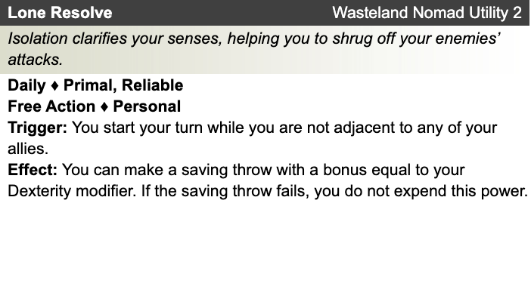

Human
- One bonus feat at 1st level (already included)
- One bonus skill from the skill class list (already included)
- +1 to fortitude, reflex, and will defenses
Ranger
- Prime Shot: If none of your allies are nearer to your target than you are, you receive a +1 bonus to ranged attack rolls against that target.
- Archer Fighting Style: +2 bonus to AC against opportunity attacks.
- Hunter's Quarry: Designate enemy nearest you as your quarry; once per round, deal +1d6 damage to quarry

Theme: Wasteland Nomad [Dark Sun]
- See source book for information
Saif’s Equipment: Bandages, Rags
Magic items:
Weapon:
Weapon:
Weapon:
Weapon:
Armor:
Shield:
Arms:
Feet:
Hands:
Head:
Neck:
Ring:
Ring:
Waist:
Resistances:
Action Point Tally:
Daily Item Powers Per Day: Heroic Tier Milestones: / / /
Death Saving Throw Failures:
More about Saif:

Level 3
Unaligned
Strength 14 (+2)  Constitution 12 (+1)  Dexterity 18 (+4)  Intelligence 11 (+0)  Wisdom 13 (+1)  Charisma 10 (+0) | Height: 6' 1"  Weight: 195 lb  Skin:  Eyes:  Hair:
Maximum Hit Points: 34
Bloodied: 17
Surge Value: 8
Surges / Day: 7 [includes constitution modifier]
Size: Medium
Speed: 6 squares
Vision: Normal
Initiative: | 1d20 +6 | = 1 [half level] + 4 [dexterity]
Base Strength Attack: | 1d20 +4 | = + 1 [half level] + 2 [strength] + 1 (fixed enhancement bonus)
Base Dexterity Attack: | 1d20 +6 | = + 1 [half level] + 4 [dexterity] + 1 (fixed enhancement bonus)
Base Constitution Attack: | 1d20 +3 | = + 1 [half level] + 1 [constitution] + 1 (fixed enhancement bonus)
Base Intelligence Attack: | 1d20 +2 | = + 1 [half level] + 0 [intelligence] + 1 (fixed enhancement bonus)
Base Wisdom Attack: | 1d20 +3 | = + 1 [half level] + 1 [wisdom] + 1 (fixed enhancement bonus)
Base Charisma Attack: | 1d20 +2 | = + 1 [half level] + 0 [charisma] + 1 (fixed enhancement bonus)

Armor Class: | 15 | = 10 + 1 [half level] + 4 [dexterity]
Fortitude Defense: | 15 | = 10 + 1 [half level] + 1 [Human] + 1 [ranger] + 2 [strength]
Reflex Defense: | 17 | = 10 + 1 [half level] + 1 [Human] + 1 [ranger] + 4 [dexterity]
Will Defense: | 13 | = 10 + 1 [half level] + 1 [Human] + 1 [wisdom]
If your campaign uses the fixed-enhancement bonus system [PH2/Dark Sun], level 3 characters get +1 on attack/damage (1d6 extra damage on a critical hit) and +0 on all defenses. These bonuses do not stack with magic items.
Armor: None ("cloth")
Shield: None
Attacks:
Unarmed Melee: +3 [base strength attack] vs AC; damage 1[W]=1d4+2 [strength bonus]
Wasteland Fury +5^{w} [best ability vs AC]
Careful Attack [melee] [see online revision] +3^{w} [base strength attack] vs AC
Careful Attack [ranged] [see online revision] +5^{w} [base dexterity attack] vs AC
Nimble Strike +5^{w} [base dexterity attack] vs AC
Evasive Strike (melee) +3^{w} [base strength attack] vs AC
Evasive Strike (ranged) +5^{w} [base dexterity attack] vs AC
Split the Tree +5^{w} [base dexterity attack] vs AC
Stalking the Prey:
^{w} Weapon-based power. Apply adjustments for proficiency, situation, feats, magic, etc.
Base Saving throw: d20 +1 [human perseverence] vs 10
Encumberance 4e  Normal Load: Heavy Load: Maximum Drag Load 140 lb. 280 lb. 700 lb. | Encumberance 3.5  Light load: Medium load: Heavy load: Lift over head: Lift off ground: Push or drag: 58 lb. or less 59-116 lb. 117-175 lb. 175 lb. 350 lb. 875 lb.

Languages: | Tamwar
Rituals Known:
Skills:
Acrobatics: | +10 | = 4 [dexterity] + 1 [half level] +5 [class training]
Arcana: | +1 | = 0 [intelligence] + 1 [half level]
Athletics: | +3 | = 2 [strength] + 1 [half level]
Bluff: | +1 | = 0 [charisma] + 1 [half level]
Diplomacy: | +1 | = 0 [charisma] + 1 [half level]
Dungeoneering: | +2 | = 1 [wisdom] + 1 [half level]
Endurance: | +7 | = 1 [constitution] + 1 [half level] +5 [class training]
Heal: | +7 | = 1 [wisdom] + 1 [half level] +5 [class training]
History: | +1 | = 0 [intelligence] + 1 [half level]
Insight: | +2 | = 1 [wisdom] + 1 [half level]
Intimidate: | +1 | = 0 [charisma] + 1 [half level]
Nature: | +9 | = 1 [wisdom] + 1 [half level] +5 [class training] + 2 [background]
Perception: | +7 | = 1 [wisdom] + 1 [half level] +5 [class training]
Religion: | +1 | = 0 [intelligence] + 1 [half level]
Stealth: | +10 | = 4 [dexterity] + 1 [half level] +5 [class training]
Streetwise: | +1 | = 0 [charisma] + 1 [half level]
Thievery: | +5 | = 4 [dexterity] + 1 [half level]
Feats:
- Lethal Hunter: The extra damage dice from your Hunter’s Quarry class feature increase from d6s to d8s.
- Human Perseverance: +1 feat bonus to saving throws.
- Dune’s Advantage: When you hit a target granting combat advantage to you with your wasteland fury, the target is dazed until the end of your next turn.

At-Will:
Melee Basic Attack: By weapon, damage 1[W]+2 [strength bonus] [standard action]
Ranged Basic Attack: By weapon, damage 1[W]+4 [dexterity bonus] [standard action]
Bull Rush: +2 [base strength attack] vs fortitude [standard action]
Grab: +2 [base strength attack] vs reflex [standard action]
Move grabbed target: +2 [base strength attack] vs fortitude [standard action]
Escape: +9 [acrobatics] vs reflex / +2 [athletics] vs fortitude [move action]
Hunter's Quarry [Ranger][minor action]: See class features
Other Standard Actions: | Administer a potion; Aid another [revised: skill check vs. 10+level/2, success helps +2, failure hurts -1]; Charge [+1 to basic melee attack or bull rush]; Coup de grace; Equip / stow shield; Ready an action; Total defense; Sustain standard action; Some skills during combat (i.e., Acrobatics -- fast escape; Bluff, Heal -- first aid (use second wind DC10, stabilize the dying DC15, grant a saving throw DC15), Intimidate, Thievery depending on circumstances);
Other Move Actions: | Crawl; Run [speed 8]; Stand up; Shift; Squeeze; Walk; may include some skills during combat (i.e., Acrobatics, Athletics); half of a Double Move (if taken in place of a standard action)
Other Minor Actions: | Draw / sheathe weapon; Drink a potion; Drop prone; Load a crossbow; Open / close a door; Pick up an item; Retrieve / stow an item; Perception -- active (as per revision), Sustain minor action; Some skills during combat (i.e., Insight)
Other Immediate Actions: | Readied action
Other Opportunity Actions: | Opportunity attack
Other Free Actions: | Drop held items; End a grab; Talk
Other Non-Actions: | Delay; Endurance checks; Insight to counter Bluff; Knowledge checks; Perception -- passive
Short rest: | Healing surges as available
Five minutes: | Normal escape from restraints (Acrobatics)
One hour: | Forage; Streetwise check

Encounter Powers:
Spend an Action Point [free action, not in surprise round]
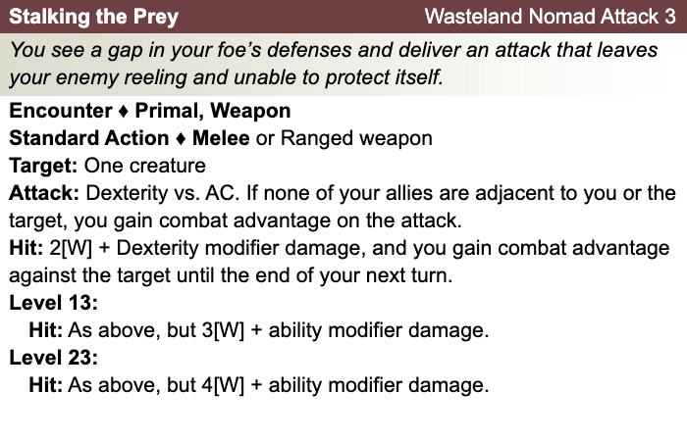
Daily Powers:

Human
- One bonus feat at 1st level (already included)
- One bonus skill from the skill class list (already included)
- +1 to fortitude, reflex, and will defenses
Ranger
- Prime Shot: If none of your allies are nearer to your target than you are, you receive a +1 bonus to ranged attack rolls against that target.
- Archer Fighting Style: +2 bonus to AC against opportunity attacks.
- Hunter's Quarry: Designate enemy nearest you as your quarry; once per round, deal +1d6 damage to quarry
Theme: Wasteland Nomad [Dark Sun]
- See source book for information
Saif's Equipment: Bandages, Rags
Magic items:
Weapon:
Weapon:
Weapon:
Weapon:
Armor:
Shield:
Arms:
Feet:
Hands:
Head:
Neck:
Ring:
Ring:
Waist:
Resistances:
Action Point Tally:
Daily Item Powers Per Day: Heroic Tier Milestones: / / /
Death Saving Throw Failures:
More about Saif:

Level 4
Unaligned
Strength 14 (+2)  Constitution 13 (+1)  Dexterity 18 (+4)  Intelligence 11 (+0)  Wisdom 14 (+2)  Charisma 10 (+0) | Height: 6' 1"  Weight: 195 lb  Skin:  Eyes:  Hair:
Maximum Hit Points: 40
Bloodied: 20
Surge Value: 10
Surges / Day: 7 [includes constitution modifier]
Size: Medium
Speed: 6 squares
Vision: Normal
Initiative: | 1d20 +6 | = 2 [half level] + 4 [dexterity]
Base Strength Attack: | 1d20 +5 | = + 2 [half level] + 2 [strength] + 1 (fixed enhancement bonus)
Base Dexterity Attack: | 1d20 +7 | = + 2 [half level] + 4 [dexterity] + 1 (fixed enhancement bonus)
Base Constitution Attack: | 1d20 +4 | = + 2 [half level] + 1 [constitution] + 1 (fixed enhancement bonus)
Base Intelligence Attack: | 1d20 +3 | = + 2 [half level] + 0 [intelligence] + 1 (fixed enhancement bonus)
Base Wisdom Attack: | 1d20 +4 | = + 2 [half level] + 1 [wisdom] + 1 (fixed enhancement bonus)
Base Charisma Attack: | 1d20 +3 | = + 2 [half level] + 0 [charisma] + 1 (fixed enhancement bonus)

Armor Class: | 17 | = 10 + 2 [half level] + 4 [dexterity] + 1 (fixed enhancement bonus)
Fortitude Defense: | 17 | = 10 + 2 [half level] + 1 [Human] + 1 [ranger] + 2 [strength] + 1 (fixed enhancement bonus)
Reflex Defense: | 19 | = 10 + 2 [half level] + 1 [Human] + 1 [ranger] + 4 [dexterity] + 1 (fixed enhancement bonus)
Will Defense: | 15 | = 10 + 2 [half level] + 1 [Human] + 1 [wisdom] + 1 (fixed enhancement bonus)
If your campaign uses the fixed-enhancement bonus system [PH2/Dark Sun], level 4 characters get +1 on attack/damage (1d6 extra damage on a critical hit) and +1 on all defenses. These bonuses do not stack with magic items.
Armor: None ("cloth")
Shield: None
Attacks:
Unarmed Melee: +4 [base strength attack] vs AC; damage 1[W]=1d4+2 [strength bonus]
Wasteland Fury +6^{w} [best ability vs AC]
Careful Attack [melee] [see online revision] +4^{w} [base strength attack] vs AC
Careful Attack [ranged] [see online revision] +6^{w} [base dexterity attack] vs AC
Nimble Strike +6^{w} [base dexterity attack] vs AC
Evasive Strike (melee) +4^{w} [base strength attack] vs AC
Evasive Strike (ranged) +6^{w} [base dexterity attack] vs AC
Split the Tree +6^{w} [base dexterity attack] vs AC
Stalking the Prey:
^{w} Weapon-based power. Apply adjustments for proficiency, situation, feats, magic, etc.
Base Saving throw: d20 +1 [human perseverence] vs 10
Encumberance 4e  Normal Load: Heavy Load: Maximum Drag Load 140 lb. 280 lb. 700 lb. | Encumberance 3.5  Light load: Medium load: Heavy load: Lift over head: Lift off ground: Push or drag: 58 lb. or less 59-116 lb. 117-175 lb. 175 lb. 350 lb. 875 lb.

Languages: | Tamwar
Rituals Known:
Skills:
Acrobatics: | +11 | = 4 [dexterity] + 2 [half level] +5 [class training]
Arcana: | +2 | = 0 [intelligence] + 2 [half level]
Athletics: | +4 | = 2 [strength] + 2 [half level]
Bluff: | +2 | = 0 [charisma] + 2 [half level]
Diplomacy: | +2 | = 0 [charisma] + 2 [half level]
Dungeoneering: | +4 | = 2 [wisdom] + 2 [half level]
Endurance: | +8 | = 1 [constitution] + 2 [half level] +5 [class training]
Heal: | +9 | = 2 [wisdom] + 2 [half level] +5 [class training]
History: | +2 | = 0 [intelligence] + 2 [half level]
Insight: | +4 | = 2 [wisdom] + 2 [half level]
Intimidate: | +2 | = 0 [charisma] + 2 [half level]
Nature: | +11 | = 2 [wisdom] + 2 [half level] +5 [class training] + 2 [background]
Perception: | +9 | = 2 [wisdom] + 2 [half level] +5 [class training]
Religion: | +2 | = 0 [intelligence] + 2 [half level]
Stealth: | +11 | = 4 [dexterity] + 2 [half level] +5 [class training]
Streetwise: | +2 | = 0 [charisma] + 2 [half level]
Thievery: | +6 | = 4 [dexterity] + 2 [half level]
Feats:
- Lethal Hunter: The extra damage dice from your Hunter’s Quarry class feature increase from d6s to d8s.
- Human Perseverance: +1 feat bonus to saving throws.
- Dune’s Advantage: When you hit a target granting combat advantage to you with your wasteland fury, the target is dazed until the end of your next turn.
- Drag to Death: When you hit with your wasteland fury, after the attack you can slide the target 2 squares to a square that is not adjacent to one of your allies. You can then shift 3 squares to a square adjacent to the target.

At-Will:
Melee Basic Attack: By weapon, damage 1[W]+2 [strength bonus] [standard action]
Ranged Basic Attack: By weapon, damage 1[W]+4 [dexterity bonus] [standard action]
Bull Rush: +2 [base strength attack] vs fortitude [standard action]
Grab: +2 [base strength attack] vs reflex [standard action]
Move grabbed target: +2 [base strength attack] vs fortitude [standard action]
Escape: +9 [acrobatics] vs reflex / +2 [athletics] vs fortitude [move action]
Hunter's Quarry [Ranger][minor action]: See class features
Other Standard Actions: | Administer a potion; Aid another [revised: skill check vs. 10+level/2, success helps +2, failure hurts -1]; Charge [+1 to basic melee attack or bull rush]; Coup de grace; Equip / stow shield; Ready an action; Total defense; Sustain standard action; Some skills during combat (i.e., Acrobatics -- fast escape; Bluff, Heal -- first aid (use second wind DC10, stabilize the dying DC15, grant a saving throw DC15), Intimidate, Thievery depending on circumstances);
Other Move Actions: | Crawl; Run [speed 8]; Stand up; Shift; Squeeze; Walk; may include some skills during combat (i.e., Acrobatics, Athletics); half of a Double Move (if taken in place of a standard action)
Other Minor Actions: | Draw / sheathe weapon; Drink a potion; Drop prone; Load a crossbow; Open / close a door; Pick up an item; Retrieve / stow an item; Perception -- active (as per revision), Sustain minor action; Some skills during combat (i.e., Insight)
Other Immediate Actions: | Readied action
Other Opportunity Actions: | Opportunity attack
Other Free Actions: | Drop held items; End a grab; Talk
Other Non-Actions: | Delay; Endurance checks; Insight to counter Bluff; Knowledge checks; Perception -- passive
Short rest: | Healing surges as available
Five minutes: | Normal escape from restraints (Acrobatics)
One hour: | Forage; Streetwise check

Encounter Powers:
Spend an Action Point [free action, not in surprise round]
Daily Powers:

Human
- One bonus feat at 1st level (already included)
- One bonus skill from the skill class list (already included)
- +1 to fortitude, reflex, and will defenses
Ranger
- Prime Shot: If none of your allies are nearer to your target than you are, you receive a +1 bonus to ranged attack rolls against that target.
- Archer Fighting Style: +2 bonus to AC against opportunity attacks.
- Hunter's Quarry: Designate enemy nearest you as your quarry; once per round, deal +1d6 damage to quarry.
Theme: Wasteland Nomad [Dark Sun]
- See source book for information
Saif’s Equipment: Bandages, Rags
Magic items:
Weapon:
Weapon:
Weapon:
Weapon:
Armor:
Shield:
Arms:
Feet:
Hands:
Head:
Neck:
Ring:
Ring:
Waist:
Resistances:
Action Point Tally:
Daily Item Powers Per Day: Heroic Tier Milestones: / / /
Death Saving Throw Failures:
More about this character:

