Tija
Human Rogue
Level 1
Unaligned
Strength 13 (+1)  Constitution 11 (+0)  Dexterity 16 (+3)  Intelligence 12 (+1)  Wisdom 10 (+0)  Charisma 16 (+3) | Height: 6' 0"  Weight: 190 lb  Skin:  Eyes:  Hair:
Maximum Hit Points: 23
Bloodied: 11
Surge Value: 5
Surges / Day: 6
Size: Medium
Speed: 6 squares
Vision: Normal
Initiative: | 1d20 +3 | = + 3 [dexterity]
Base Strength Attack: | 1d20 +1 | = + 1 [strength]
Base Dexterity Attack: | 1d20 +3 | = + 3 [dexterity]
Base Constitution Attack: | 1d20 +0 | = + 0 [constitution]
Base Intelligence Attack: | 1d20 +1 | = + 1 [intelligence]
Base Wisdom Attack: | 1d20 +0 | = + 0 [wisdom]
Base Charisma Attack: | 1d20 +3 | = + 3 [charisma]

Armor Class: | 13 | = 10 + 3 [dexterity]
Fortitude Defense: | 12 | = 10 + 1 [Human] + 1 [strength]
Reflex Defense: | 16 | = 10 + 1 [Human] + 2 [rogue] + 3 [dexterity]
Will Defense: | 14 | = 10 + 1 [Human] + 3 [charisma]
If your campaign uses the fixed-enhancement bonus system [PH2/Dark Sun], level 1 characters get +0 on attack/damage (0d6 extra damage on a critical hit) and +0 on all defenses. These bonuses do not stack with magic items.
Armor: None ("cloth")
Shield: None
Attacks:
Unarmed Melee: +1 [base strength attack] vs AC; damage 1[W]=1d4+1 [strength bonus]
Poisoned Strike +3^{w} [best ability vs AC]
Deft Strike +3^{w} [base dexterity attack] vs AC
Sly Flourish +3^{w} [base dexterity attack] vs AC
Positioning Strike +3^{w} [base dexterity attack] vs AC
Trick Strike +3^{w} [base dexterity attack] vs AC
^{w} Weapon-based power. Apply adjustments for proficiency, situation, feats, magic, etc.
Base Saving throw: d20 +1 [human perseverence] vs 10
Encumberance 4e  Normal Load: Heavy Load: Maximum Drag Load 130 lb. 260 lb. 650 lb. | Encumberance 3.5  Light load: Medium load: Heavy load: Lift over head: Lift off ground: Push or drag: 50 lb. or less 51-100 lb. 101-150 lb. 150 lb. 300 lb. 750 lb.

Languages: | Tyrian, Tamwar
Rituals Known:
Skills:
Acrobatics: | +3 | = 3 [dexterity]
Arcana: | +1 | = 1 [intelligence]
Athletics: | +1 | = 1 [strength]
Bluff: | +8 | = 3 [charisma] +5 [class training]
Diplomacy: | +3 | = 3 [charisma]
Dungeoneering: | +5 | = 0 [wisdom] +5 [class training]
Endurance: | +0 | = 0 [constitution]
Heal: | +0 | = 0 [wisdom]
History: | +1 | = 1 [intelligence]
Insight: | +5 | = 0 [wisdom] +5 [class training]
Intimidate: | +8 | = 3 [charisma] +5 [class training]
Nature: | +0 | = 0 [wisdom]
Perception: | +0 | = 0 [wisdom]
Religion: | +1 | = 1 [intelligence]
Stealth: | +8 | = 3 [dexterity] +5 [class training]
Streetwise: | +8 | = 3 [charisma] +5 [class training]
Thievery: | +10 | = 3 [dexterity] +5 [class training] + 2 [background]
Feats:
Backstabber: The extra damage die from your Sneak Attack class feature increases from d6s to d8s.
Human Perseverance: +1 feat bonus to saving throws

At-Will:
Melee Basic Attack: By weapon, damage 1[W]+1 [strength bonus] [standard action]
Ranged Basic Attack: By weapon, damage 1[W]+3 [dexterity bonus] [standard action]
Bull Rush: +1 [base strength attack] vs fortitude [standard action]
Grab: +1 [base strength attack] vs reflex [standard action]
Move grabbed target: +1 [base strength attack] vs fortitude [standard action]
Escape: +3 [acrobatics] vs reflex / +1 [athletics] vs fortitude [move action]
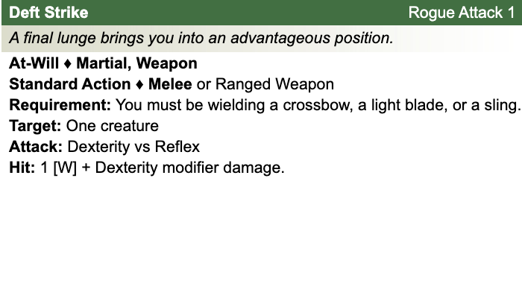
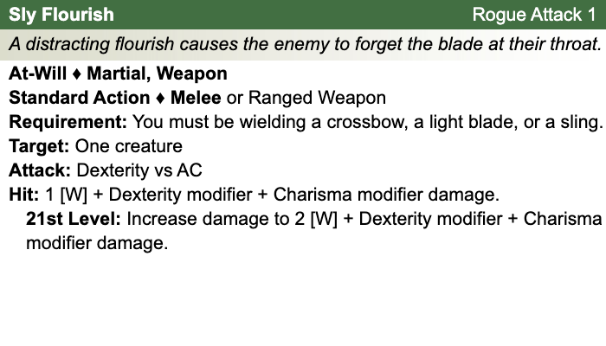
Other Standard Actions: | Administer a potion; Aid another [revised: skill check vs. 10+level/2, success helps +2, failure hurts -1]; Charge [+1 to basic melee attack or bull rush]; Coup de grace; Equip / stow shield; Ready an action; Total defense; Sustain standard action; Some skills during combat (i.e., Acrobatics -- fast escape; Bluff, Heal -- first aid (use second wind DC10, stabilize the dying DC15, grant a saving throw DC15), Intimidate, Thievery depending on circumstances);
Other Move Actions: | Crawl; Run [speed 8]; Stand up; Shift; Squeeze; Walk; may include some skills during combat (i.e., Acrobatics, Athletics); half of a Double Move (if taken in place of a standard action)
Other Minor Actions: | Draw / sheathe weapon; Drink a potion; Drop prone; Load a crossbow; Open / close a door; Pick up an item; Retrieve / stow an item; Perception -- active (as per revision), Sustain minor action; Some skills during combat (i.e., Insight)
Other Immediate Actions: | Readied action
Other Opportunity Actions: | Opportunity attack
Other Free Actions: | Drop held items; End a grab; Talk
Other Non-Actions: | Delay; Endurance checks; Insight to counter Bluff; Knowledge checks; Perception -- passive
Short rest: | Healing surges as available
Five minutes: | Normal escape from restraints (Acrobatics)
One hour: | Forage; Streetwise check

Encounter Powers:
Spend an Action Point [free action, not in surprise round]
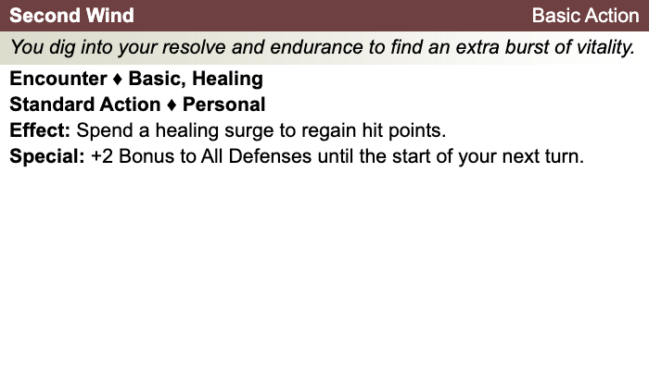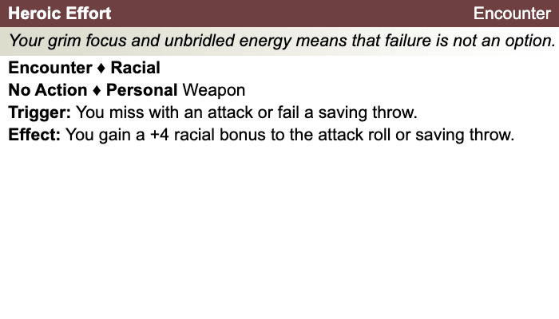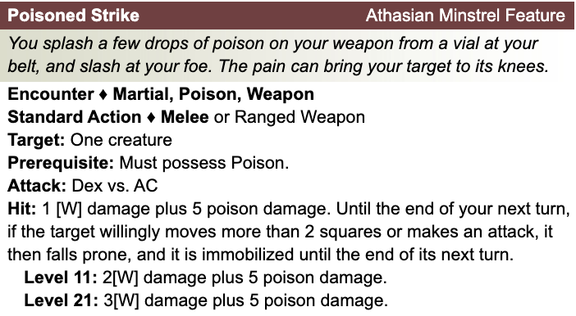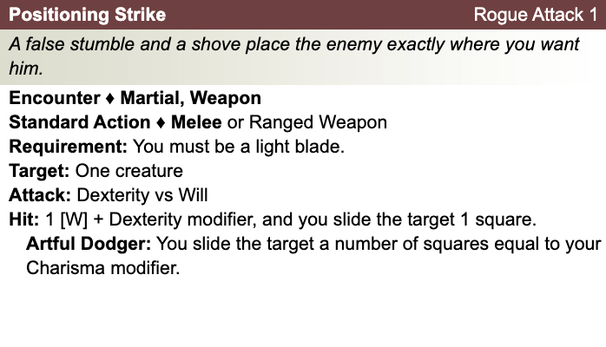

Daily Powers:
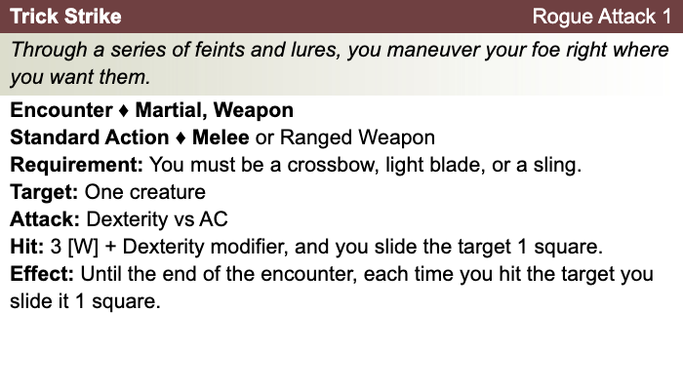

Human
- One bonus feat at 1st level (already included)
- One bonus skill from the skill class list (already included)
- +1 to fortitude, reflex, and will defenses
Rogue
- First Strike: At the start of an encounter, you have combat advantage against any creatures that have not yet acted in that encounter.
- Rogue Weapon Talent: When you wield a chatchka, your weapon damage die increases by one size. When you wield a Widow’s Knife, you gain a +1 bonus to attack rolls.
- Artful Dodger: Add your charisma modifier to AC against opportunity attacks.
- Sneak Attack: Once per round with combat advantage (using light blade, hand crossbow. sling, or short bow), add +2d8 damage to a successful attack.
Theme: Athasian Minstrel [Dark Sun]
- See source book for information
Tija's Equipment: Bandages, Rags
Magic items:
Weapon:
Weapon:
Weapon:
Weapon:
Armor:
Shield:
Arms:
Feet:
Hands:
Head:
Neck:
Ring:
Ring:
Waist:
Resistances:
Action Point Tally:
Daily Item Powers Per Day: Heroic Tier Milestones: / / /
Death Saving Throw Failures:
More about Tija:

Level 2
Unaligned
Strength 13 (+1)  Constitution 11 (+0)  Dexterity 16 (+3)  Intelligence 12 (+1)  Wisdom 10 (+0)  Charisma 16 (+3) | Height: 6' 0"  Weight: 190 lb  Skin:  Eyes:  Hair:
Maximum Hit Points: 28
Bloodied: 14
Surge Value: 7
Surges / Day: 6
Size: Medium
Speed: 6 squares
Vision: Normal
Initiative: | 1d20 +4 | = 1 [half level] + 3 [dexterity]
Base Strength Attack: | 1d20 +3 | = + 1 [half level] + 1 [strength] +1 (fixed enhancement bonus)
Base Dexterity Attack: | 1d20 +5 | = + 1 [half level] + 3 [dexterity] +1 (fixed enhancement bonus)
Base Constitution Attack: | 1d20 +2 | = + 1 [half level] + 0 [constitution] +1 (fixed enhancement bonus)
Base Intelligence Attack: | 1d20 +3 | = + 1 [half level] + 1 [intelligence] +1 (fixed enhancement bonus)
Base Wisdom Attack: | 1d20 +2 | = + 1 [half level] + 0 [wisdom] +1 (fixed enhancement bonus)
Base Charisma Attack: | 1d20 +5 | = + 1 [half level] + 3 [charisma] +1 (fixed enhancement bonus)

Armor Class: | 14 | = 10 + 1 [half level] + 3 [dexterity]
Fortitude Defense: | 13 | = 10 + 1 [half level] + 1 [Human] + 1 [strength]
Reflex Defense: | 17 | = 10 + 1 [half level] + 1 [Human] + 2 [rogue] + 3 [dexterity]
Will Defense: | 15 | = 10 + 1 [half level] + 1 [Human] + 3 [charisma]
If your campaign uses the fixed-enhancement bonus system [PH2/Dark Sun], level 2 characters get +1 on attack/damage (1d6 extra damage on a critical hit) and +0 on all defenses. These bonuses do not stack with magic items.
Armor: None ("cloth")
Shield: None
Attacks:
Unarmed Melee: +2 [base strength attack] vs AC; damage 1[W]=1d4+1 [strength bonus]
Poisoned Strike +4^{w} [best ability vs AC]
Deft Strike +4^{w} [base dexterity attack] vs AC
Sly Flourish +4^{w} [base dexterity attack] vs AC
Positioning Strike +4^{w} [base dexterity attack] vs AC
Trick Strike +4^{w} [base dexterity attack] vs AC
^{w} Weapon-based power. Apply adjustments for proficiency, situation, feats, magic, etc.
Base Saving throw: d20 +1 [human perseverence] vs 10
Encumberance 4e  Normal Load: Heavy Load: Maximum Drag Load 130 lb. 260 lb. 650 lb. | Encumberance 3.5  Light load: Medium load: Heavy load: Lift over head: Lift off ground: Push or drag: 50 lb. or less 51-100 lb. 101-150 lb. 150 lb. 300 lb. 750 lb.

Languages: | Tyrian, Tamwar
Rituals Known:
Skills:
Acrobatics: | +4 | = 3 [dexterity] + 1 [half level]
Arcana: | +2 | = 1 [intelligence] + 1 [half level]
Athletics: | +2 | = 1 [strength] + 1 [half level]
Bluff: | +9 | = 3 [charisma] + 1 [half level] +5 [class training]
Diplomacy: | +4 | = 3 [charisma] + 1 [half level]
Dungeoneering: | +6 | = 0 [wisdom] + 1 [half level] +5 [class training]
Endurance: | +1 | = 0 [constitution] + 1 [half level]
Heal: | +1 | = 0 [wisdom] + 1 [half level]
History: | +2 | = 1 [intelligence] + 1 [half level]
Insight: | +6 | = 0 [wisdom] + 1 [half level] +5 [class training]
Intimidate: | +9 | = 3 [charisma] + 1 [half level] +5 [class training]
Nature: | +1 | = 0 [wisdom] + 1 [half level]
Perception: | +1 | = 0 [wisdom] + 1 [half level]
Religion: | +2 | = 1 [intelligence] + 1 [half level]
Stealth: | +9 | = 3 [dexterity] + 1 [half level] +5 [class training]
Streetwise: | +11 | = 3 [charisma] + 1 [half level] +5 [class training] + 2 [background]
Thievery: | +9 | = 3 [dexterity] + 1 [half level] +5 [class training]
Feats:
Backstabber: The extra damage die from your Sneak Attack class feature increases from d6s to d8s.
Human Perseverance: +1 feat bonus to saving throws
Stinging Poison: If you hit your target with your poisoned strike, the target takes a -2 penalty to saving throws until the end of your next turn.

At-Will:
Melee Basic Attack: By weapon, damage 1[W]+1 [strength bonus] [standard action]
Ranged Basic Attack: By weapon, damage 1[W]+3 [dexterity bonus] [standard action]
Bull Rush: +1 [base strength attack] vs fortitude [standard action]
Grab: +1 [base strength attack] vs reflex [standard action]
Move grabbed target: +1 [base strength attack] vs fortitude [standard action]
Escape: +3 [acrobatics] vs reflex / +1 [athletics] vs fortitude [move action]
Other Standard Actions: | Administer a potion; Aid another [revised: skill check vs. 10+level/2, success helps +2, failure hurts -1]; Charge [+1 to basic melee attack or bull rush]; Coup de grace; Equip / stow shield; Ready an action; Total defense; Sustain standard action; Some skills during combat (i.e., Acrobatics -- fast escape; Bluff, Heal -- first aid (use second wind DC10, stabilize the dying DC15, grant a saving throw DC15), Intimidate, Thievery depending on circumstances);
Other Move Actions: | Crawl; Run [speed 8]; Stand up; Shift; Squeeze; Walk; may include some skills during combat (i.e., Acrobatics, Athletics); half of a Double Move (if taken in place of a standard action)
Other Minor Actions: | Draw / sheathe weapon; Drink a potion; Drop prone; Load a crossbow; Open / close a door; Pick up an item; Retrieve / stow an item; Perception -- active (as per revision), Sustain minor action; Some skills during combat (i.e., Insight)
Other Immediate Actions: | Readied action
Other Opportunity Actions: | Opportunity attack
Other Free Actions: | Drop held items; End a grab; Talk
Other Non-Actions: | Delay; Endurance checks; Insight to counter Bluff; Knowledge checks; Perception -- passive
Short rest: | Healing surges as available
Five minutes: | Normal escape from restraints (Acrobatics)
One hour: | Forage; Streetwise check

Encounter Powers:
Spend an Action Point [free action, not in surprise round]
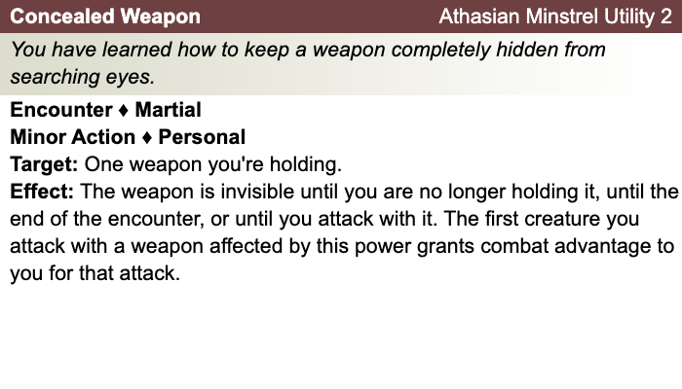

Daily Powers:

Human
- One bonus feat at 1st level (already included)
- One bonus skill from the skill class list (already included)
- +1 to fortitude, reflex, and will defenses
Rogue
- First Strike: At the start of an encounter, you have combat advantage against any creatures that have not yet acted in that encounter.
- Rogue Weapon Talent: When you wield a chatchka, your weapon damage die increases by one size. When you wield a Widow’s Knife, you gain a +1 bonus to attack rolls.
- Artful Dodger: Add your charisma modifier to AC against opportunity attacks.
- Sneak Attack: Once per round with combat advantage (using light blade, hand crossbow. sling, or short bow), add +2d8 damage to a successful attack.
Theme: Athasian Minstrel [Dark Sun]
- See source book for information
Tija's Equipment: Bandages, Rags
Magic items:
Weapon:
Weapon:
Weapon:
Weapon:
Armor:
Shield:
Arms:
Feet:
Hands:
Head:
Neck:
Ring:
Ring:
Waist:
Resistances:
Action Point Tally:
Daily Item Powers Per Day: Heroic Tier Milestones: / / /
Death Saving Throw Failures:
More about Tija:

Level 3
Unaligned
Strength 13 (+1)  Constitution 11 (+0)  Dexterity 16 (+3)  Intelligence 12 (+1)  Wisdom 10 (+0)  Charisma 16 (+3) | Height: 6' 0"  Weight: 190 lb  Skin:  Eyes:  Hair:
Maximum Hit Points: 33
Bloodied: 16
Surge Value: 8
Surges / Day: 6
Size: Medium
Speed: 6 squares
Vision: Normal
Initiative: | 1d20 +4 | = 1 [half level] + 3 [dexterity]
Base Strength Attack: | 1d20 +3 | = + 1 [half level] + 1 [strength] +1 (fixed enhancement bonus)
Base Dexterity Attack: | 1d20 +5 | = + 1 [half level] + 3 [dexterity] +1 (fixed enhancement bonus)
Base Constitution Attack: | 1d20 +2 | = + 1 [half level] + 0 [constitution] +1 (fixed enhancement bonus)
Base Intelligence Attack: | 1d20 +3 | = + 1 [half level] + 1 [intelligence] +1 (fixed enhancement bonus)
Base Wisdom Attack: | 1d20 +2 | = + 1 [half level] + 0 [wisdom] +1 (fixed enhancement bonus)
Base Charisma Attack: | 1d20 +5 | = + 1 [half level] + 3 [charisma] +1 (fixed enhancement bonus)

Armor Class: | 14 | = 10 + 1 [half level] + 3 [dexterity]
Fortitude Defense: | 13 | = 10 + 1 [half level] + 1 [Human] + 1 [strength]
Reflex Defense: | 17 | = 10 + 1 [half level] + 1 [Human] + 2 [rogue] + 3 [dexterity]
Will Defense: | 15 | = 10 + 1 [half level] + 1 [Human] + 3 [charisma]
If your campaign uses the fixed-enhancement bonus system [PH2/Dark Sun], level 3 characters get +1 on attack/damage (1d6 extra damage on a critical hit) and +0 on all defenses. These bonuses do not stack with magic items.
Armor: None ("cloth")
Shield: None
Attacks:
Unarmed Melee: +2 [base strength attack] vs AC; damage 1[W]=1d4+1 [strength bonus]
Poisoned Strike +4^{w} [best ability vs AC]
Deft Strike +4^{w} [base dexterity attack] vs AC
Sly Flourish +4^{w} [base dexterity attack] vs AC
Positioning Strike +4^{w} [base dexterity attack] vs AC
Trick Strike +4^{w} [base dexterity attack] vs AC
Fever Poison:
^{w} Weapon-based power. Apply adjustments for proficiency, situation, feats, magic, etc.
Base Saving throw: d20 +1 [human perseverence] vs 10
Encumberance 4e  Normal Load: Heavy Load: Maximum Drag Load 130 lb. 260 lb. 650 lb. | Encumberance 3.5  Light load: Medium load: Heavy load: Lift over head: Lift off ground: Push or drag: 50 lb. or less 51-100 lb. 101-150 lb. 150 lb. 300 lb. 750 lb.

Languages: | Tyrian, Tamwar
Rituals Known:
Skills:
Acrobatics: | +4 | = 3 [dexterity] + 1 [half level]
Arcana: | +2 | = 1 [intelligence] + 1 [half level]
Athletics: | +2 | = 1 [strength] + 1 [half level]
Bluff: | +9 | = 3 [charisma] + 1 [half level] +5 [class training]
Diplomacy: | +4 | = 3 [charisma] + 1 [half level]
Dungeoneering: | +6 | = 0 [wisdom] + 1 [half level] +5 [class training]
Endurance: | +1 | = 0 [constitution] + 1 [half level]
Heal: | +1 | = 0 [wisdom] + 1 [half level]
History: | +2 | = 1 [intelligence] + 1 [half level]
Insight: | +6 | = 0 [wisdom] + 1 [half level] +5 [class training]
Intimidate: | +9 | = 3 [charisma] + 1 [half level] +5 [class training]
Nature: | +1 | = 0 [wisdom] + 1 [half level]
Perception: | +1 | = 0 [wisdom] + 1 [half level]
Religion: | +2 | = 1 [intelligence] + 1 [half level]
Stealth: | +9 | = 3 [dexterity] + 1 [half level] +5 [class training]
Streetwise: | +11 | = 3 [charisma] + 1 [half level] +5 [class training] + 2 [background]
Thievery: | +9 | = 3 [dexterity] + 1 [half level] +5 [class training]
Feats:
Backstabber: The extra damage die from your Sneak Attack class feature increases from d6s to d8s.
Human Perseverance: +1 feat bonus to saving throws
Stinging Poison: If you hit your target with your poisoned strike, the target takes a -2 penalty to saving throws until the end of your next turn.
At-Will:
Melee Basic Attack: By weapon, damage 1[W]+1 [strength bonus] [standard action]
Ranged Basic Attack: By weapon, damage 1[W]+3 [dexterity bonus] [standard action]
Bull Rush: +1 [base strength attack] vs fortitude [standard action]
Grab: +1 [base strength attack] vs reflex [standard action]
Move grabbed target: +1 [base strength attack] vs fortitude [standard action]
Escape: +3 [acrobatics] vs reflex / +1 [athletics] vs fortitude [move action]
Other Standard Actions: | Administer a potion; Aid another [revised: skill check vs. 10+level/2, success helps +2, failure hurts -1]; Charge [+1 to basic melee attack or bull rush]; Coup de grace; Equip / stow shield; Ready an action; Total defense; Sustain standard action; Some skills during combat (i.e., Acrobatics -- fast escape; Bluff, Heal -- first aid (use second wind DC10, stabilize the dying DC15, grant a saving throw DC15), Intimidate, Thievery depending on circumstances);
Other Move Actions: | Crawl; Run [speed 8]; Stand up; Shift; Squeeze; Walk; may include some skills during combat (i.e., Acrobatics, Athletics); half of a Double Move (if taken in place of a standard action)
Other Minor Actions: | Draw / sheathe weapon; Drink a potion; Drop prone; Load a crossbow; Open / close a door; Pick up an item; Retrieve / stow an item; Perception -- active (as per revision), Sustain minor action; Some skills during combat (i.e., Insight)
Other Immediate Actions: | Readied action
Other Opportunity Actions: | Opportunity attack
Other Free Actions: | Drop held items; End a grab; Talk
Other Non-Actions: | Delay; Endurance checks; Insight to counter Bluff; Knowledge checks; Perception -- passive
Short rest: | Healing surges as available
Five minutes: | Normal escape from restraints (Acrobatics)
One hour: | Forage; Streetwise check

Encounter Powers:
Spend an Action Point [free action, not in surprise round]
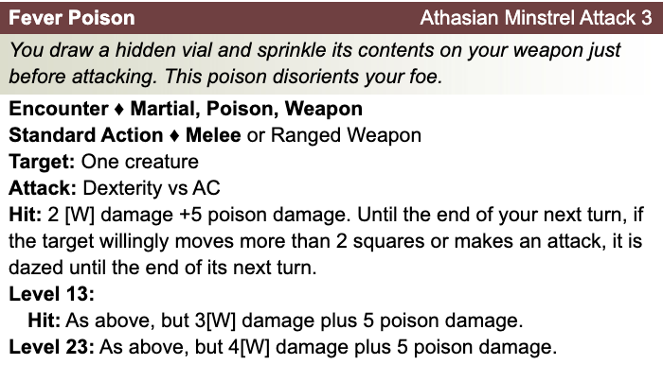

Daily Powers:

Human
- One bonus feat at 1st level (already included)
- One bonus skill from the skill class list (already included)
- +1 to fortitude, reflex, and will defenses
Rogue
- First Strike: At the start of an encounter, you have combat advantage against any creatures that have not yet acted in that encounter.
- Rogue Weapon Talent: When you wield a chatchka, your weapon damage die increases by one size. When you wield a Widow’s Knife, you gain a +1 bonus to attack rolls.
- Artful Dodger: Add your charisma modifier to AC against opportunity attacks.
- Sneak Attack: Once per round with combat advantage (using light blade, hand crossbow. sling, or short bow), add +2d8 damage to a successful attack.
Theme: Athasian Minstrel [Dark Sun]
- See source book for information
Tija's Equipment: Bandages, Rags
Magic items:
Weapon:
Weapon:
Weapon:
Weapon:
Armor:
Shield:
Arms:
Feet:
Hands:
Head:
Neck:
Ring:
Ring:
Waist:
Resistances:
Action Point Tally:
Daily Item Powers Per Day: Heroic Tier Milestones: / / /
Death Saving Throw Failures:
More about Tija:

Level 4
Unaligned
Strength 14 (+2)  Constitution 12 (+1)  Dexterity 16 (+3)  Intelligence 12 (+1)  Wisdom 10 (+0)  Charisma 16 (+3) | Height: 6' 1"  Weight: 195 lb  Skin:  Eyes:  Hair:
Maximum Hit Points: 39
Bloodied: 19
Surge Value: 9
Surges / Day: 7 [includes constitution modifier]
Size: Medium
Speed: 6 squares
Vision: Normal
Initiative: | 1d20 +5 | = 2 [half level] + 3 [dexterity]
Base Strength Attack: | 1d20 +4 | = + 2 [half level] + 1 [strength] +1 (fixed enhancement bonus)
Base Dexterity Attack: | 1d20 +6 | = + 2 [half level] + 3 [dexterity] +1 (fixed enhancement bonus)
Base Constitution Attack: | 1d20 +3 | = + 2 [half level] + 0 [constitution] +1 (fixed enhancement bonus)
Base Intelligence Attack: | 1d20 +4 | = + 2 [half level] + 1 [intelligence] +1 (fixed enhancement bonus)
Base Wisdom Attack: | 1d20 +3 | = + 2 [half level] + 0 [wisdom] +1 (fixed enhancement bonus)
Base Charisma Attack: | 1d20 +6 | = + 2 [half level] + 3 [charisma] +1 (fixed enhancement bonus)

Armor Class: | 16 | = 10 + 2 [half level] + 3 [dexterity] +1 (fixed enhancement bonus)
Fortitude Defense: | 16 | = 10 + 2 [half level] + 1 [Human] + 2 [strength] +1 (fixed enhancement bonus)
Reflex Defense: | 19 | = 10 + 2 [half level] + 1 [Human] + 2 [rogue] + 3 [dexterity] +1 (fixed enhancement bonus)
Will Defense: | 17 | = 10 + 2 [half level] + 1 [Human] + 3 [charisma] +1 (fixed enhancement bonus)
If your campaign uses the fixed-enhancement bonus system [PH2/Dark Sun], level 4 characters get +1 on attack/damage (1d6 extra damage on a critical hit) and +1 on all defenses. These bonuses do not stack with magic items.
Armor: None ("cloth")
Shield: None
Attacks:
Unarmed Melee: +4 [base strength attack] vs AC; damage 1[W]=1d4+2 [strength bonus]
Poisoned Strike +5^{w} [best ability vs AC]
Deft Strike +5^{w} [base dexterity attack] vs AC
Sly Flourish +5^{w} [base dexterity attack] vs AC
Positioning Strike +5^{w} [base dexterity attack] vs AC
Trick Strike +5^{w} [base dexterity attack] vs AC
Fever Poison:
^{w} Weapon-based power. Apply adjustments for proficiency, situation, feats, magic, etc.
Base Saving throw: d20 +1 [human perseverence] vs 10
Encumberance 4e  Normal Load: Heavy Load: Maximum Drag Load 140 lb. 280 lb. 700 lb. | Encumberance 3.5  Light load: Medium load: Heavy load: Lift over head: Lift off ground: Push or drag: 58 lb. or less 59-116 lb. 117-175 lb. 175 lb. 350 lb. 875 lb.

Languages: | Tyrian, Tamwar
Rituals Known:
Skills:
Acrobatics: | +5 | = 3 [dexterity] + 2 [half level]
Arcana: | +3 | = 1 [intelligence] + 2 [half level]
Athletics: | +4 | = 2 [strength] + 2 [half level]
Bluff: | +10 | = 3 [charisma] + 2 [half level] +5 [class training]
Diplomacy: | +5 | = 3 [charisma] + 2 [half level]
Dungeoneering: | +7 | = 0 [wisdom] + 2 [half level] +5 [class training]
Endurance: | +3 | = 1 [constitution] + 2 [half level]
Heal: | +2 | = 0 [wisdom] + 2 [half level]
History: | +3 | = 1 [intelligence] + 2 [half level]
Insight: | +7 | = 0 [wisdom] + 2 [half level] +5 [class training]
Intimidate: | +10 | = 3 [charisma] + 2 [half level] +5 [class training]
Nature: | +2 | = 0 [wisdom] + 2 [half level]
Perception: | +2 | = 0 [wisdom] + 2 [half level]
Religion: | +3 | = 1 [intelligence] + 2 [half level]
Stealth: | +10 | = 3 [dexterity] + 2 [half level] +5 [class training]
Streetwise: | +12 | = 3 [charisma] + 2 [half level] +5 [class training] + 2 [background]
Thievery: | +10 | = 3 [dexterity] + 2 [half level] +5 [class training]
Feats:
Backstabber: The extra damage die from your Sneak Attack class feature increases from d6s to d8s.
Human Perseverance: +1 feat bonus to saving throws
Stinging Poison: If you hit your target with your poisoned strike, the target takes a -2 penalty to saving throws until the end of your next turn.
Inescapable Poison: Your poisoned strike deals 2 extra poison damage. In addition, when you miss a target with, your poisoned strike, that target takes 7 poison damage.

At-Will:
Melee Basic Attack: By weapon, damage 1[W]+1 [strength bonus] [standard action]
Ranged Basic Attack: By weapon, damage 1[W]+3 [dexterity bonus] [standard action]
Bull Rush: +1 [base strength attack] vs fortitude [standard action]
Grab: +1 [base strength attack] vs reflex [standard action]
Move grabbed target: +1 [base strength attack] vs fortitude [standard action]
Escape: +3 [acrobatics] vs reflex / +1 [athletics] vs fortitude [move action]
Other Standard Actions: | Administer a potion; Aid another [revised: skill check vs. 10+level/2, success helps +2, failure hurts -1]; Charge [+1 to basic melee attack or bull rush]; Coup de grace; Equip / stow shield; Ready an action; Total defense; Sustain standard action; Some skills during combat (i.e., Acrobatics -- fast escape; Bluff, Heal -- first aid (use second wind DC10, stabilize the dying DC15, grant a saving throw DC15), Intimidate, Thievery depending on circumstances);
Other Move Actions: | Crawl; Run [speed 8]; Stand up; Shift; Squeeze; Walk; may include some skills during combat (i.e., Acrobatics, Athletics); half of a Double Move (if taken in place of a standard action)
Other Minor Actions: | Draw / sheathe weapon; Drink a potion; Drop prone; Load a crossbow; Open / close a door; Pick up an item; Retrieve / stow an item; Perception -- active (as per revision), Sustain minor action; Some skills during combat (i.e., Insight)
Other Immediate Actions: | Readied action
Other Opportunity Actions: | Opportunity attack
Other Free Actions: | Drop held items; End a grab; Talk
Other Non-Actions: | Delay; Endurance checks; Insight to counter Bluff; Knowledge checks; Perception -- passive
Short rest: | Healing surges as available
Five minutes: | Normal escape from restraints (Acrobatics)
One hour: | Forage; Streetwise check

Encounter Powers:
Spend an Action Point [free action, not in surprise round]

Daily Powers:

Human
- One bonus feat at 1st level (already included)
- One bonus skill from the skill class list (already included)
- +1 to fortitude, reflex, and will defenses
- This human chose the Heroic Effort human encounter utility -- +4 to any attack roll, ability check, saving throw, or skill check in order to turn a failure to a success. Forego the extra at-will class attack power to use this ability.
Rogue
- First Strike
- Rogue Weapon Talent -- per update, dagger must be used as a weapon
- This rogue chose the rogue weapon talent [PH1].
- This rogue chose the artful dodger style. Remember to add your charisma modifier to AC against opportunity attacks.
- Sneak Attack [+2d8 at level 4] [once per round with combat advantage; using light blade, hand crossbow. sling, or short bow]
- Essentials rules appear to consider shortbow a principal rogue weapon like the crossbow.
Theme: Athasian Minstrel [Dark Sun]
- See source book for information
Tija's Equipment: Bandages, Rags
Magic items:
Weapon:
Weapon:
Weapon:
Weapon:
Armor:
Shield:
Arms:
Feet:
Hands:
Head:
Neck:
Ring:
Ring:
Waist:
Resistances:
Action Point Tally:
Daily Item Powers Per Day: Heroic Tier Milestones: / / /
Death Saving Throw Failures:
More about Tija:

