Qiantha
Human Fighter
Level 1
Unaligned
Strength 18 (+4)  Constitution 12 (+1)  Dexterity 14 (+2)  Intelligence 11 (+0)  Wisdom 13 (+1)  Charisma 10 (+0) | Height: 6' 2"  Weight: 220 lb  Skin:  Eyes:  Hair:
Maximum Hit Points: 32 [includes toughness]
Bloodied: 16
Surge Value: 8
Surges / Day: 10 [includes constitution modifier]
Size: Medium
Speed: 6 squares
Vision: Normal
Initiative: | 1d20 +2 | = + 2 [dexterity]
Base Strength Attack: | 1d20 +4 | = + 4 [strength]
Base Dexterity Attack: | 1d20 +2 | = + 2 [dexterity]
Base Constitution Attack: | 1d20 +1 | = + 1 [constitution]
Base Intelligence Attack: | 1d20 +0 | = + 0 [intelligence]
Base Wisdom Attack: | 1d20 +1 | = + 1 [wisdom]
Base Charisma Attack: | 1d20 +0 | = + 0 [charisma]

Armor Class: | 13 | = 10 + 2 [dexterity] + 1 [arena fighter]
Fortitude Defense: | 17 | = 10 + 1 [Human] + 2 [fighter] + 4 [strength]
Reflex Defense: | 13 | = 10 + 1 [Human] + 2 [dexterity]
Will Defense: | 12 | = 10 + 1 [Human] + 1 [wisdom]
If your campaign uses the fixed-enhancement bonus system [PH2/Dark Sun], level 1 characters get +0 on attack/damage (0d6 extra damage on a critical hit) and +0 on all defenses. These bonuses do not stack with magic items.
Armor: None ("cloth")
Shield: None
Attacks:
Unarmed Melee: +4 [base strength attack] vs AC; damage 1[W]=1d4+4 [strength bonus]
Disrupting Advance +4^{w} [best ability vs AC]
Footwork Lure +4^{w} [base strength attack] vs AC
Vicious Offensive +4^{w} [base strength attack] vs AC
Goading Maneuver:
Master's Edge:
^{w} Weapon-based power. Apply adjustments for proficiency, situation, feats, magic, etc.
Base Saving throw: d20 vs 10
Encumberance 4e  Normal Load: Heavy Load: Maximum Drag Load 180 lb. 360 lb. 900 lb. | Encumberance 3.5  Light load: Medium load: Heavy load: Lift over head: Lift off ground: Push or drag: 100 lb. or less 101-200 lb. 201-300 lb. 300 lb. 600 lb. 1500 lb.

Languages: | Raamite
Rituals Known:
Skills:
Acrobatics: | +2 | = 2 [dexterity]
Arcana: | +0 | = 0 [intelligence]
Athletics: | +11 | = 4 [strength] +5 [class training] + 2 [background]
Bluff: | +0 | = 0 [charisma]
Diplomacy: | +0 | = 0 [charisma]
Dungeoneering: | +1 | = 1 [wisdom]
Endurance: | +6 | = 1 [constitution] +5 [class training]
Heal: | +6 | = 1 [wisdom] +5 [class training]
History: | +0 | = 0 [intelligence]
Insight: | +1 | = 1 [wisdom]
Intimidate: | +5 | = 0 [charisma] +5 [class training]
Nature: | +1 | = 1 [wisdom]
Perception: | +1 | = 1 [wisdom]
Religion: | +0 | = 0 [intelligence]
Stealth: | +2 | = 2 [dexterity]
Streetwise: | +0 | = 0 [charisma]
Thievery: | +2 | = 2 [dexterity]
Feats:
Action Surge: You gain a +3 bonus to attack rolls you make during any action you gained by spending an action point.
Toughness: You gain an additional 5 hit points at each tier of play (at 1st, 11th, and 21st level.)

At-Will:
Melee Basic Attack: By weapon, damage 1[W]+4 [strength bonus] [standard action]
Ranged Basic Attack: By weapon, damage 1[W]+2 [dexterity bonus] [standard action]
Bull Rush: +4 [base strength attack] vs fortitude [standard action]
Grab: +4 [base strength attack] vs reflex [standard action]
Move grabbed target: +4 [base strength attack] vs fortitude [standard action]
Escape: +2 [acrobatics] vs reflex / +11 [athletics] vs fortitude [move action]
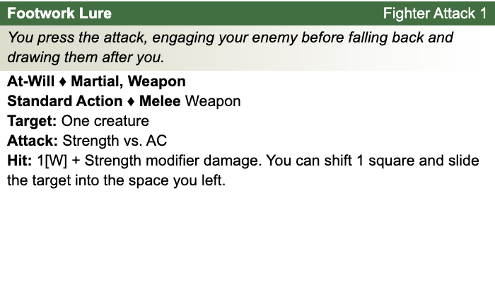
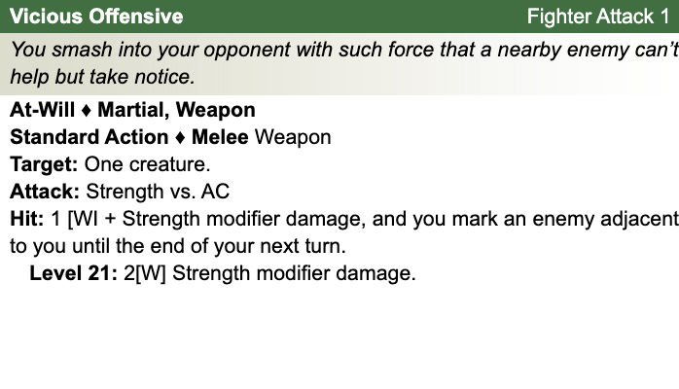
Other Standard Actions: | Administer a potion; Aid another [revised: skill check vs. 10+level/2, success helps +2, failure hurts -1]; Charge [+1 to basic melee attack or bull rush]; Coup de grace; Equip / stow shield; Ready an action; Total defense; Sustain standard action; Some skills during combat (i.e., Acrobatics -- fast escape; Bluff, Heal -- first aid (use second wind DC10, stabilize the dying DC15, grant a saving throw DC15), Intimidate, Thievery depending on circumstances);
Other Move Actions: | Crawl; Run [speed 8]; Stand up; Shift; Squeeze; Walk; may include some skills during combat (i.e., Acrobatics, Athletics); half of a Double Move (if taken in place of a standard action)
Other Minor Actions: | Draw / sheathe weapon; Drink a potion; Drop prone; Load a crossbow; Open / close a door; Pick up an item; Retrieve / stow an item; Perception -- active (as per revision), Sustain minor action; Some skills during combat (i.e., Insight)
Other Immediate Actions: | Readied action
Other Opportunity Actions: | Opportunity attack
Other Free Actions: | Drop held items; End a grab; Talk
Other Non-Actions: | Delay; Endurance checks; Insight to counter Bluff; Knowledge checks; Perception -- passive
Short rest: | Healing surges as available
Five minutes: | Normal escape from restraints (Acrobatics)
One hour: | Forage; Streetwise check

Encounter Powers:
Spend an Action Point [free action, not in surprise round]

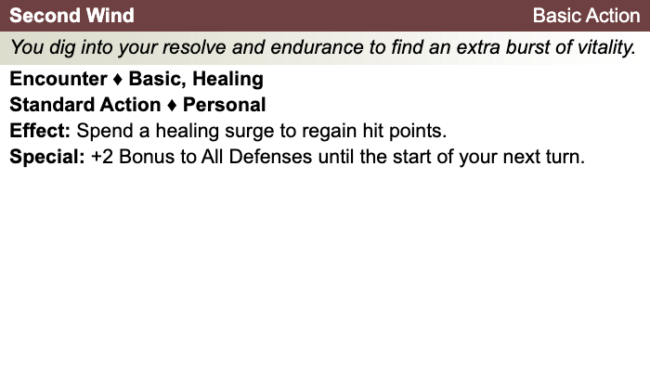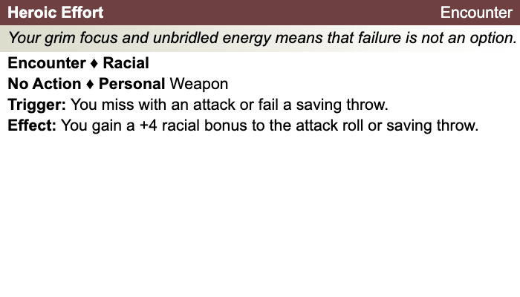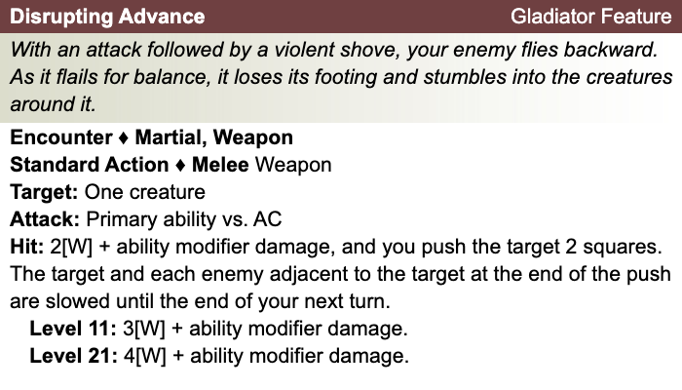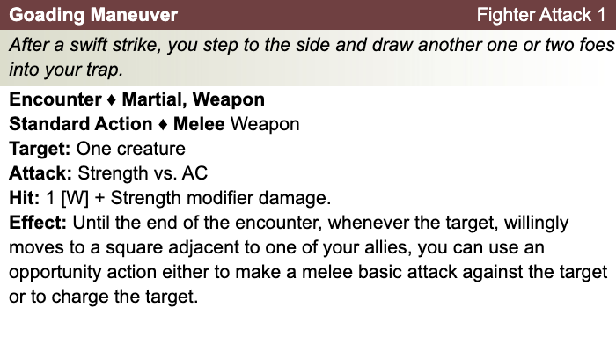

Daily Powers:
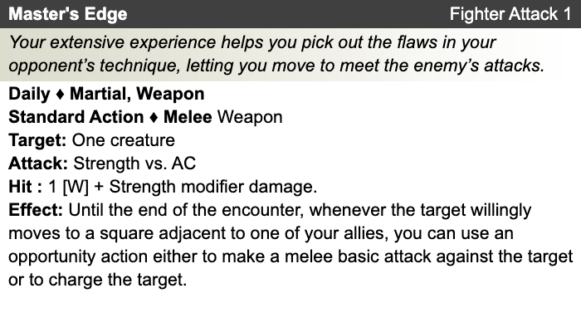
Human
- One bonus feat at 1st level (already included)
- One bonus skill from the skill class list (already included)
- +1 to fortitude, reflex, and will defenses
Fighter
- Combat Challenge (mark enemy) [see online revision]
- This fighter chose Combat Superiority class feature.
- This fighter chose the arena style ["Dark Sun"][+2 proficiency bonus on attack rolls with improvised / untrained weapons; 1d8 damage one-handed, 1d10 damage two-handed; at least two free proficiencies with superior weapons "arena weapons"]

Level 2
Unaligned
Strength 18 (+4)  Constitution 12 (+1)  Dexterity 14 (+2)  Intelligence 11 (+0)  Wisdom 13 (+1)  Charisma 10 (+0) | Height: 6' 2"  Weight: 220 lb  Skin:  Eyes:  Hair:
Maximum Hit Points: 38 [includes toughness]
Bloodied: 19
Surge Value: 9
Surges / Day: 10 [includes constitution modifier]
Size: Medium
Speed: 6 squares
Vision: Normal
Initiative: | 1d20 +3 | = 1 [half level] + 2 [dexterity]
Base Strength Attack: | 1d20 +6 | = + 1 [half level] + 4 [strength] +1 (fixed enhancement bonus)
Base Dexterity Attack: | 1d20 +4 | = + 1 [half level] + 2 [dexterity] +1 (fixed enhancement bonus)
Base Constitution Attack: | 1d20 +3 | = + 1 [half level] + 1 [constitution] +1 (fixed enhancement bonus)
Base Intelligence Attack: | 1d20 +2 | = + 1 [half level] + 0 [intelligence] +1 (fixed enhancement bonus)
Base Wisdom Attack: | 1d20 +3 | = + 1 [half level] + 1 [wisdom] +1 (fixed enhancement bonus)
Base Charisma Attack: | 1d20 +2 | = + 1 [half level] + 0 [charisma] +1 (fixed enhancement bonus)

Armor Class: | 14 | = 10 + 1 [half level] + 2 [dexterity] + 1 [arena fighter]
Fortitude Defense: | 18 | = 10 + 1 [half level] + 1 [Human] + 2 [fighter] + 4 [strength]
Reflex Defense: | 14 | = 10 + 1 [half level] + 1 [Human] + 2 [dexterity]
Will Defense: | 13 | = 10 + 1 [half level] + 1 [Human] + 1 [wisdom]
If your campaign uses the fixed-enhancement bonus system [PH2/Dark Sun], level 2 characters get +1 on attack/damage (1d6 extra damage on a critical hit) and +0 on all defenses. These bonuses do not stack with magic items.
Armor: None ("cloth")
Shield: None
Attacks:
Unarmed Melee: +6 [base strength attack] vs AC; damage 1[W]=1d4+4 [strength bonus] +1 [fixed enhancement bonus
Footwork Lure +6^{w} [base strength attack] vs AC
Vicious Offensive +5^{w} [base strength attack] vs AC
Goading Manuever:
Master's Edge:
^{w} Weapon-based power. Apply adjustments for proficiency, situation, feats, magic, etc.
Base Saving throw: d20 vs 10
Encumberance 4e  Normal Load: Heavy Load: Maximum Drag Load 180 lb. 360 lb. 900 lb. | Encumberance 3.5  Light load: Medium load: Heavy load: Lift over head: Lift off ground: Push or drag: 100 lb. or less 101-200 lb. 201-300 lb. 300 lb. 600 lb. 1500 lb.

Languages: | Raamite
Rituals Known:
Skills:
Acrobatics: | +3 | = 2 [dexterity] + 1 [half level]
Arcana: | +1 | = 0 [intelligence] + 1 [half level]
Athletics: | +12 | = 4 [strength] + 1 [half level] +5 [class training] + 2 [background]
Bluff: | +1 | = 0 [charisma] + 1 [half level]
Diplomacy: | +1 | = 0 [charisma] + 1 [half level]
Dungeoneering: | +2 | = 1 [wisdom] + 1 [half level]
Endurance: | +7 | = 1 [constitution] + 1 [half level] +5 [class training]
Heal: | +7 | = 1 [wisdom] + 1 [half level] +5 [class training]
History: | +1 | = 0 [intelligence] + 1 [half level]
Insight: | +2 | = 1 [wisdom] + 1 [half level]
Intimidate: | +6 | = 0 [charisma] + 1 [half level] +5 [class training]
Nature: | +2 | = 1 [wisdom] + 1 [half level]
Perception: | +2 | = 1 [wisdom] + 1 [half level]
Religion: | +1 | = 0 [intelligence] + 1 [half level]
Stealth: | +3 | = 2 [dexterity] + 1 [half level]
Streetwise: | +1 | = 0 [charisma] + 1 [half level]
Thievery: | +3 | = 2 [dexterity] + 1 [half level]
Feats:
Action Surge: You gain a +3 bonus to attack rolls you make during any action you gained by spending an action point.
Toughness: You gain an additional 5 hit points at each tier of play (at 1st, 11th, and 21st level.)

Disrupting Shove: When you hit a target with your disrupting advance, the target falls prone at the end of the push.

At-Will:
Melee Basic Attack: By weapon, damage 1[W]+4 [strength bonus] [standard action]
Ranged Basic Attack: By weapon, damage 1[W]+2 [dexterity bonus] [standard action]
Bull Rush: +5 [base strength attack] vs fortitude [standard action]
Grab: +5 [base strength attack] vs reflex [standard action]
Move grabbed target: +5 [base strength attack] vs fortitude [standard action]
Escape: +3 [acrobatics] vs reflex / +12 [athletics] vs fortitude [move action]
Other Standard Actions: | Administer a potion; Aid another [revised: skill check vs. 10+level/2, success helps +2, failure hurts -1]; Charge [+1 to basic melee attack or bull rush]; Coup de grace; Equip / stow shield; Ready an action; Total defense; Sustain standard action; Some skills during combat (i.e., Acrobatics -- fast escape; Bluff, Heal -- first aid (use second wind DC10, stabilize the dying DC15, grant a saving throw DC15), Intimidate, Thievery depending on circumstances);
Other Move Actions: | Crawl; Run [speed 8]; Stand up; Shift; Squeeze; Walk; may include some skills during combat (i.e., Acrobatics, Athletics); half of a Double Move (if taken in place of a standard action)
Other Minor Actions: | Draw / sheathe weapon; Drink a potion; Drop prone; Load a crossbow; Open / close a door; Pick up an item; Retrieve / stow an item; Perception -- active (as per revision), Sustain minor action; Some skills during combat (i.e., Insight)
Other Immediate Actions: | Readied action
Other Opportunity Actions: | Opportunity attack
Other Free Actions: | Drop held items; End a grab; Talk
Other Non-Actions: | Delay; Endurance checks; Insight to counter Bluff; Knowledge checks; Perception – passive
Short rest: | Healing surges as available
Five minutes: | Normal escape from restraints (Acrobatics)
One hour: | Forage; Streetwise check

Encounter Powers:
Spend an Action Point [free action, not in surprise round]

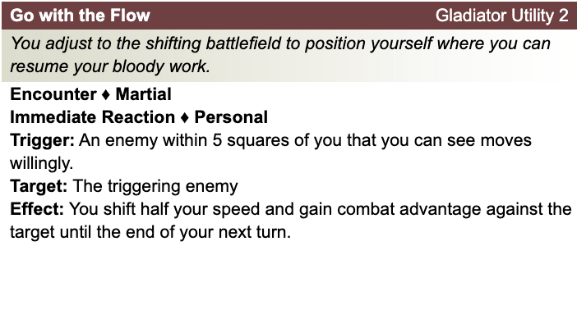

Daily Powers:

Human
- One bonus feat at 1st level (already included)
- One bonus skill from the skill class list (already included)
- +1 to fortitude, reflex, and will defenses
Fighter
- Combat Challenge: After attacking an enemy, choose to mark that target; mark lasts until the end of your next turn. While target is marked, it takes a -2 penalty to attack rolls for any attack that doesn’t include you as a target. A creature can be subject to only one mark at a time. A new mark supersedes a mark that was already in place.
- Combat Superiority: Add Wisdom modifier to opportunity attacks; an enemy struck by your opportunity attacks stops moving, if a move provoked the attack.
- Arena Fighting: +2 proficiency bonus on attack rolls with improvised / untrained weapons; 1d8 damage one-handed, 1d10 damage two-handed; arena-training with Tortoise Blade and Carrikal.)
Qiantha's Equipment: Bandages, Rags
Magic items:
Weapon:
Weapon:
Weapon:
Weapon:
Armor:
Shield:
Arms:
Feet:
Hands:
Head:
Neck:
Ring:
Ring:
Waist:
Resistances:
Action Point Tally:
Daily Item Powers Per Day: Heroic Tier Milestones: / / /
Death Saving Throw Failures:
More about Qiantha:

Theme: Gladiator [Dark Sun]
- See source book for information

Level 3
Unaligned
Strength 18 (+4)  Constitution 12 (+1)  Dexterity 14 (+2)  Intelligence 11 (+0)  Wisdom 13 (+1)  Charisma 10 (+0) | Height: 6' 2"  Weight: 220 lb  Skin:  Eyes:  Hair:
Maximum Hit Points: 44 [includes toughness]
Bloodied: 22
Surge Value: 11
Surges / Day: 10 [includes constitution modifier]
Size: Medium
Speed: 6 squares
Vision: Normal
Initiative: | 1d20 +3 | = 1 [half level] + 2 [dexterity]
Base Strength Attack: | 1d20 +6 | = + 1 [half level] + 4 [strength] +1 (fixed enhancement bonus)
Base Dexterity Attack: | 1d20 +4 | = + 1 [half level] + 2 [dexterity] +1 (fixed enhancement bonus)
Base Constitution Attack: | 1d20 +3 | = + 1 [half level] + 1 [constitution] +1 (fixed enhancement bonus)
Base Intelligence Attack: | 1d20 +2 | = + 1 [half level] + 0 [intelligence] +1 (fixed enhancement bonus)
Base Wisdom Attack: | 1d20 +3 | = + 1 [half level] + 1 [wisdom] +1 (fixed enhancement bonus)
Base Charisma Attack: | 1d20 +2zf | = + 1 [half level] + 0 [charisma] +1 (fixed enhancement bonus)

Armor Class: | 14 | = 10 + 1 [half level] + 2 [dexterity] + 1 [arena fighter]
Fortitude Defense: | 18 | = 10 + 1 [half level] + 1 [Human] + 2 [fighter] + 4 [strength]
Reflex Defense: | 14 | = 10 + 1 [half level] + 1 [Human] + 2 [dexterity]
Will Defense: | 13 | = 10 + 1 [half level] + 1 [Human] + 1 [wisdom]
If your campaign uses the fixed-enhancement bonus system [PH2/Dark Sun], level 3 characters get +1 on attack/damage (1d6 extra damage on a critical hit) and +0 on all defenses. These bonuses do not stack with magic items.
Armor: None ("cloth")
Shield: None
Attacks:
Unarmed Melee: +6 [base strength attack] vs AC; damage 1[W]=1d4+4 [strength bonus] +1 [fixed enhancement bonus]
Footwork Lure +6^{w} [base strength attack] vs AC
Vicious Offensive +6^{w} [base strength attack] vs AC
Goading Manuever:
Master's Edge:
Savage Sweep:
^{w} Weapon-based power. Apply adjustments for proficiency, situation, feats, magic, etc.
Base Saving throw: d20 vs 10
Encumberance 4e  Normal Load: Heavy Load: Maximum Drag Load 180 lb. 360 lb. 900 lb. | Encumberance 3.5  Light load: Medium load: Heavy load: Lift over head: Lift off ground: Push or drag: 100 lb. or less 101-200 lb. 201-300 lb. 300 lb. 600 lb. 1500 lb.

Languages: | Raamite
Rituals Known:
Skills:
Acrobatics: | +3 | = 2 [dexterity] + 1 [half level]
Arcana: | +1 | = 0 [intelligence] + 1 [half level]
Athletics: | +12 | = 4 [strength] + 1 [half level] +5 [class training] + 2 [background]
Bluff: | +1 | = 0 [charisma] + 1 [half level]
Diplomacy: | +1 | = 0 [charisma] + 1 [half level]
Dungeoneering: | +2 | = 1 [wisdom] + 1 [half level]
Endurance: | +7 | = 1 [constitution] + 1 [half level] +5 [class training]
Heal: | +7 | = 1 [wisdom] + 1 [half level] +5 [class training]
History: | +1 | = 0 [intelligence] + 1 [half level]
Insight: | +2 | = 1 [wisdom] + 1 [half level]
Intimidate: | +6 | = 0 [charisma] + 1 [half level] +5 [class training]
Nature: | +2 | = 1 [wisdom] + 1 [half level]
Perception: | +2 | = 1 [wisdom] + 1 [half level]
Religion: | +1 | = 0 [intelligence] + 1 [half level]
Stealth: | +3 | = 2 [dexterity] + 1 [half level]
Streetwise: | +1 | = 0 [charisma] + 1 [half level]
Thievery: | +3 | = 2 [dexterity] + 1 [half level]
Feats:
Action Surge: You gain a +3 bonus to attack rolls you make during any action you gained by spending an action point.
Toughness: You gain an additional 5 hit points at each tier of play (at 1st, 11th, and 21st level.)

Disrupting Shove: When you hit a target with your disrupting advance, the target falls prone at the end of the push.

At-Will:
Melee Basic Attack: By weapon, damage 1[W]+4 [strength bonus] [standard action]
Ranged Basic Attack: By weapon, damage 1[W]+2 [dexterity bonus] [standard action]
Bull Rush: +5 [base strength attack] vs fortitude [standard action]
Grab: +5 [base strength attack] vs reflex [standard action]
Move grabbed target: +5 [base strength attack] vs fortitude [standard action]
Escape: +3 [acrobatics] vs reflex / +12 [athletics] vs fortitude [move action]
Other Standard Actions: | Administer a potion; Aid another [revised: skill check vs. 10+level/2, success helps +2, failure hurts -1]; Charge [+1 to basic melee attack or bull rush]; Coup de grace; Equip / stow shield; Ready an action; Total defense; Sustain standard action; Some skills during combat (i.e., Acrobatics -- fast escape; Bluff, Heal -- first aid (use second wind DC10, stabilize the dying DC15, grant a saving throw DC15), Intimidate, Thievery depending on circumstances);
Other Move Actions: | Crawl; Run [speed 8]; Stand up; Shift; Squeeze; Walk; may include some skills during combat (i.e., Acrobatics, Athletics); half of a Double Move (if taken in place of a standard action)
Other Minor Actions: | Draw / sheathe weapon; Drink a potion; Drop prone; Load a crossbow; Open / close a door; Pick up an item; Retrieve / stow an item; Perception -- active (as per revision), Sustain minor action; Some skills during combat (i.e., Insight)
Other Immediate Actions: | Readied action
Other Opportunity Actions: | Opportunity attack
Other Free Actions: | Drop held items; End a grab; Talk
Other Non-Actions: | Delay; Endurance checks; Insight to counter Bluff; Knowledge checks; Perception – passive
Short rest: | Healing surges as available
Five minutes: | Normal escape from restraints (Acrobatics)
One hour: | Forage; Streetwise check

Encounter Powers:
Spend an Action Point [free action, not in surprise round]

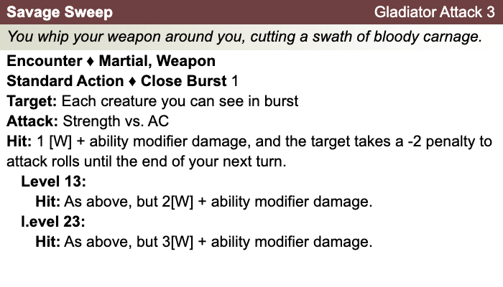
Daily Powers:

Human
- One bonus feat at 1st level (already included)
- One bonus skill from the skill class list (already included)
- +1 to fortitude, reflex, and will defenses
Fighter
- Combat Challenge: After attacking an enemy, choose to mark that target; mark lasts until the end of your next turn. While target is marked, it takes a -2 penalty to attack rolls for any attack that doesn’t include you as a target. A creature can be subject to only one mark at a time. A new mark supersedes a mark that was already in place.
- Combat Superiority: Add Wisdom modifier to opportunity attacks; an enemy struck by your opportunity attacks stops moving, if a move provoked the attack.
- Arena Fighting: +2 proficiency bonus on attack rolls with improvised / untrained weapons; 1d8 damage one-handed, 1d10 damage two-handed; arena-training with Tortoise Blade and Carrikal.)
Qiantha's Equipment: Bandages, Rags
Magic items:
Weapon:
Weapon:
Weapon:
Weapon:
Armor:
Shield:
Arms:
Feet:
Hands:
Head:
Neck:
Ring:
Ring:
Waist:
Resistances:
Action Point Tally:
Daily Item Powers Per Day: Heroic Tier Milestones: / / /
Death Saving Throw Failures:
More about Qiantha:

Level 4
Unaligned
Strength 18 (+4)  Constitution 13 (+1)  Dexterity 14 (+2)  Intelligence 11 (+0)  Wisdom 14 (+2)  Charisma 10 (+0) | Height: 6' 2"  Weight: 220 lb  Skin:  Eyes:  Hair:
Maximum Hit Points: 51 [includes toughness]
Bloodied: 25
Surge Value: 12
Surges / Day: 10 [includes constitution modifier]
Size: Medium
Speed: 6 squares
Vision: Normal
Initiative: | 1d20 +4 | = 2 [half level] + 2 [dexterity]
Base Strength Attack: | 1d20 +7 | = + 2 [half level] + 4 [strength] + 1 (fixed enhancement bonus)
Base Dexterity Attack: | 1d20 +5 | = + 2 [half level] + 2 [dexterity] + 1 (fixed enhancement bonus)
Base Constitution Attack: | 1d20 +4 | = + 2 [half level] + 1 [constitution] + 1 (fixed enhancement bonus)
Base Intelligence Attack: | 1d20 +3 | = + 2 [half level] + 0 [intelligence] + 1 (fixed enhancement bonus)
Base Wisdom Attack: | 1d20 +5 | = + 2 [half level] + 2 [wisdom] + 1 (fixed enhancement bonus)
Base Charisma Attack: | 1d20 +3 | = + 2 [half level] + 0 [charisma] + 1 (fixed enhancement bonus)

Armor Class: | 16 | = 10 + 2 [half level] + 2 [dexterity] + 1 [arena fighter] + 1 (fixed enhancement bonus) + 1 (fixed enhancement bonus)
Fortitude Defense: | 20 | = 10 + 2 [half level] + 1 [Human] + 2 [fighter] + 4 [strength] + 1 (fixed enhancement bonus)
Reflex Defense: | 16 | = 10 + 2 [half level] + 1 [Human] + 2 [dexterity] + 1 (fixed enhancement bonus)
Will Defense: | 16 | = 10 + 2 [half level] + 1 [Human] + 2 [wisdom] + 1 (fixed enhancement bonus)
If your campaign uses the fixed-enhancement bonus system [PH2/Dark Sun], level 4 characters get +1 on attack/damage (1d6 extra damage on a critical hit) and +1 on all defenses. These bonuses do not stack with magic items.
Armor: None ("cloth")
Shield: None
Attacks:
Unarmed Melee: +6 [base strength attack] vs AC; damage 1[W]=1d4+4 [strength bonus]
Footwork Lure +6^{w} [base strength attack] vs AC
Vicious Offensive +6^{w} [base strength attack] vs AC
Goading Maneuver:
Master's Edge:
Savage Sweep:
^{w} Weapon-based power. Apply adjustments for proficiency, situation, feats, magic, etc.
Base Saving throw: d20 vs 10
Encumberance 4e  Normal Load: Heavy Load: Maximum Drag Load 180 lb. 360 lb. 900 lb. | Encumberance 3.5  Light load: Medium load: Heavy load: Lift over head: Lift off ground: Push or drag: 100 lb. or less 101-200 lb. 201-300 lb. 300 lb. 600 lb. 1500 lb.

Languages: | Raamite
Rituals Known:
Skills:
Acrobatics: | +4 | = 2 [dexterity] + 2 [half level]
Arcana: | +2 | = 0 [intelligence] + 2 [half level]
Athletics: | +13 | = 4 [strength] + 2 [half level] +5 [class training] + 2 [background]
Bluff: | +2 | = 0 [charisma] + 2 [half level]
Diplomacy: | +2 | = 0 [charisma] + 2 [half level]
Dungeoneering: | +4 | = 2 [wisdom] + 2 [half level]
Endurance: | +8 | = 1 [constitution] + 2 [half level] +5 [class training]
Heal: | +9 | = 2 [wisdom] + 2 [half level] +5 [class training]
History: | +2 | = 0 [intelligence] + 2 [half level]
Insight: | +4 | = 2 [wisdom] + 2 [half level]
Intimidate: | +7 | = 0 [charisma] + 2 [half level] +5 [class training]
Nature: | +4 | = 2 [wisdom] + 2 [half level]
Perception: | +4 | = 2 [wisdom] + 2 [half level]
Religion: | +2 | = 0 [intelligence] + 2 [half level]
Stealth: | +4 | = 2 [dexterity] + 2 [half level]
Streetwise: | +2 | = 0 [charisma] + 2 [half level]
Thievery: | +4 | = 2 [dexterity] + 2 [half level]
Feats:
Action Surge: You gain a +3 bonus to attack rolls you make during any action you gained by spending an action point.
Toughness: You gain an additional 5 hit points at each tier of play (at 1st, 11th, and 21st level.)

Disrupting Shove: When you hit a target with your disrupting advance, the target falls prone at the end of the push.

Brutish Disruption: When you hit a target with your disrupting
advance, you push the target a number of squares equal to 2 + your Constitution modifier, instead of 2 squares.

At-Will:
Melee Basic Attack: By weapon, damage 1[W]+4 [strength bonus] [standard action]
Ranged Basic Attack: By weapon, damage 1[W]+2 [dexterity bonus] [standard action]
Bull Rush: +5 [base strength attack] vs fortitude [standard action]
Grab: +5 [base strength attack] vs reflex [standard action]
Move grabbed target: +5 [base strength attack] vs fortitude [standard action]
Escape: +3 [acrobatics] vs reflex / +12 [athletics] vs fortitude [move action]
Other Standard Actions: | Administer a potion; Aid another [revised: skill check vs. 10+level/2, success helps +2, failure hurts -1]; Charge [+1 to basic melee attack or bull rush]; Coup de grace; Equip / stow shield; Ready an action; Total defense; Sustain standard action; Some skills during combat (i.e., Acrobatics -- fast escape; Bluff, Heal -- first aid (use second wind DC10, stabilize the dying DC15, grant a saving throw DC15), Intimidate, Thievery depending on circumstances);
Other Move Actions: | Crawl; Run [speed 8]; Stand up; Shift; Squeeze; Walk; may include some skills during combat (i.e., Acrobatics, Athletics); half of a Double Move (if taken in place of a standard action)
Other Minor Actions: | Draw / sheathe weapon; Drink a potion; Drop prone; Load a crossbow; Open / close a door; Pick up an item; Retrieve / stow an item; Perception -- active (as per revision), Sustain minor action; Some skills during combat (i.e., Insight)
Other Immediate Actions: | Readied action
Other Opportunity Actions: | Opportunity attack
Other Free Actions: | Drop held items; End a grab; Talk
Other Non-Actions: | Delay; Endurance checks; Insight to counter Bluff; Knowledge checks; Perception – passive
Short rest: | Healing surges as available
Five minutes: | Normal escape from restraints (Acrobatics)
One hour: | Forage; Streetwise check

Encounter Powers:
Spend an Action Point [free action, not in surprise round]

Daily Powers:

Human
- One bonus feat at 1st level (already included)
- One bonus skill from the skill class list (already included)
- +1 to fortitude, reflex, and will defenses
Fighter
- Combat Challenge: After attacking an enemy, choose to mark that target; mark lasts until the end of your next turn. While target is marked, it takes a -2 penalty to attack rolls for any attack that doesn’t include you as a target. A creature can be subject to only one mark at a time. A new mark supersedes a mark that was already in place.
- Combat Superiority: Add Wisdom modifier to opportunity attacks; an enemy struck by your opportunity attacks stops moving, if a move provoked the attack.
- Arena Fighting: +2 proficiency bonus on attack rolls with improvised / untrained weapons; 1d8 damage one-handed, 1d10 damage two-handed; arena-training with Tortoise Blade and Carrikal.)
Qiantha's Equipment: Bandages, Rags
Magic items:
Weapon:
Weapon:
Weapon:
Weapon:
Armor:
Shield:
Arms:
Feet:
Hands:
Head:
Neck:
Ring:
Ring:
Waist:
Resistances:
Action Point Tally:
Daily Item Powers Per Day: Heroic Tier Milestones: / / /
Death Saving Throw Failures:
More about this character:

