Bethiah
Human Warlord
Level 1
Unaligned
Strength 16 (+3)  Constitution 12 (+1)  Dexterity 10 (+0)  Intelligence 16 (+3)  Wisdom 11 (+0)  Charisma 13 (+1) | Height: 6' 2"  Weight: 210 lb  Skin:  Eyes:  Hair:
Maximum Hit Points: 24
Bloodied: 12
Surge Value: 6
Surges / Day: 8 [includes constitution modifier]
Size: Medium
Speed: 6 squares
Vision: Normal
Initiative: | 1d20 +2 | = + 0 [dexterity] + 2 [combat leader]
Base Strength Attack: | 1d20 +3 | = + 3 [strength]
Base Dexterity Attack: | 1d20 +0 | = + 0 [dexterity]
Base Constitution Attack: | 1d20 +1 | = + 1 [constitution]
Base Intelligence Attack: | 1d20 +3 | = + 3 [intelligence]
Base Wisdom Attack: | 1d20 +0 | = + 0 [wisdom]
Base Charisma Attack: | 1d20 +1 | = + 1 [charisma]

Armor Class: | 13 | = 10 + 3 [intelligence]
Fortitude Defense: | 15 | = 10 + 1 [Human] + 1 [warlord] + 3 [strength]
Reflex Defense: | 14 | = 10 + 1 [Human] + 3 [intelligence]
Will Defense: | 13 | = 10 + 1 [Human] + 1 [warlord] + 1 [charisma]
If your campaign uses the fixed-enhancement bonus system [PH2/Dark Sun], level 1 characters get +0 on attack/damage (0d6 extra damage on a critical hit) and +0 on all defenses. These bonuses do not stack with magic items.
Armor: None ("cloth")
Shield: None
Attacks:
Unarmed Melee: +3 [base strength attack] vs AC; damage 1[W]=1d4+3 [strength bonus]
Quick Formation +3^{w} [best ability vs AC]
Viper's Strike +3^{w} [base strength attack] vs AC
Wolfpack Tactics +3^{w} [base strength attack] vs AC
Warlord's Favor +3^{w} [base strength attack] vs AC
Lead the Attack +3^{w} [base strength attack] vs AC
^{w} Weapon-based power. Apply adjustments for proficiency, situation, feats, magic, etc.
Base Saving throw: d20 vs 10
Encumberance 4e  Normal Load: Heavy Load: Maximum Drag Load 160 lb. 320 lb. 800 lb. | Encumberance 3.5  Light load: Medium load: Heavy load: Lift over head: Lift off ground: Push or drag: 76 lb. or less 77-153 lb. 154-230 lb. 230 lb. 460 lb. 1150 lb.

Languages: | Balican, Tyrian, Raamite, Nibanese
Rituals Known:
Skills:
Acrobatics: | +0 | = 0 [dexterity]
Arcana: | +3 | = 3 [intelligence]
Athletics: | +8 | = 3 [strength] +5 [class training]
Bluff: | +1 | = 1 [charisma]
Diplomacy: | +6 | = 1 [charisma] +5 [class training]
Dungeoneering: | +0 | = 0 [wisdom]
Endurance: | +6 | = 1 [constitution] +5 [class training]
Heal: | +5 | = 0 [wisdom] +5 [class training]
History: | +10 | = 3 [intelligence] +5 [class training] + 2 [background]
Insight: | +0 | = 0 [wisdom]
Intimidate: | +1 | = 1 [charisma]
Nature: | +0 | = 0 [wisdom]
Perception: | +0 | = 0 [wisdom]
Religion: | +3 | = 3 [intelligence]
Stealth: | +0 | = 0 [dexterity]
Streetwise: | +1 | = 1 [charisma]
Thievery: | +0 | = 0 [dexterity]
Feats:
- Tactical Assault: When an ally who can see you spends an action point to make an attack, the attack’s damage roll gains a bonus equal to your Intelligence modifier.
- Weapon Focus (Light Blade): You gain a +1 feat bonus to damage rolls with Light Blades. At 11th level, this bonus increases to +2. At 21st level, it increases to +3.

At-Will:
Melee Basic Attack: By weapon, damage 1[W]+3 [strength bonus] [standard action]
Ranged Basic Attack: By weapon, damage 1[W] [standard action]
Bull Rush: +3 [base strength attack] vs fortitude [standard action]
Grab: +3 [base strength attack] vs reflex [standard action]
Move grabbed target: +3 [base strength attack] vs fortitude [standard action]
Escape: +0 [acrobatics] vs reflex / +8 [athletics] vs fortitude [move action]
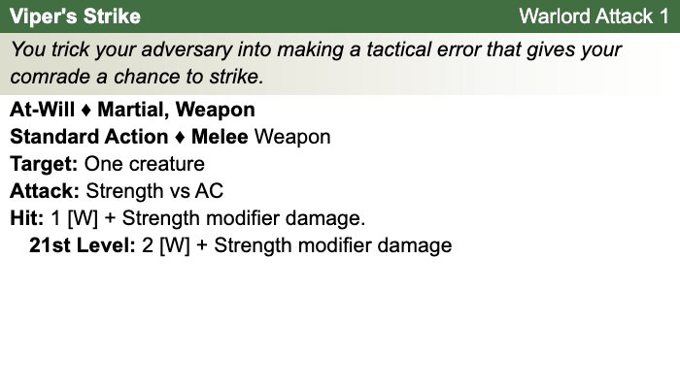
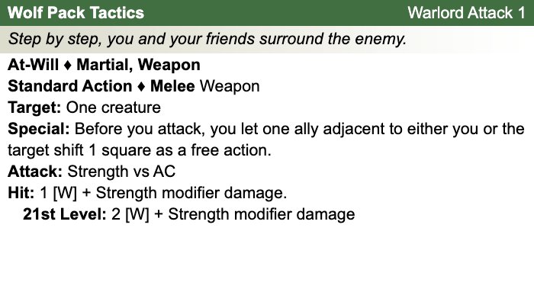
Other Standard Actions: | Administer a potion; Aid another [revised: skill check vs. 10+level/2, success helps +2, failure hurts -1]; Charge [+1 to basic melee attack or bull rush]; Coup de grace; Equip / stow shield; Ready an action; Total defense; Sustain standard action; Some skills during combat (i.e., Acrobatics -- fast escape; Bluff, Heal -- first aid (use second wind DC10, stabilize the dying DC15, grant a saving throw DC15), Intimidate, Thievery depending on circumstances);
Other Move Actions: | Crawl; Run [speed 8]; Stand up; Shift; Squeeze; Walk; may include some skills during combat (i.e., Acrobatics, Athletics); half of a Double Move (if taken in place of a standard action)
Other Minor Actions: | Draw / sheathe weapon; Drink a potion; Drop prone; Load a crossbow; Open / close a door; Pick up an item; Retrieve / stow an item; Perception -- active (as per revision), Sustain minor action; Some skills during combat (i.e., Insight)
Other Immediate Actions: | Readied action
Other Opportunity Actions: | Opportunity attack
Other Free Actions: | Drop held items; End a grab; Talk
Other Non-Actions: | Delay; Endurance checks; Insight to counter Bluff; Knowledge checks; Perception -- passive
Short rest: | Healing surges as available
Five minutes: | Normal escape from restraints (Acrobatics)
One hour: | Forage; Streetwise check

Encounter Powers:
Spend an Action Point [free action, not in surprise round]
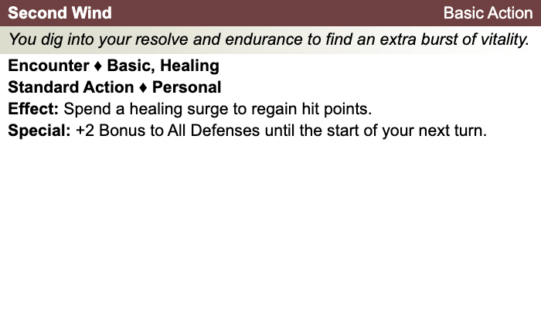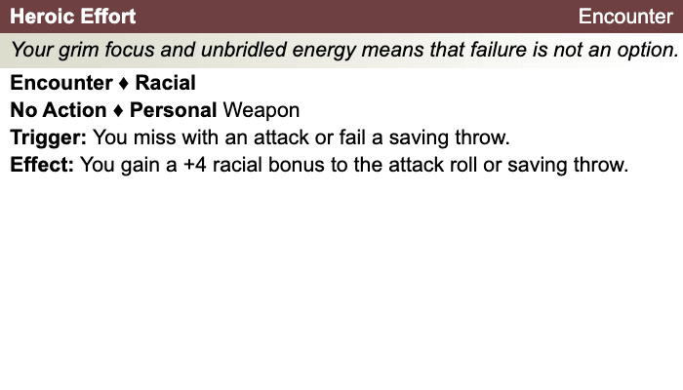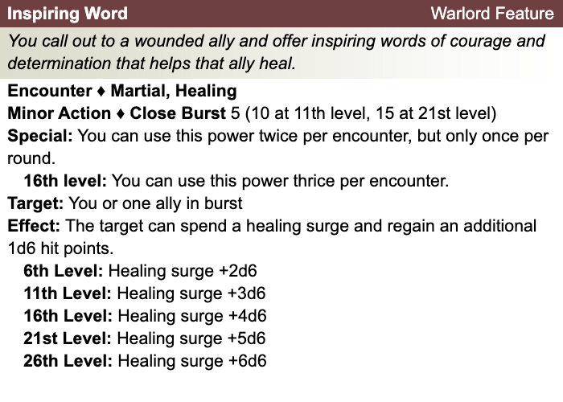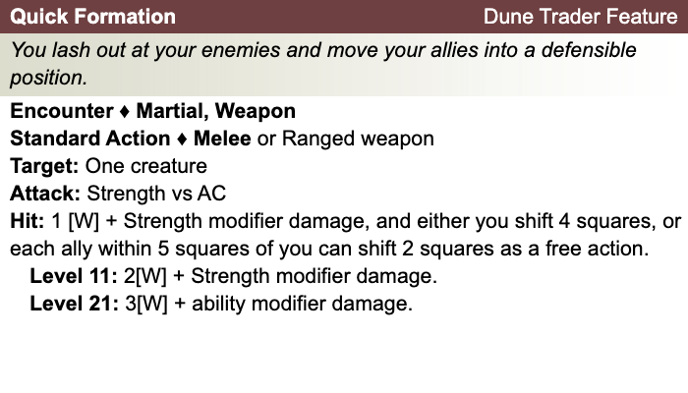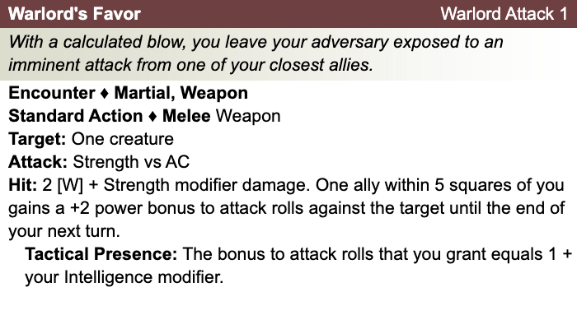

Daily Powers:
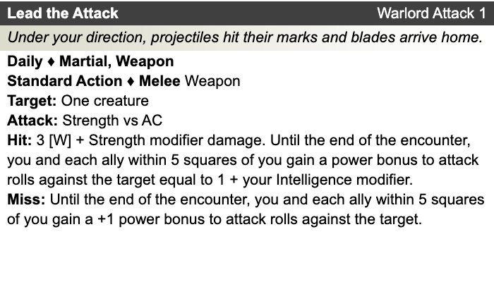
Human
- One bonus feat at 1st level (already included)
- One bonus skill from the skill class list (already included)
- +1 to fortitude, reflex, and will defenses
Warlord
- Combat Leader: You and each ally within 10 squares who can see and hear you gain a +2 power bonus to initiative.
- Tactical Presence: When an ally you can see spends an action point to make an extra attack, that ally gains a bonus to the attack roll equal to one-half your Intelligence modifier.
Theme: Dune Trader [Dark Sun]
- See source book for information
Bethiah's Equipment: Bandages, Rags
Magic items:
Weapon:
Weapon:
Weapon:
Weapon:
Armor:
Shield:
Arms:
Feet:
Hands:
Head:
Neck:
Ring:
Ring:
Waist:
Resistances:
Action Point Tally:
Daily Item Powers Per Day: Heroic Tier Milestones: / / /
Death Saving Throw Failures:
More about Bethiah:

Level 2
Unaligned
Strength 16 (+3)  Constitution 12 (+1)  Dexterity 10 (+0)  Intelligence 16 (+3)  Wisdom 11 (+0)  Charisma 13 (+1) | Height: 6' 2"  Weight: 210 lb  Skin:  Eyes:  Hair:
Maximum Hit Points: 29
Bloodied: 14
Surge Value: 7
Surges / Day: 8 [includes constitution modifier]
Size: Medium
Speed: 6 squares
Vision: Normal
Initiative: | 1d20 +3 | = 1 [half level] + 0 [dexterity] + 2 [combat leader]
Base Strength Attack: | 1d20 +5 | = + 1 [half level] + 3 [strength] + 1 (fixed enhancement bonus)
Base Dexterity Attack: | 1d20 +2 | = + 1 [half level] + 0 [dexterity] + 1 (fixed enhancement bonus)
Base Constitution Attack: | 1d20 +3 | = + 1 [half level] + 1 [constitution] + 1 (fixed enhancement bonus)
Base Intelligence Attack: | 1d20 +5 | = + 1 [half level] + 3 [intelligence] + 1 (fixed enhancement bonus)
Base Wisdom Attack: | 1d20 +2 | = + 1 [half level] + 0 [wisdom] + 1 (fixed enhancement bonus)
Base Charisma Attack: | 1d20 +3 | = + 1 [half level] + 1 [charisma] + 1 (fixed enhancement bonus)

Armor Class: | 14 | = 10 + 1 [half level] + 3 [intelligence]
Fortitude Defense: | 16 | = 10 + 1 [half level] + 1 [Human] + 1 [warlord] + 3 [strength]
Reflex Defense: | 15 | = 10 + 1 [half level] + 1 [Human] + 3 [intelligence]
Will Defense: | 14 | = 10 + 1 [half level] + 1 [Human] + 1 [warlord] + 1 [charisma]
If your campaign uses the fixed-enhancement bonus system [PH2/Dark Sun], level 2 characters get +1 on attack/damage (1d6 extra damage on a critical hit) and +0 on all defenses. These bonuses do not stack with magic items.
Armor: None ("cloth")
Shield: None
Attacks:
Unarmed Melee: +4 [base strength attack] vs AC; damage 1[W]=1d4+3 [strength bonus]
Quick Formation +4^{w} [best ability vs AC]
Viper's Strike +4^{w} [base strength attack] vs AC
Wolfpack Tactics +4^{w} [base strength attack] vs AC
Warlord's Favor +4^{w} [base strength attack] vs AC
Lead the Attack +4^{w} [base strength attack] vs AC
^{w} Weapon-based power. Apply adjustments for proficiency, situation, feats, magic, etc.
Base Saving throw: d20 vs 10
Encumberance 4e  Normal Load: Heavy Load: Maximum Drag Load 160 lb. 320 lb. 800 lb. | Encumberance 3.5  Light load: Medium load: Heavy load: Lift over head: Lift off ground: Push or drag: 76 lb. or less 77-153 lb. 154-230 lb. 230 lb. 460 lb. 1150 lb.

Languages: | Balican, Tyrian, Raamite, Nibanese
Rituals Known:
Skills:
Acrobatics: | +1 | = 0 [dexterity] + 1 [half level]
Arcana: | +4 | = 3 [intelligence] + 1 [half level]
Athletics: | +9 | = 3 [strength] + 1 [half level] +5 [class training]
Bluff: | +2 | = 1 [charisma] + 1 [half level]
Diplomacy: | +7 | = 1 [charisma] + 1 [half level] +5 [class training]
Dungeoneering: | +1 | = 0 [wisdom] + 1 [half level]
Endurance: | +7 | = 1 [constitution] + 1 [half level] +5 [class training]
Heal: | +6 | = 0 [wisdom] + 1 [half level] +5 [class training]
History: | +11 | = 3 [intelligence] + 1 [half level] +5 [class training] + 2 [background]
Insight: | +1 | = 0 [wisdom] + 1 [half level]
Intimidate: | +2 | = 1 [charisma] + 1 [half level]
Nature: | +1 | = 0 [wisdom] + 1 [half level]
Perception: | +1 | = 0 [wisdom] + 1 [half level]
Religion: | +4 | = 3 [intelligence] + 1 [half level]
Stealth: | +1 | = 0 [dexterity] + 1 [half level]
Streetwise: | +2 | = 1 [charisma] + 1 [half level]
Thievery: | +1 | = 0 [dexterity] + 1 [half level]
Feats:
- Tactical Assault: When an ally who can see you spends an action point to make an attack, the attack’s damage roll gains a bonus equal to your Intelligence modifier.
- Weapon Focus (Light Blade): You gain a +1 feat bonus to damage rolls with Light Blades. At 11th level, this bonus increases to +2. At 21st level, it increases to +3.
- Advantageous Formation: When one of your allies affected by your quick formation shifts adjacent to an enemy, he or she gains combat advantage against that enemy until the end of your next turn.

At-Will:
Melee Basic Attack: By weapon, damage 1[W]+3 [strength bonus] [standard action]
Ranged Basic Attack: By weapon, damage 1[W] [standard action]
Bull Rush: +3 [base strength attack] vs fortitude [standard action]
Grab: +3 [base strength attack] vs reflex [standard action]
Move grabbed target: +3 [base strength attack] vs fortitude [standard action]
Escape: +0 [acrobatics] vs reflex / +8 [athletics] vs fortitude [move action]
Other Standard Actions: | Administer a potion; Aid another [revised: skill check vs. 10+level/2, success helps +2, failure hurts -1]; Charge [+1 to basic melee attack or bull rush]; Coup de grace; Equip / stow shield; Ready an action; Total defense; Sustain standard action; Some skills during combat (i.e., Acrobatics -- fast escape; Bluff, Heal -- first aid (use second wind DC10, stabilize the dying DC15, grant a saving throw DC15), Intimidate, Thievery depending on circumstances);
Other Move Actions: | Crawl; Run [speed 8]; Stand up; Shift; Squeeze; Walk; may include some skills during combat (i.e., Acrobatics, Athletics); half of a Double Move (if taken in place of a standard action)
Other Minor Actions: | Draw / sheathe weapon; Drink a potion; Drop prone; Load a crossbow; Open / close a door; Pick up an item; Retrieve / stow an item; Perception -- active (as per revision), Sustain minor action; Some skills during combat (i.e., Insight)
Other Immediate Actions: | Readied action
Other Opportunity Actions: | Opportunity attack
Other Free Actions: | Drop held items; End a grab; Talk
Other Non-Actions: | Delay; Endurance checks; Insight to counter Bluff; Knowledge checks; Perception -- passive
Short rest: | Healing surges as available
Five minutes: | Normal escape from restraints (Acrobatics)
One hour: | Forage; Streetwise check

Encounter Powers:
Spend an Action Point [free action, not in surprise round]
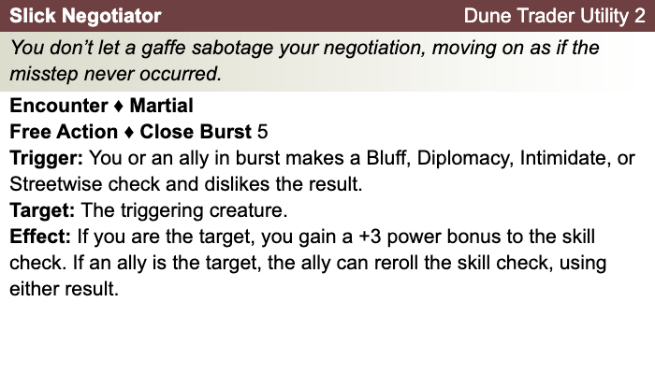

Daily Powers:
Human
- One bonus feat at 1st level (already included)
- One bonus skill from the skill class list (already included)
- +1 to fortitude, reflex, and will defenses
Warlord
- Combat Leader: You and each ally within 10 squares who can see and hear you gain a +2 power bonus to initiative.
- Tactical Presence: When an ally you can see spends an action point to make an extra attack, that ally gains a bonus to the attack roll equal to one-half your Intelligence modifier.
Theme: Dune Trader [Dark Sun]
- See source book for information
Bethiah's Equipment: Bandages, Rags
Magic items:
Weapon:
Weapon:
Weapon:
Weapon:
Armor:
Shield:
Arms:
Feet:
Hands:
Head:
Neck:
Ring:
Ring:
Waist:
Resistances:
Action Point Tally:
Daily Item Powers Per Day: Heroic Tier Milestones: / / /
Death Saving Throw Failures:
More about Bethiah:

Level 3
Unaligned
Strength 16 (+3)  Constitution 12 (+1)  Dexterity 10 (+0)  Intelligence 16 (+3)  Wisdom 11 (+0)  Charisma 13 (+1) | Height: 6' 2"  Weight: 210 lb  Skin:  Eyes:  Hair:
Maximum Hit Points: 34
Bloodied: 17
Surge Value: 8
Surges / Day: 8 [includes constitution modifier]
Size: Medium
Speed: 6 squares
Vision: Normal
Initiative: | 1d20 +3 | = 1 [half level] + 0 [dexterity] + 2 [combat leader]
Base Strength Attack: | 1d20 +5 | = + 1 [half level] + 3 [strength] + 1 (fixed enhancement bonus)
Base Dexterity Attack: | 1d20 +2 | = + 1 [half level] + 0 [dexterity] + 1 (fixed enhancement bonus)
Base Constitution Attack: | 1d20 +3 | = + 1 [half level] + 1 [constitution] + 1 (fixed enhancement bonus)
Base Intelligence Attack: | 1d20 +5 | = + 1 [half level] + 3 [intelligence] + 1 (fixed enhancement bonus)
Base Wisdom Attack: | 1d20 +2 | = + 1 [half level] + 0 [wisdom] + 1 (fixed enhancement bonus)
Base Charisma Attack: | 1d20 +3 | = + 1 [half level] + 1 [charisma] + 1 (fixed enhancement bonus)

Armor Class: | 14 | = 10 + 1 [half level] + 3 [intelligence]
Fortitude Defense: | 16 | = 10 + 1 [half level] + 1 [Human] + 1 [warlord] + 3 [strength]
Reflex Defense: | 15 | = 10 + 1 [half level] + 1 [Human] + 3 [intelligence]
Will Defense: | 14 | = 10 + 1 [half level] + 1 [Human] + 1 [warlord] + 1 [charisma]
If your campaign uses the fixed-enhancement bonus system [PH2/Dark Sun], level 3 characters get +1 on attack/damage (1d6 extra damage on a critical hit) and +0 on all defenses. These bonuses do not stack with magic items.
Armor: None ("cloth")
Shield: None
Attacks:
Unarmed Melee: +4 [base strength attack] vs AC; damage 1[W]=1d4+3 [strength bonus]
Quick Formation +4^{w} [best ability vs AC]
Viper's Strike +4^{w} [base strength attack] vs AC
Wolfpack Tactics +4^{w} [base strength attack] vs AC
Warlord's Favor +4^{w} [base strength attack] vs AC
Lead the Attack +4^{w} [base strength attack] vs AC
Delaying Strike:
^{w} Weapon-based power. Apply adjustments for proficiency, situation, feats, magic, etc.
Base Saving throw: d20 vs 10
Encumberance 4e  Normal Load: Heavy Load: Maximum Drag Load 160 lb. 320 lb. 800 lb. | Encumberance 3.5  Light load: Medium load: Heavy load: Lift over head: Lift off ground: Push or drag: 76 lb. or less 77-153 lb. 154-230 lb. 230 lb. 460 lb. 1150 lb.

Languages: | Balican, Tyrian, Raamite, Nibanese
Rituals Known:
Skills:
Acrobatics: | +1 | = 0 [dexterity] + 1 [half level]
Arcana: | +4 | = 3 [intelligence] + 1 [half level]
Athletics: | +9 | = 3 [strength] + 1 [half level] +5 [class training]
Bluff: | +2 | = 1 [charisma] + 1 [half level]
Diplomacy: | +7 | = 1 [charisma] + 1 [half level] +5 [class training]
Dungeoneering: | +1 | = 0 [wisdom] + 1 [half level]
Endurance: | +7 | = 1 [constitution] + 1 [half level] +5 [class training]
Heal: | +6 | = 0 [wisdom] + 1 [half level] +5 [class training]
History: | +11 | = 3 [intelligence] + 1 [half level] +5 [class training] + 2 [background]
Insight: | +1 | = 0 [wisdom] + 1 [half level]
Intimidate: | +2 | = 1 [charisma] + 1 [half level]
Nature: | +1 | = 0 [wisdom] + 1 [half level]
Perception: | +1 | = 0 [wisdom] + 1 [half level]
Religion: | +4 | = 3 [intelligence] + 1 [half level]
Stealth: | +1 | = 0 [dexterity] + 1 [half level]
Streetwise: | +2 | = 1 [charisma] + 1 [half level]
Thievery: | +1 | = 0 [dexterity] + 1 [half level]
Feats:
- Tactical Assault: When an ally who can see you spends an action point to make an attack, the attack’s damage roll gains a bonus equal to your Intelligence modifier.
- Weapon Focus (Light Blade): You gain a +1 feat bonus to damage rolls with Light Blades. At 11th level, this bonus increases to +2. At 21st level, it increases to +3.
- Advantageous Formation: When one of your allies affected by your quick formation shifts adjacent to an enemy, he or she gains combat advantage against that enemy until the end of your next turn.

At-Will:
Melee Basic Attack: By weapon, damage 1[W]+3 [strength bonus] [standard action]
Ranged Basic Attack: By weapon, damage 1[W] [standard action]
Bull Rush: +3 [base strength attack] vs fortitude [standard action]
Grab: +3 [base strength attack] vs reflex [standard action]
Move grabbed target: +3 [base strength attack] vs fortitude [standard action]
Escape: +0 [acrobatics] vs reflex / +8 [athletics] vs fortitude [move action]
Other Standard Actions: | Administer a potion; Aid another [revised: skill check vs. 10+level/2, success helps +2, failure hurts -1]; Charge [+1 to basic melee attack or bull rush]; Coup de grace; Equip / stow shield; Ready an action; Total defense; Sustain standard action; Some skills during combat (i.e., Acrobatics -- fast escape; Bluff, Heal -- first aid (use second wind DC10, stabilize the dying DC15, grant a saving throw DC15), Intimidate, Thievery depending on circumstances);
Other Move Actions: | Crawl; Run [speed 8]; Stand up; Shift; Squeeze; Walk; may include some skills during combat (i.e., Acrobatics, Athletics); half of a Double Move (if taken in place of a standard action)
Other Minor Actions: | Draw / sheathe weapon; Drink a potion; Drop prone; Load a crossbow; Open / close a door; Pick up an item; Retrieve / stow an item; Perception -- active (as per revision), Sustain minor action; Some skills during combat (i.e., Insight)
Other Immediate Actions: | Readied action
Other Opportunity Actions: | Opportunity attack
Other Free Actions: | Drop held items; End a grab; Talk
Other Non-Actions: | Delay; Endurance checks; Insight to counter Bluff; Knowledge checks; Perception -- passive
Short rest: | Healing surges as available
Five minutes: | Normal escape from restraints (Acrobatics)
One hour: | Forage; Streetwise check

Encounter Powers:
Spend an Action Point [free action, not in surprise round]
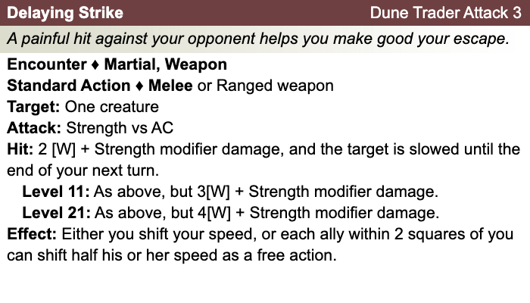

Daily Powers:
Human
- One bonus feat at 1st level (already included)
- One bonus skill from the skill class list (already included)
- +1 to fortitude, reflex, and will defenses
Warlord
- Combat Leader (+2 initiative for self and all allies within ten squares who see & hear you)
- This warlord chose the tactical presence. Any ally in sight who spends an action point to attack gets a bonus on attack roll equal to half your intelligence modifier. Can receive benefit from only one warlord at a time.
- Inspiring Word (target spends healing surge and gains an additional1d6 at level 3)
Theme: Dune Trader [Dark Sun]
- See source book for information
Bethiah's Equipment: Bandages, Rags

Magic items:
Weapon:
Weapon:
Weapon:
Weapon:
Armor:
Shield:
Arms:
Feet:
Hands:
Head:
Neck:
Ring:
Ring:
Waist:
Resistances:
Action Point Tally:
Daily Item Powers Per Day: Heroic Tier Milestones: / / /
Death Saving Throw Failures:
More about Bethiah:

Level 4
Unaligned
Strength 17 (+3)  Constitution 12 (+1)  Dexterity 10 (+0)  Intelligence 17 (+3)  Wisdom 11 (+0)  Charisma 13 (+1) | Height: 6' 2"  Weight: 220 lb  Skin:  Eyes:  Hair:
Maximum Hit Points: 39
Bloodied: 19
Surge Value: 9
Surges / Day: 8 [includes constitution modifier]
Size: Medium
Speed: 6 squares
Vision: Normal
Initiative: | 1d20 +4 | = 2 [half level] + 0 [dexterity] + 2 [combat leader]
Base Strength Attack: | 1d20 +6 | = + 2 [half level] + 3 [strength] + 1 (fixed enhancement bonus)
Base Dexterity Attack: | 1d20 +3 | = + 2 [half level] + 0 [dexterity] + 1 (fixed enhancement bonus)
Base Constitution Attack: | 1d20 +4 | = + 2 [half level] + 1 [constitution] + 1 (fixed enhancement bonus)
Base Intelligence Attack: | 1d20 +6 | = + 2 [half level] + 3 [intelligence] + 1 (fixed enhancement bonus)
Base Wisdom Attack: | 1d20 +3 | = + 2 [half level] + 0 [wisdom] + 1 (fixed enhancement bonus)
Base Charisma Attack: | 1d20 +4 | = + 2 [half level] + 1 [charisma] + 1 (fixed enhancement bonus)

Armor Class: | 16 | = 10 + 2 [half level] + 3 [intelligence] + 1 (fixed enhancement bonus)
Fortitude Defense: | 18 | = 10 + 2 [half level] + 1 [Human] + 1 [warlord] + 3 [strength] + 1 (fixed enhancement bonus)
Reflex Defense: | 17 | = 10 + 2 [half level] + 1 [Human] + 3 [intelligence] + 1 (fixed enhancement bonus)
Will Defense: | 16 | = 10 + 2 [half level] + 1 [Human] + 1 [warlord] + 1 [charisma] + 1 (fixed enhancement bonus)
If your campaign uses the fixed-enhancement bonus system [PH2/Dark Sun], level 4 characters get +1 on attack/damage (1d6 extra damage on a critical hit) and +1 on all defenses. These bonuses do not stack with magic items.
Armor: None ("cloth")
Shield: None
Attacks:
Unarmed Melee: +5 [base strength attack] vs AC; damage 1[W]=1d4+3 [strength bonus]
Quick Formation +5^{w} [best ability vs AC]
Viper's Strike +5^{w} [base strength attack] vs AC
Wolfpack Tactics +5^{w} [base strength attack] vs AC
Warlord's Favor +5^{w} [base strength attack] vs AC
Lead the Attack +5^{w} [base strength attack] vs AC
Delaying Strike:
^{w} Weapon-based power. Apply adjustments for proficiency, situation, feats, magic, etc.
Base Saving throw: d20 vs 10
Encumberance 4e  Normal Load: Heavy Load: Maximum Drag Load 170 lb. 340 lb. 850 lb. | Encumberance 3.5  Light load: Medium load: Heavy load: Lift over head: Lift off ground: Push or drag: 86 lb. or less 87-173 lb. 174-260 lb. 260 lb. 520 lb. 1300 lb.

Languages: | Balican, Tyrian, Raamite, Nibanese
Rituals Known:
Skills:
Acrobatics: | +2 | = 0 [dexterity] + 2 [half level]
Arcana: | +5 | = 3 [intelligence] + 2 [half level]
Athletics: | +10 | = 3 [strength] + 2 [half level] +5 [class training]
Bluff: | +3 | = 1 [charisma] + 2 [half level]
Diplomacy: | +8 | = 1 [charisma] + 2 [half level] +5 [class training]
Dungeoneering: | +2 | = 0 [wisdom] + 2 [half level]
Endurance: | +8 | = 1 [constitution] + 2 [half level] +5 [class training]
Heal: | +7 | = 0 [wisdom] + 2 [half level] +5 [class training]
History: | +12 | = 3 [intelligence] + 2 [half level] +5 [class training] + 2 [background]
Insight: | +2 | = 0 [wisdom] + 2 [half level]
Intimidate: | +3 | = 1 [charisma] + 2 [half level]
Nature: | +2 | = 0 [wisdom] + 2 [half level]
Perception: | +2 | = 0 [wisdom] + 2 [half level]
Religion: | +5 | = 3 [intelligence] + 2 [half level]
Stealth: | +2 | = 0 [dexterity] + 2 [half level]
Streetwise: | +3 | = 1 [charisma] + 2 [half level]
Thievery: | +2 | = 0 [dexterity] + 2 [half level]
Feats:
- Tactical Assault: When an ally who can see you spends an action point to make an attack, the attack’s damage roll gains a bonus equal to your Intelligence modifier.
- Weapon Focus (Light Blade): You gain a +1 feat bonus to damage rolls with Light Blades. At 11th level, this bonus increases to +2. At 21st level, it increases to +3.
- Advantageous Formation: When one of your allies affected by your quick formation shifts adjacent to an enemy, he or she gains combat advantage against that enemy until the end of your next turn.
- Quick Defense: When you use your quick formation, any character who shifts as a result of the power gains a +2 bonus to all defenses until the end of your next turn.

At-Will:
Melee Basic Attack: By weapon, damage 1[W]+3 [strength bonus] [standard action]
Ranged Basic Attack: By weapon, damage 1[W] [standard action]
Bull Rush: +3 [base strength attack] vs fortitude [standard action]
Grab: +3 [base strength attack] vs reflex [standard action]
Move grabbed target: +3 [base strength attack] vs fortitude [standard action]
Escape: +0 [acrobatics] vs reflex / +8 [athletics] vs fortitude [move action]
Other Standard Actions: | Administer a potion; Aid another [revised: skill check vs. 10+level/2, success helps +2, failure hurts -1]; Charge [+1 to basic melee attack or bull rush]; Coup de grace; Equip / stow shield; Ready an action; Total defense; Sustain standard action; Some skills during combat (i.e., Acrobatics -- fast escape; Bluff, Heal -- first aid (use second wind DC10, stabilize the dying DC15, grant a saving throw DC15), Intimidate, Thievery depending on circumstances);
Other Move Actions: | Crawl; Run [speed 8]; Stand up; Shift; Squeeze; Walk; may include some skills during combat (i.e., Acrobatics, Athletics); half of a Double Move (if taken in place of a standard action)
Other Minor Actions: | Draw / sheathe weapon; Drink a potion; Drop prone; Load a crossbow; Open / close a door; Pick up an item; Retrieve / stow an item; Perception -- active (as per revision), Sustain minor action; Some skills during combat (i.e., Insight)
Other Immediate Actions: | Readied action
Other Opportunity Actions: | Opportunity attack
Other Free Actions: | Drop held items; End a grab; Talk
Other Non-Actions: | Delay; Endurance checks; Insight to counter Bluff; Knowledge checks; Perception -- passive
Short rest: | Healing surges as available
Five minutes: | Normal escape from restraints (Acrobatics)
One hour: | Forage; Streetwise check

Encounter Powers:
Spend an Action Point [free action, not in surprise round]

Daily Powers:

Human
- One bonus feat at 1st level (already included)
- One bonus skill from the skill class list (already included)
- +1 to fortitude, reflex, and will defenses
Warlord
- Combat Leader (+2 initiative for self and all allies within ten squares who see & hear you)
- This warlord chose the tactical presence. Any ally in sight who spends an action point to attack gets a bonus on attack roll equal to half your intelligence modifier. Can receive benefit from only one warlord at a time.
- Inspiring Word (target spends healing surge and gains an additional1d6 at level 3)
Theme: Dune Trader [Dark Sun]
- See source book for information
Bethiah's Equipment: Bandages, Rags
Magic items:
Weapon:
Weapon:
Weapon:
Weapon:
Armor:
Shield:
Arms:
Feet:
Hands:
Head:
Neck:
Ring:
Ring:
Waist:
Resistances:
Action Point Tally:
Daily Item Powers Per Day: Heroic Tier Milestones: / / /
Death Saving Throw Failures:
More about Bethiah:

