Ascension
  - Dark Sun

Chapter One: Exiles

Scene I: Dawn
A scarlet solar system orbits a red supergiant in an endless, starless black. Its third planet is a desert with oceans of churning dust and a single Pangaean continent. This is Athas.
Snow atop the Ringing Mountains melts during the season of High Sun. It trickles down the mountainsides, and pools in an underground basin below the great city of Tyr. Seven cities with seven sovereigns are all that remain of Athas’ civilization. These sovereigns are as ancient as the sands themselves and as merciless as the desert night. Tyr is the greatest of these cities, and so the others are collectively known as the Seven Cities of Tyr.
These cities are spread across a wasteland that stretches from the Ringing Mountains to the Ocean of Silt. Those who live within the cities do so beneath the tyranny of the sovereigns. For those outside the great cities, if the torrid days and frigid nights do not claim one’s life, the other desert denizens will. This is the only life left on Athas. These are the Tablelands.
Caravan routes traverse the Tablelands. Some lie abandoned beneath the sands, while others remain the primary thoroughfares of the Tyr Region. Three of these cross amidst rocky badlands at Altaruk, a trading outpost north of the Estuary of the Forked Tongue and east of the Ivory Triangle.
Roll a d10. (Wild Talents, DSCS p. 81.)
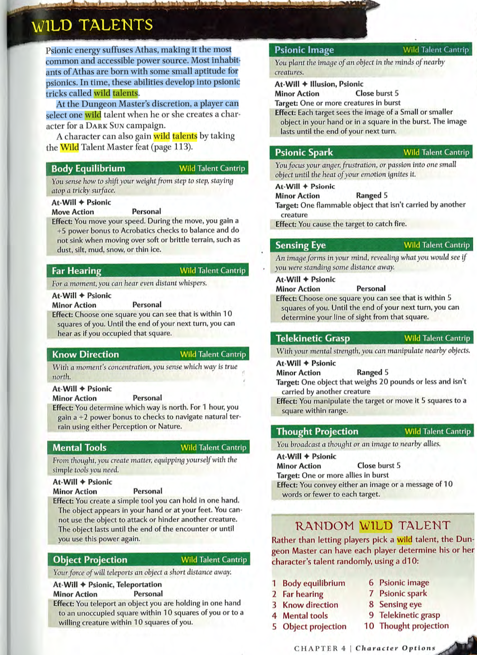
…
(Distribute Wild Talents.) The great stone North Gate hinges firmly shut behind you. Your only possessions are the Bandages and Rags which clothe your body. You do not even share a common language with all these strangers with whom you find yourself. It is the dawn on the first day of Bloom and of the season of Sun Ascending. To survive you will need Food, Water, and Shelter before nightfall. To the North, the road leads to Stony Barrens. To the East and West lie Rocky Badlands. How do you proceed?
- Rocky Badlands: Most hilly regions on Athas are rocky badlands— highly eroded mazes of sharp-edged ridges, winding canyons, and thorn-choked ravines. Daunting escarpments force travelers into meandering courses along the ravine floors, which often end in blind canyons or loop back on themselves. Badlands can be barren, waterless wastes, but many are filled with thorny brush that can completely clog the ravine floors. Rocky badlands are difficult to cross, no matter which way a traveler means to go. Sticking to a canyon’s floor is easy enough, but a canyon rarely leads in the direction one desires, and the thick, prickly brush makes for very hard going. Climbing up the walls to crest a badland ridge usually involves a dangerous scramble of several hundred feet, and travel along the top of a knife-edged ridge is equally challenging.
  - More Information: The Altaruk City Guard keeps watch over the Badlands from their Guard Towers that surround the city on both its East and West Walls. They watch over the maze of ridges, and make sure nobody makes camp within one day’s travel of Altaruk.
- Stony Barrens: Stony barrens dominate the Tablelands. Most barrens are bedrock shelves exposed by windstorms. These weathered plains are covered with rocks that range in size from pebbles and gritty dust to huge piles of standing boulders. In places, the bare rock gives way to hard-packed red earth, and yellow sand collects in crevices, forming dunes or drifts. Huge mesas and pointed buttes dot the plains, a testimony to the corrosive power of the elements. Cacti proliferate in stony barrens. Hundreds of species grow throughout, appearing in all shapes and sizes, from small, thorny buttons to towering saguaros. Some cacti are edible, making suitable fare for travelers low on supplies. Others are stealthy predators that can kill careless travelers; in the Athasian wilderness, one can never be certain who is the hunter and who is the hunted.
  - More Information: The Altaruk City Guard keeps watch over the Barrens from the two guard towers on either side of the North Gate. They watch over the cacti-dotted bedrock plain, and make sure nobody makes camp within one day’s travel of Altaruk.

- Common Language: The Tablelands are as diverse as they are hostile. Tyrian is the language of merchants and minstrels, and therefore the most common tongue spoken in the Seven Cities, but even the acquisition of this tongue is a privilege reserved for those educated classes. Only the most scholarly people can read or write in anything but the most basic script of their native language. Look at Languages on your Character Sheet to see which Languages you speak. The first language listed is your primary language, with the others following in order of your competency. (Players decide whether to RP this or not, no mechanical effects or consequences.)
- Wild Talents: (Read the blue highlighted paragraph on page 3 aloud.)
- Tyr: Every year at Lowsun, the Great Water Caravans set out from Tyr across the Great Alluvial Wastes to bring sustenance to the seven cities. You would need seven Survival Days each to cross these Sandy Wastes.
- Exile, Bloom or Sun Ascending, Altaruk: (Read “Altaruk.”)
…

Altaruk
(Party asks about Exile, Bloom, Sun Ascending, or Altaruk.) Altaruk follows House Law. Three Balican houses control Altaruk, and your various minor crimes would normally have resulted in execution. However, today is the first day of Bloom, and in accordance with House Law, trespassers on the eve of Bloom are spared and “given to the sun.” It is known that some of these exiles can reenter the city under the darkness of night, because they are occasionally caught and executed for their past crimes.
- House Law: House Law is a broad body of “common-law” practices in trading cities throughout Altaruk. House Law does not hold justice as its central principle, but rather peace. It is essentially meant to hold the truce between the Houses and allow for safe trade and good relations between these powerful merchant-dynasties.
- Return to City: Roll a Knowledge check.
  - Fail: You don’t know a great way back in. You could try to just take your chances and scale the twenty-foot wall behind you.
    - Scale Wall: Roll a Skill check. (Athletics 25)
      - Success: Your superhuman athleticism propels you up the wall. You are now surrounded by six City Guards, who are completely surprised you were able to just do that. Two of them are within melee range. You have a Surprise round. (Share the Altaruk map with party; Improvise!)
      - Fail 0-10: Yeah, you definitely make contact with the wall with your feet and hands. Not a lot else happens. You sort of wriggle vertically against the wall for a few seconds trying to get some footing in the smooth fortifications.
      - Fail 10-20: You make it a good ten feet up the twenty-foot wall. Good job! Roll a Skill check. (Acrobatics 15.)
        - Success: You successfully do a backflip off the wall, landing gracefully.
        - Fail: You land poorly. Take (1d4) damage.
      - Fail 20-25: You make it just shy of the top of the parapet! Your hand reaches out but then gravity rips you downward. Roll a Skill check. (Acrobatics 20)
        - Success: You land like a cat on your two feet.
        - Fail: You drop onto your back. You take (1d4²) damage and are prone.
  - Streetwise 15: (Read “Find the Veiled Alliance I”)
  - Arcana 20: (Read “Find the Veiled Alliance I”)
  - Veiled Alliance Theme: (Read “Find the Veiled Alliance I”)
  - Insight 20: You recall someone you met while in the city. She was wearing a burqa so you could only see her eyes, but in those eyes, you swear you saw something unusual. Often, the eyes of these slave-women were cast down or staring ahead blankly. Hers met yours. You vividly recall the feeling, as though she measured you, before passing you by. Then she was gone. That was when you came through the South Gate are your way into Altaruk. Your Insight gives you bonus to knowledge checks to identify the Veiled Alliance.

Find the Veiled Alliance I
There is a rumor that the Houses may appear to govern the city, so as not to draw the ire of the sovereigns, but the real power belongs to a group called the “Veiled Alliance.” Not much is known about this group, other than that they seem to have similar powers as the Sovereigns’ Templars, but they fight against the Sovereigns. You know of a woman named Jupiter in the city. They call her the Secret Mother of Altaruk. She hides among the other slave-girls in a burqa, and so she is difficult to find. However, you know she sleeps in the Elvan Ghetto where she secretly brings the elves food in exchange for shelter. The elves can help you find her if you can get them to trust you. First, you’ll have to get to the Elvan Ghetto. Do you seek out the Alliance?
…
(Share Altaruk Map.) As you can see, Altaruk is just a single road that passes directly through these rocky badlands. It is fortified on every side by twenty-foot walls, with six watchposts each at the North and South Gates, and then five along each of the East and West Walls, looking down into the city. During the day, it’ll be impossible to get past the City Guard, but at night, it’s possible. Roll a Skill check. (Streetwise 15)
- Success: During the Festival of the Cooling Sun, there was a slave riot in the Market Square, at A on your map. Somebody freed all the slaves that were being auctioned on the second day, and many of them turned on their masters. It was a blood bath and the City Guard had to use artillery to restore peace. The carnage left a small Crack in the Wall that the city hasn’t paid to cover up. If you wait until the dark, you might be able to squeeze back into the city, but then you’ll have to sneak through the city to reach the Elvan Ghetto, at D on your map. How do you proceed?
  - Crack in the Wall: First, you must hide until nightfall. Do you proceed to the Rocky Badlands or Stony Barrens?
    - Stay Close to Altaruk: It is common sense for any Athasian that if you stay within a day’s travel of Altaruk, the City Guard will see you from one of their watchtowers. A patrol will be sent out for you. If that patrol is overwhelmed, they’ll send a posse. You will be captured, brought to the Market Square, and publicly executed. These events are certain as Silt flowing from West to East. Do you proceed to the Rocky Badlands or Stony Barrens?
- Fail: First, you must hide until nightfall. Do you proceed to the Rocky Badlands or Stony Barrens?
  - Stay Close to Altaruk: It is common sense for your characters that if you stay within a day’s travel of Altaruk, the City Guard will see you from one of their watchtowers. A patrol will be sent out for you. If that patrol is overwhelmed, they’ll send a posse. You will be captured, brought to the Market Square, and publicly executed. These events are certain as Silt flowing from West to East. Do you proceed to the Rocky Badlands or Stony Barrens?
…
Determine your party formation. (Continue to p. 11 for Stony Barrens or p. 29 for Rocky Badlands.)

Encounter: Guard Patrol
(The party attempts to take Extended Rest before Scene IV, or sneak back into Altaruk.) An hour or so passes before a mounted patrol approaches. Two City Guards in blue ankle-length garments with silver trim approach astride Kank Soldiers. They ride to you at a trot, “Move away from the city, now.” How do you react?
- Party Moves On: The patrol regards you with suspicion as you move away. (Go to next scene.)
- Resist: The guards let out a war shriek. Roll initiative! (Play out encounter.)
2x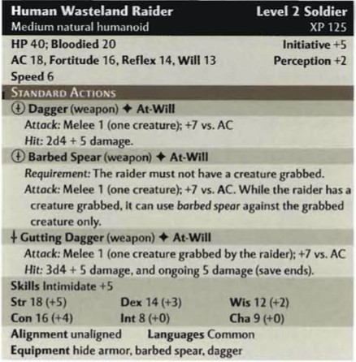
2x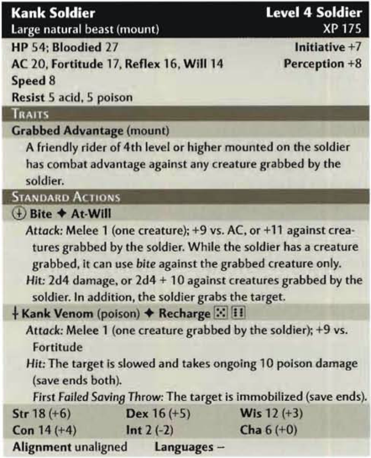
…
(The party wins the encounter.) You defeat the mounted patrol and loot their gear. You gain two sets of Hide Armor, two Barbed Spears, two Kank Chitins, two Vials of Balm, two Survival Days, two Main Packs, and fifteen Shekels (cp). You level up. Here are your new character sheets. This was a particularly difficult encounter, so you receive two action points.
- Balm: When a character applies a Vial of Balm, they are immune to Sun Sickness for one day.
- Kank Poison: You need Empty Vials to harvest the kank’s poison.
  - Use Empty Vial(s): You dig your bare hands into the meat of the kank, and rip out its leathery venom glands. You squeeze these into the Vials. You now have (x) Kank Venom Vials. (x equals number of vials character chooses to fill.)
…
Now Altaruk will be forced to send a posse to get you. Do you wish to take a short rest before proceeding?
OR

(The party loses the encounter.) You awaken on the Guard’s saddle, on the way back to Altaruk…
- Escape: Roll a Skill check. (Acrobatics 20.)
  - Success: You escape your restraints. Roll initiative!
  - Fail to Act: They bring you to Altaruk and imprison you in a windowless cell with a stone door…
    - Escape: Roll a Skill check. (Acrobatics 20.)
      - Success: You escape your restraints. You are in a windowless room, with a locked stone door in front of you. How do you proceed?
          - Break Door: The door is firmly shut and locked. Roll a Skill check.
            - Athletics 25: You manage to wedge the door open enough for an ally to crawl out. There are City Guards at the end of the hallway and they shout, “Get back in your cell!” Roll initiative!
          - Wait for Morning: At dawn, the door opens, and four City Guards enter the room. Roll initiative!
            - Success: More Guards clatter down the hallway towards you. Roll initiative!
            - Fail to Act: You are bound again, and dragged out of your cell into the harsh light of dawn.
    - Fail to Act: You’re kept until the morning. The guards enter, and you are dragged out of your cell into the harsh light of dawn…
      - Escape: Roll a Skill check. (Acrobatics 20.)
        - Success: You escape your restraints. You are surrounded by seven City Guards and a crowd of onlookers. Roll initiative!
      - Fail to Act: You are dragged across the main drag to the Market Square, where the Captain of the Guard describes you as marauders, and spits on you as he condemns you to death..
        - Escape: Roll a Skill check. (Acrobatics 20.)
        - Success: You escape your restraints. You are surrounded by the City Guard and the Captain of the Guard. Roll initiative!
          - Fail to Act: You are dragged to the Stables. One by one, you are hoisted over the Kank pen, and lowered in. The kanks start by melting your flesh with corrosive acid until you are goo. Then they consume you with their proboscises. You are dead.
            - Death: There is no afterlife from Athas. Flesh becomes bones. Bones become dust. The spark of life fades into the Black. Because there is no afterlife, there are no resurrections. Death is final and absolute.

Extended Rest
(Party defeats the Guard Patrol, then takes an extended rest before Scene IV.) You complete your Extended Rest, but meanwhile, a posse from Altaruk has surrounded your camp. They slowly close the perimeter. Roll initiative!

Scene II: Daybreak (Stony Barrens)
The avenue slopes downward between walls of stone. It widens as you emerge into flat, desolate barrens of exposed bedrock where sands dance on the whistling wind. The only elevation breaking the horizon is a lone mesa. The road winds across the plain to reach it. As you enter these stony barrens, you find Loose Stones. Do you arm yourselves with these?
- Take Rocks: Refer to the Player’s Handbook p. 219, for “Improvised Weapons.” You have no Storag, so you can only carry one Item in each of your hands.
  - Use Rags to Carry Items: Sure you can do that, but bear in mind that will leave vital parts of your body exposed to direct sunshine, which could be extremely hazardous to your health.
…

Surviving the Desert I
Day breaks across the barrens. With no shade out on the plain, you feel the full brunt of its scalding rays. (Roll Sun Sickness Attacks, DSCS p. 199)
- Unclothed: With nothing between you and the sun, you feel its rays all the sharper. (+5 to Sun Sickness Attacks against any Unclothed character.)
…
The Merchant’s Calendar calls this month Bloom, because it is when the dark sun starts to engorge once more to fill the whole sky. Common people, especially slaves, call this and the month preceding it, “the clear season”, because it is the only time of the year when the shimmer of heat distortion does not blur one’s view of their surroundings.
With no provisions, just your Bandages, Rags, and whatever you can carry, you must apply some of your Skills if you are to survive even one day in the Tablelands. Everyone roll initiative.
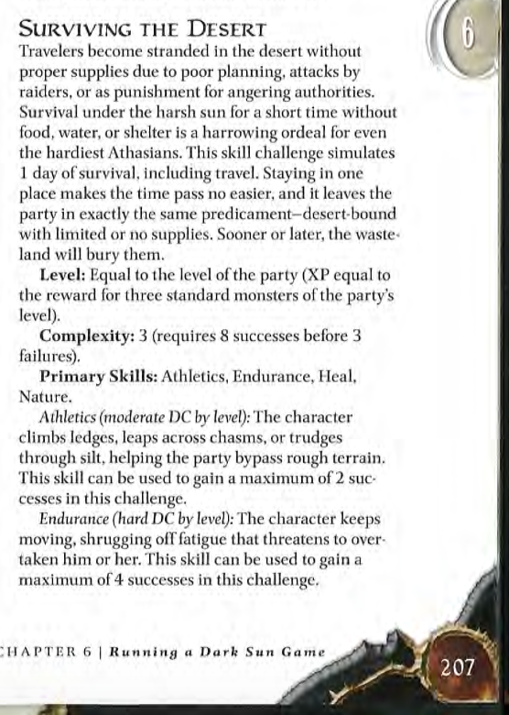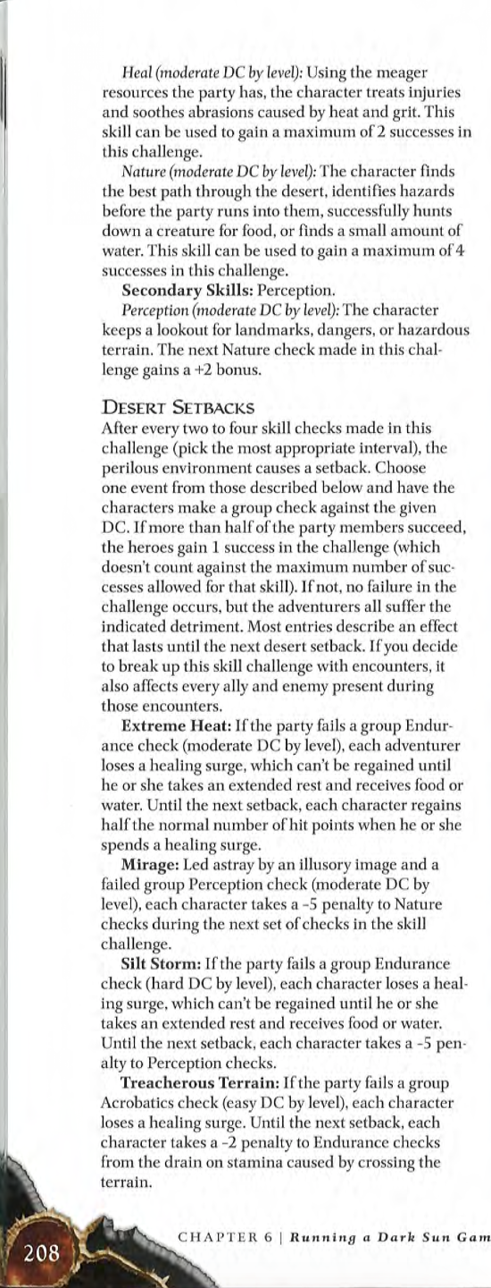
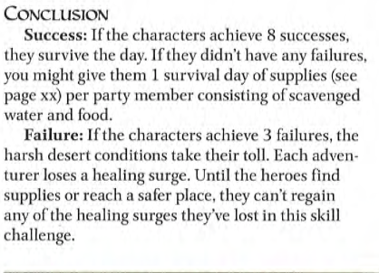
…
(To first player in Initiative order) How do you use your Skills to survive the desert? (Survive the Desert, DSCS p. 207, -2 to Nature from Stony Barrens)
(Proceed to each player in turn once, repeating the phrase “How do you use your Skills to survive the desert?” The party can roll four times before the first encounter. They can only roll once on each of the Primary skills, or on the secondary Skill. If the parties do not make four rolls, then read the following…) Roll Endurance checks in order of initiative.
- Three fails: You drop to your hands and knees, barely able to stand. You are exhausted, parched, famished, and burnt. Lose a healing surge.

Encounter: Silt Runners
Roll a Skill check. (Perception 10)
- Fail: Up ahead, there is a stony plateau filled with barbed cacti. There is a firepit to the right of the path, surrounding which are diminutive bipedal reptiles, They are dressed in mud-brown tunics, and adorn themselves with Fetishes of Human Body Parts. They look up at you and snarl as you approach. Roll initiative!
- Success: Up ahead, you hear chattering voices, and the scraping of weapons being sharpened. How do you proceed?
  - Perception 20: They are speaking in what sounds like Draconic.
    - Draconic: “I’m hungry!” “Den cook ‘u snot!” “No ‘u cook, it u’r turn.” (Snarl.)
  - Get Closer: You move closer and peek over the nearest cacti. Roll a Skill check. (Stealth vs Perception.)
    - Success: Up ahead, there is a stony plateau filled with barbed cacti. There is a firepit to the right of the path, surrounding which are diminutive bipedal reptiles. They are dressed in mud-brown tunics, and adorn themselves with Fetishes of Human Body Parts. They are scraping bone weapons against rocks to sharpen them, and chattering amongst themselves. They do not seem to notice you.
    - Fail: : Up ahead, there is a stony plateau filled with barbed cacti. There is a firepit to the right of the path, surrounding which are diminutive bipedal reptiles, They are dressed in mud-brown tunics, and adorn themselves with Fetishes of Human Body Parts. They look up at you and snarl as you approach. Roll initiative!
…
(Play out encounter.)
- Qiantha
  - (Just attacked.) Do you use your Combat Challenge to mark that target?
  - (Makes opportunity attack.) Did you add your Wisdom bonus to your opportunity attack from Combat Superiority?
- Saif
  - (Receives opportunity attack.) Did you add +2 to your AC from your Archer Fighting Style?
  - (Starts turn.) Do you want to use your minor action to designate the enemy nearest to you as your Hunter’s Quarry?
    - (Attacks quarry.) Do you want to deal extra damage with this attack to your Hunter’s Quarry?
  - (Attack target nearer to you than any of your allies.) Add +1 to your attack roll from Prime Shot.
- Tija
  - (Start of encounter.) You have combat advantage against any creature that has not acted yet from First Strike.
  - (Receives opportunity attack.) Add your Charisma modifier to your AC from Artful Dodger.
  - (Wields Chatchka or Light Blade, rolls attack roll.) Add +1 to your attack from Rogue Weapon Talent.
  - (Attacks target from combat advantage with light blade, crossbow, or sling, then rolls damage.) Do you choose to deal extra damage with a Sneak Attack?
- Bethiah
  - (Roll initiative.) You and every ally within 10 squares of you gets +2 power bonus to initiative from Combat Leader.
  - (Ally you can see spends action point to make extra attack.) Your ally gains a bonus to the attack roll equal to one-half your Intelligence modifier from your Tactical Presence.
2x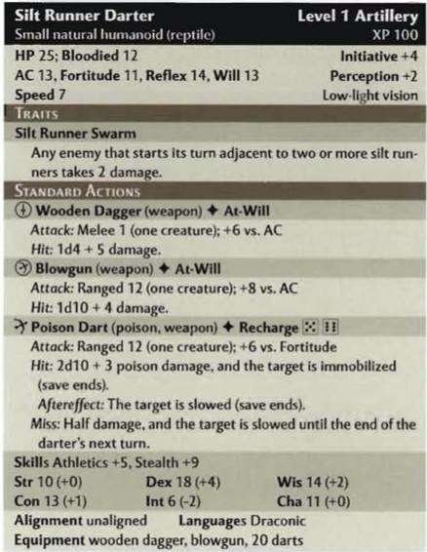
3x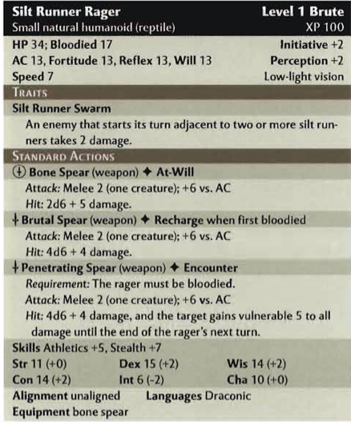
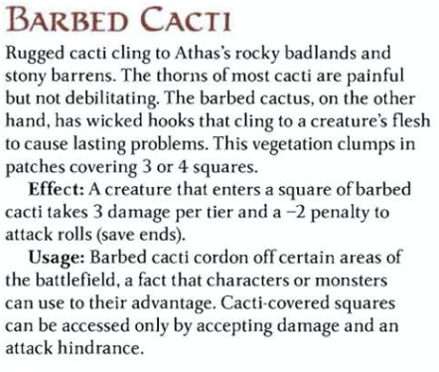
…
With your enemies defeated, you loot their campsite. They have a stack of Firewood next to their fire that could last a full night. Additionally, two sets of Wrist Razors, two Widow’s Knives, one Talid, two Blowguns, forty Darts, six Poison Vials, a Tattered Tall Pocket, and two Survival Days. Refer to p. 120-122 of the Dark Sun Campaign Setting book for pictures and descriptions of Athasian Weapons. How do you share these resources amongst yourselves?
- Survival Day: A survival day is a day’s ration for one person for one day on Athas. Anyone who has a Survival Day to consume can live for one day in the Tablelands without rolling skill checks. A Survival Day is 8 lbs.
- Blowguns: The blowguns use the same rules as the Dejada on pg. 120. (Hand Ammunition Tracker.) Ammunition is a finite resource in the Tablelands. To use your blowgun, you will need to find or craft darts.
  - Craft Darts: Unfortunately, this is not a skill that you currently possess. However, it is possible to learn how to create weapons from the resources available.
- Poison Vials: These vials are small enough that you can carry them in your palm while also holding a weapon, outside of combat. Be careful, though, as they are fragile and may crack during combat.
- Tattered Tall Pocket: (Share Inventory Sheets.) A Tall Pocket can hold 10 lbs. of equipment, or house a single 50’ Rope. This Tattered Tall Pocket has seen better days.
  - Open Tall Pocket: This Tall Pocket is empty.
- Fetish of Human Body Parts: These Fetishes are made from human extremities, fingers, toes, and a full set of human teeth. They are vile. (+2 to Intimidate, -2 to Diplomacy, Neck slot, one per player.)

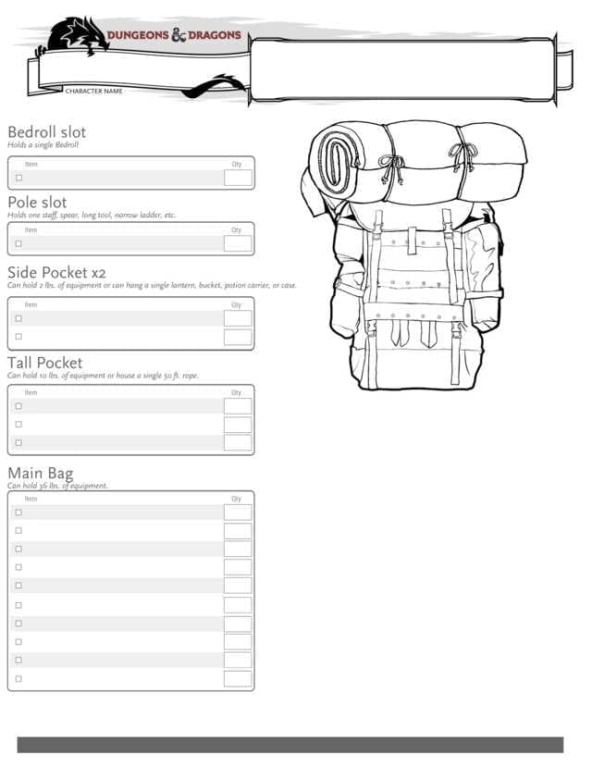
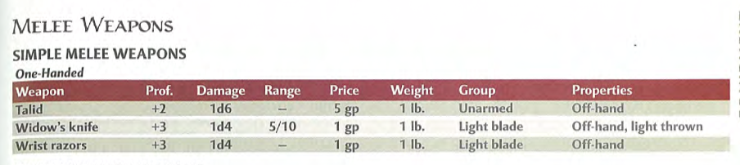
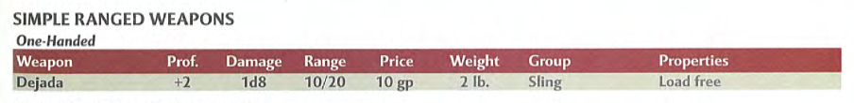

…
The adrenaline of combat has spiked your heart. You recollect valuable lessons from your lifetime to succeed. You level up. Here are your new character sheets. Additionally you receive a shiny new action point. Do you wish to take a Short Rest before proceeding?
- Fixed Enhancement Bonus: Athas is not a world of sword and sorcery. It is a world of stone and bone and sharpened stick. To compensate for the dearth of magical resources, Athasian survivors must harness inner reserves of strength and skill to cope with the challenges of life beneath the dark sun. The Fixed Enhancement Bonus system simulates this.

Scene III: High Noon (Stony Barrens)

Surviving the Desert II
You continue across the barrens towards the mesa. Shortly after dawn, a Kestrekel caws angrily at you from its perch on a cactus. It is the first to notice you, and begin following you across the barrens, staying just out of your reach and flying away if you get too close, only to return with a few friends later on. You count twelve by high noon. The mesa is ahead of you. Its shade would be welcome respite for you as the dark sun arcs across the clear sepia sky. Your flesh crisps beneath the fiery gaze of daylight. High noon is the hottest time of the day in the Tablelands. Roll a Group Endurance Check. (Extreme Heat, DSCS p. 208; roll Sun Sickness Attacks.)
…
You have (x) Survival Day(s). One of you can consume it to automatically survive for the day. Roll initiative.
…
(To first player in Initiative order) How do you use your Skills to survive the desert? (Survive the Desert, DSCS p. 207, -2 to Nature from Stony Barrens.)
(Proceed to each player in turn once, repeating the phrase “How do you use your Skills to survive the desert?” The party can roll four times before the first encounter. They can only roll once on each of the Primary skills, or on the secondary Skill. If the parties do not make four rolls actively, then read the following…) Roll Endurance checks individually in order of initiative. (Roll the remaining checks as Endurance checks.)
- Three fails: You drop to your hands and knees, barely able to stand. You are exhausted, parched, famished, and burnt. Lose a healing surge.
- Eight Successes, Zero Fails: You don’t just survive your first day as an exile. You flourish. You are able to gather one Survival Day from the resources you find in the desert around you.

Encounter: A Murder of Kestrekels
The murder of kestrekels cease perching on the ridges. Now they circle overhead, watching, waiting, until you’re too weak to fend them off. The moment you drop, that’s when they’ll feast upon you with their sharp talons and hooked yellow beaks. On the low ridge up ahead, you see a swarm of them gathered around something, plunging their beaks into it. The Kestrekels above you call out to the ones feasting ahead, and they take to the sky. Suddenly the sky is full of dark wings, cawing to one another, and swooping down upon you. Roll initiative!
- Nature DC 15: Kestrekels seek out the sick and injured, their dark eyes watching for any sign of weakness. As the prey is sapped, the beasts probe their coming meal by darting closer for quick bites. Travelers dogged by these carrion birds can lure them close by feigning injuries, but this trick rarely works on any but the most eager beasts.
- Arcana 10: Kestrekel Feathers can be used to make powerful cloth armor.
12x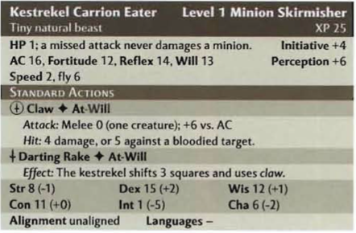
1x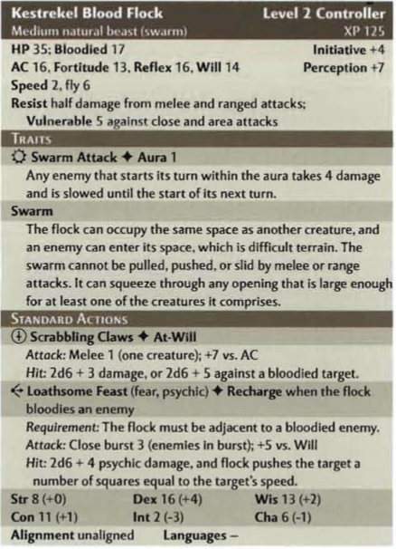
…
(Play out encounter.)
- Fixed Enhancement Bonus
  - (Character rolls for damage.) Did you remember to add your fixed enhancement bonus to your attack and damage?
…

You defeat the murder. You gain Kestrekel Feathers (4) and four Survival Days.
…
(Investigate Bone Pile.) You investigate what the Blood Flock had been picking at. It is a Human Skeleton. Scraps of flesh still hang on the bones. Its eyes are gory holes that stare out at you above a broken, submerged jaw. Its clothes are tattered, but you see a Pouch, a Waterskin, and a Tattered Side Pocket, tied to his waist.
- Pouch: A Pouch may be used to store one Small Item on one’s person, and requires one Minor Action to retrieve that item.
  - Open Pouch: There’s a Flint inside. Do you take the Flint out? If you take the Flint out, you can use the Pouch, but you must carry the Flint in one hand.
- Waterskin: The Waterskin is filled with Dry Sand. Normally, a Waterskin like this could hold enough water for one person for one day.
  - Special Properties: (Player asks specifically if they can use this to chuck sand in someone’s face.) Yes, you absolutely can. (Chuck Sand, Melee Basic Attack +2, no damage, inflicts Blinded condition on target, save ends. Can be refilled with sand as Minor action.)
- Human Skeleton: The Bones are bleached in the sun. They appear fairly intact.
  - Take Bones: You gain Human Bones. (Improvised Weapons.)
- Tattered Main Bag: A Main Bag can hold 36 lbs.
…
Each step you take gets harder, but even as your body drags itself across the wasteland, your mind sharpens. Past lessons crystallize under the pressure. You level up. Here are your new character sheets. Additionally, you each receive another action point. Do you wish to take a short rest before proceeding?

Scene IV: The Mesa

Surviving the Desert III
The sun begins to dip below the mesa, which seems so close now. To your right, just two miles or so off the path, you see a Watering Hole, its cool blue surface shimmering in the evening light. Roll a Skill check. (Perception 20; roll Sun Sickness Attacks)
- Fail: How do you proceed?
  - Approach: (-5 to Nature checks.) You set out for about half an hour. The watering hole is still a little further ahead. Do you press on?
    - Yes, press on: You’re so parched, you keep marching towards the watering hole. It feels like another hour has passed. Finally, the dark sun sets beyond the mesa, and as it does, the watering hole vanishes. (-2 to Endurance checks.)
    - No, turn back: By the time you make it back to the road, the sun has dipped behind it. You take one last look at the watering hole, but it vanishes before your very eyes
- Success: Your keen eyes tell you that the Watering Hole is really just a mirage. Your only salvation is the mesa ahead of you.
…
You have (x) Survival Day(s). One of you can use it to automatically pass an Endurance check. Roll initiative.
(To first player in Initiative order) How do you use your Skills to survive the desert? (Survive the Desert, DSCS p. 207, -2 to Nature from Stony Barrens.)
(Proceed to each player in turn once, repeating the phrase “How do you use your Skills to survive the desert?” The party can roll four times before the first encounter. They can only roll once on each of the Primary skills, or on the secondary Skill. If the parties do not make four rolls actively, then read the following…) Roll Endurance checks individually in order of initiative. (Roll the remaining checks as Endurance checks.)
- Success (with one or more Failures): You reach the mesa finally, and rest. The day did not defeat you. At least, not yet.
- Three fails: You reach the mesa on your hands and knees, barely able to stand. You are exhausted, parched, famished, and burnt. Lose a healing surge.
…
The mesa is the only elevation you’ve seen since before dawn. Its high steep walls not only provide shade, but also will protect you from enemies trying to flank you while you sleep. Do you make camp here or at the top?
…
As the sun sets behind the mesa, the sepia sky burns scarlet at twilight before darkening into the oxblood of night. The torrid air begins to cool. For an hour or so, it’s almost balmy. The temperature doesn’t stop dropping. How do you proceed?

- Party uses Firewood and Flint: How do you construct a fire? (Party needs to describe all the individual steps of building a fire.)
  - Success: (GM Block 3) The fire warms your bones, protecting you from the chill of night. It also grants illumination up to fifty feet in every direction.
- Party does not use Firewood and Flint: Temperatures decline rapidly. The desert night becomes freezing cold. Even huddled for warmth, the chill of night gets into your bones. Lose one healing surge. All squares in your environment are Totally Obscured.

Encounter: Baazrag Pack
The sky has darkened to oxblood. The air has become frigid cold. Somewhere out in the darkness, you hear a buzzing, clicking noise, and the scraping of claws against the ground. Roll a Skill check. (Opposed Perception vs Stealth +2)
- Success: You see something lurking out in the darkness, just beyond the campfire. Roll initiative!
- Fail: A pack of scaly reptilian hounds lunge out of the darkness and attack! (Baazrags have Surprise round)
- Nature DC 15: Anywhere that rough terrain provides cover for their burrows, baazrags can be found in large numbers. These wild beasts are vermin that eat anything they can find. Each individual sees to its own needs, fattening up on weeds and tiny prey, and storing water in a sac under its bony back shell. When larger prey is found, the pack works together for the promise of a good meal for all. All baazrags are born female. Some members of a pack become male when an egg-laying breeder is nearby. These males tend to the breeder, defending her and her eggs as well as any hatchlings. Powerful baazrags have a natural psychic sensitivity. Large psychic disturbances irritate these creatures and can drive them to attack.
- Arcana 10: Baazrag skin can be used to make powerful leather armor.
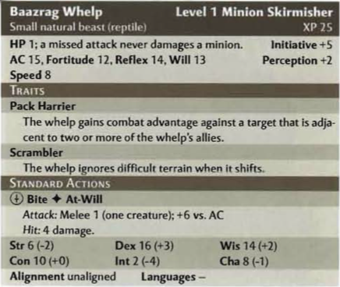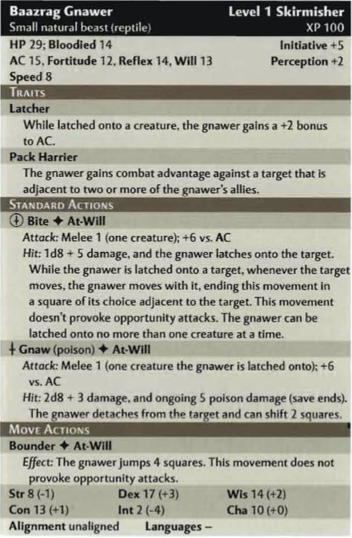
…
(Play out encounter. Remember to reference concealment rules in PHB, p. 280)
…
You defeat the pack, and reap the rewards. You gain Baazrag Skins (4) and four Survival Days.
…
To struggle is to breathe on Athas. This night is no different from any other in your life thusfar, yet something stirs within you. Your heart thumps. Warm blood courses through your veins. You have met the day head-on, and you have triumphed. You gain a level. Here are your new character sheets. Additionally, you each receive another action point. Roll a Skill check. (Perception 10)
- Success: You spot the Baazrag tracks. They seem to have come from around the other side of the mesa. How do you proceed?
- Fail: (Say nothing.)
…
(The party does not find tracks, or does not follow them.) You may take an Extended Rest if you’d like. If you take an extended rest, you lose all unspent action points, starting fresh with one. Do you take an extended rest? (If yes, skip to End of Chapter.)
…
(Party follows tracks.) Who brings a Torch? (Give Torch Cards to everyone who wants one.)
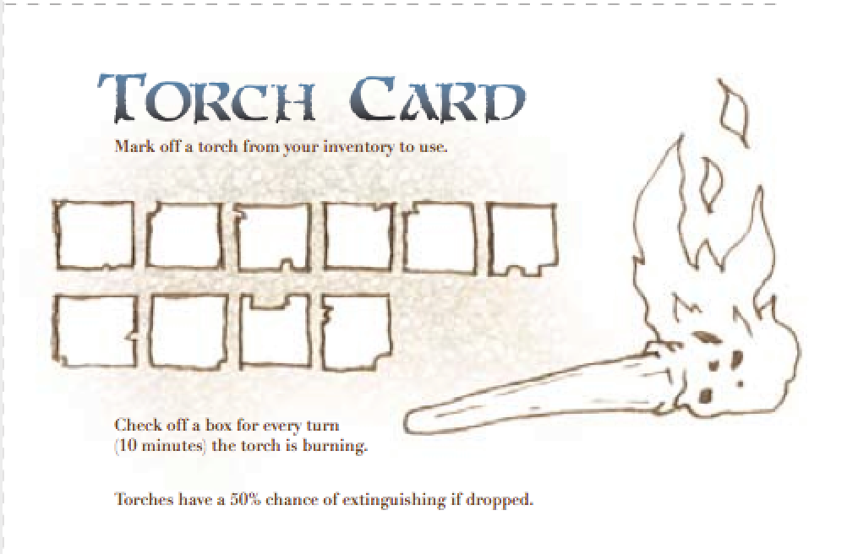

…
The tracks follow along the cliffs, and then disappear into the wall of the mesa itself. There is a Large Boulder here, up against the wall. How do you proceed?
- Torches: The Torches flicker and burn down. Mark one box on your Torch Card.
- Large Boulder: Roll a skill check. (Athletics 20)
  - Success: You are able to shift the boulder out of the way, revealing a low tunnel into the cliff-face. To proceed, you will need to go Prone and crawl.
  - Fail: You struggle in vain to move the boulder, but you can hear air behind it. Your torches flicker and burn down some more. Do you continue to try to move the boulder?
    - Yes: Roll another skill check.
    - No: How do you proceed? (Skip to End of Chapter)
…
(Party enters tunnel.) You have to crawl prone, single-file. Decide on your order.
…
Roll Skill checks. (Perception 15)
- Success: You hear buzz-clicking, and the footfalls of something big coming from up ahead. How do you proceed?
  - Stealth vs Perception (If the lead character is carrying a torch, party automatically fails.)
    - Success: Moving closer to the edge of the tunnel, you see that it opens to a wide chamber in which you could Stand Up (Move action.) There is a Large Baazrag here, patrolling, but it doesn’t seem to notice you. Against one wall there is a Human Skeleton. There is a small Pool of Water in the center of the room, and surrounding it are dozens of resting baby Baazrags.
    - Fail: Moving closer to the edge of the tunnel, you see that it opens to a wide chamber in which you could Stand Up (Move action.) There is a Large Baazrag here, and it chatters aggressively as its spiky carapace bristles upon seeing you. Against one wall there is a Human Skeleton. There is a small Pool of Water in the center of the chamber, surrounded by dozens of baby Baazrags, which awake and begin bristling. Roll initiative!
- Fail: You enter a large chamber in which you can Stand Up (Move action.) There is a Large Baazrag here, and it chatters aggressively as its spiky carapace bristles upon seeing you. Against one wall there is a Human Skeleton. There is a small Pool of Water in the center of the chamber, surrounded by dozens of baby Baazrags, which awake and begin bristling. Roll initiative!
…
(Play out encounter.)
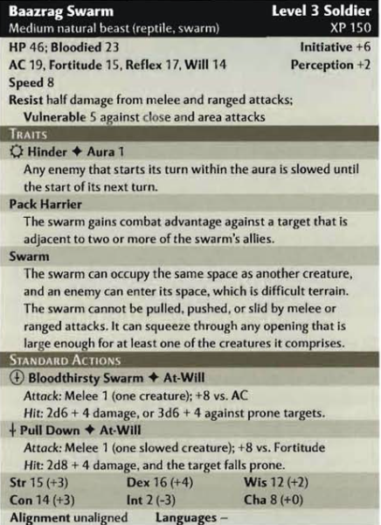
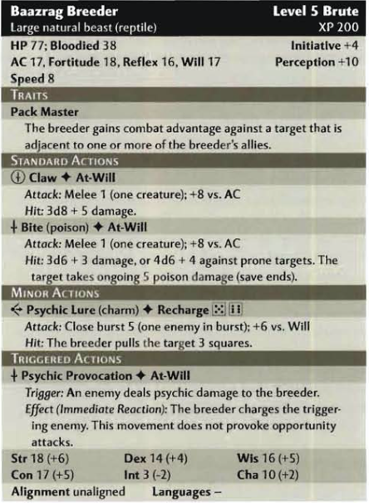
…
(Party defeats Baazrag Nest.) That was a hard-fought victory, but the rewards are great. You gain one Survival Day. Additionally, the room contains a Human Skeleton and a Pool of Water. How do you proceed?
- Torches: The Torches flicker and burn down. Mark one box on your Torch Card.
- Human Skeleton: The flesh has been picked clean off the bones, but it still has a Tattered Tall Pocket.
  - Take Bones: You gain Human Bones. (Improvised Weapons.)
  - Open Tall Pocket: This Tall Pocket contains one Balm.
- Pool of Water: The pool is surprisingly deep, and there is enough water in the pool for each of you to drink your fill for Three Days each.
…
Everything you’ve done today, you’ve had to do to survive. In that respect, this encounter was no different. However, unlike your fight with the Kestrekel flock or the Baazrag pack earlier, this time you had a choice. You chose to take a risk, and it paid off. Now you have a new, safer campsite, with access to potable water, and complete insulation from the elements. Your confidence swells. You’ve not only survived your first day as an exile, you’ve flourished. You each gain a level. You will receive new character sessions at next session. Additionally, you gain an additional action point. (Proceed to End of Chapter.)

Scene II: Daybreak (Rocky Badlands)
You enter a maze of knife-sharp ridges surrounding Altaruk. Winding corridors choked with bramble engulf you. You must traverse this hindering terrain and get at least a day’s travel away from Altaruk to avoid the City Guard’s sweeps. As you enter these rocky badlands, you find Loose Rocks. Do you arm yourselves with these?
- Take Rocks: Refer to the Player’s Handbook p. 219, for “Improvised Weapons.” You have no Storage, so you can only carry one Item in each of your hands.
  - Use Rags to Carry Items: Sure you can do that, but bear in mind that will leave vital parts of your body exposed to direct sunshine, which could be extremely hazardous to your health.

Surviving the Desert I
Day breaks across the badlands. The sharp ridges of the badlands offer no relief from the sun’s harsh glare. (Roll Sun Sickness Attacks, DSCS p. 199)
- Unclothed: With nothing between you and the sun, you feel its rays all the sharper. (+5 to Sun Sickness Attacks against any Unclothed character.)
…
The Merchant’s Calendar calls this month Bloom, because it is when the dark sun starts to engorge once more to fill the whole sky. Common people, especially slaves, call this and the month preceding it, “the clear season”, because it is the only time of the year when the shimmer of heat distortion does not blur one’s view of the horizon.
With no provisions, just your Bandages, Rags, and whatever you can hold in your two hands, you must apply some of your Skills if you are to survive even one day in the Tablelands. Everyone roll initiative.
…
(To first player in Initiative order) How do you use your Skills to survive the desert? (Survive the Desert, DSCS p. 207)
(Proceed to each player in turn once, repeating the phrase “How do you use your Skills to survive the desert?” The party can roll four times before the first encounter. They can only roll once on each of the Primary skills, or on the secondary Skill. If the parties do not make four rolls, then read the following…) Roll Endurance checks in order of initiative.
- Three fails: You drop to your hands and knees, barely able to stand. You are exhausted, parched, famished, and burnt. Lose a healing surge.

Encounter: Silt Runners
Roll a Skill check. (Perception 10)
- Fail: You emerge into a narrow pass filled with Teetering Pillars. There is a firepit, with a stack of Firewood next to it, in the center of the pass, surrounding which are diminutive bipedal reptiles. They wear mud brown tunics and adorn themselves with Fetishes of Human Body Parts. They look up at you and snarl as you approach. Roll initiative!
- Success: Up ahead, you hear chattering voices, and the scraping of weapons being sharpened. How do you proceed?
  - Perception 20: They are speaking in Draconic.
    - Draconic: “I’m hungry!” “Den cook ‘u snot!” “No ‘u cook, it u’r turn.” (Snarl.)
  - Get Closer: You move closer and look around the nearest bend. Roll a Skill check. (Stealth vs Perception.
    - Success: You emerge into a narrow pass filled with Teetering Pillars. There is a firepit, with a stack of Firewood next to it, in the center of the pass, surrounding which are diminutive bipedal reptiles. They wear mud brown tunics and adorn themselves with Fetishes of Human Body Parts. They look up at you and snarl as you approach. They are scraping bone weapons against rocks to sharpen them, and chattering amongst themselves. They do not seem to notice you.
    - Fail: You emerge into a narrow pass filled with Teetering Pillars. There is a firepit, with a stack of Firewood next to it, in the center of the pass, surrounding which are diminutive bipedal reptiles. They wear mud brown tunics and adorn themselves with Fetishes of Human Body Parts. They look up at you and snarl as you approach. Roll initiative!
(Play out the encounter.)
- Teetering Pillars: These towering stone columns narrow at the base, making them top-heavy and unstable.
- Ridges: (Challenging Terrain, Athletics DC 15 to climb, Acrobatics 15 to fall safely. 10’, 1d4¹ damage.)
- Boulders: (Blocking Terrain.)
…
(Play out encounter.)
- Qiantha
  - (Just attacked.) Do you use your Combat Challenge to mark that target?
  - (Makes opportunity attack.) Did you add your Wisdom bonus to your opportunity attack from Combat Superiority?
  - (Attacks with Improvised Weapon.) Did you add your +2 proficiency bonus from Arena Training?
    - (Hits.) Your attacks with one-handed improvised weapons deal 1d8 damage, and your attacks with two-handed improvised weapons deal 1d10 damage.

- Saif
  - (Receives opportunity attack.) Did you add +2 to your AC from your Archer Fighting Style?
  - (Starts turn.) Do you want to use your minor action to designate the enemy nearest to you as your Hunter’s Quarry?
    - (Attacks quarry.) Do you want to deal extra damage to your Hunter’s Quarry?
  - (Attack target nearer to you than any of your allies.) Did you add +1 to your attack roll from Prime Shot?
- Tija
  - (Start of encounter.) You have combat advantage against any creature that has not acted yet from First Strike.
  - (Receives opportunity attack.) Did you add your Charisma modifier to your AC from Artful Dodger?
  - (Wields Chatchka or Light Blade, rolls attack roll.) Did you add +1 to your attack from Rogue Weapon Talent?
  - (Attacks target from combat advantage with light blade, crossbow, or sling, then rolls damage.) Do you choose to deal extra damage with a Sneak Attack?
- Bethiah
  - (Roll initiative.) You and every ally within 10 squares of you gets +2 power bonus to initiative from Combat Leader.
  - (Ally you can see spends action point to make extra attack.) Your ally gains a bonus to the attack roll equal to one-half your Intelligence modifier from your Tactical Presence.
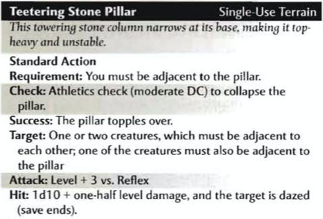

…
With your enemies defeated, you loot their campsite. They have a stack of Firewood next to their fire that could last a full night. Additionally, two sets of Wrist Razors, two Widow’s Knives, one Talid, two Blowguns, forty Darts, six Poison Vials, a Tattered Tall Pocket, and one Survival Day. Refer to p. 120-122 of the Dark Sun Campaign Setting book for pictures and descriptions of Athasian Weapons. How do you share these resources amongst yourselves?
- Survival Day: A survival day is a day’s ration for one person for one day on Athas. Anyone who has a Survival Day to consume can live for one day in the Tablelands without rolling skill checks.
- Blowguns: The blowguns use the same stats as the Dejada on pg. 120. (Hand Ammunition Tracker.) Ammunition is a finite resource in the Tablelands. To use your blowgun, you will need to find or craft darts.
- Craft Weapons/Armor: Unfortunately, this is not a skill that you currently possess. However, it is possible to learn how to create weapons and armor from the resources available from someone with that profession.
- Tattered Tall Pocket: (Share Inventory Sheets.) A Tall Pocket can hold 10 lbs. of equipment, or house a single 50’ Rope. This Tattered Tall Pocket has seen better days.
  - Open Tall Pocket: This Tall Pocket is empty.
- Fetish of Human Body Parts: These Fetishes are made from human extremities, fingers, toes, and a full set of human teeth. They are vile. (+2 to Intimidate, -2 to Diplomacy, Neck slot, one per player.)

…
The adrenaline of combat has spiked your heart. You recollect valuable lessons from your lifetime to succeed. You level up. Here are your new character sheets. Additionally you receive a shiny new action point. Do you wish to take a short rest before proceeding?
- Fixed Enhancement Bonus: ] Athas is not a world of sword and sorcery. It is a world of stone and bone and sharpened stick. To compensate for the dearth of magical resources, Athasian survivors must harness inner reserves of strength and skill to cope with the challenges of life beneath the dark sun. The Fixed Enhancement Bonus system simulates this.

Scene III: High Noon (Rocky Badlands)

Surviving the Desert II
You continue across the badlands, up and down uneven pewter slopes of wind-swept rock. Shortly after dawn, a Kestrekel caws angrily at you from its perch on a ridge above. It is the first to notice you, and begin following you across the badlands, staying just out of your reach and flying away if you get too close, only to return with a few friends later on. You count twelve by high noon. You must escape the City Guard’s perimeter. Only then will you be safe to rest from this hellish trek. Your flesh crisps beneath the fiery gaze of daylight. High noon is the hottest time of the day in the Tablelands. Roll a Group Endurance Check.
(Extreme Heat, DSCS p. 208; roll Sun Sickness Attacks.)
…
You have (x) Survival Day(s). Roll initiative.
…
(To first player in Initiative order) How do you use your Skills to survive the desert? (Survive the Desert, DSCS p. 207)
(Proceed to each player in turn once, repeating the phrase “How do you use your Skills to survive the desert?” The party can roll four times before the first encounter. They can only roll once on each of the Primary skills, or on the secondary Skill. If the parties do not make four rolls actively, then read the following…) Roll Endurance checks individually in order of initiative. (Roll the remaining checks as Endurance checks.)
…
- Three fails: You drop to your hands and knees, barely able to stand. You are exhausted, parched, famished, and burnt. Lose a healing surge.
- Eight Successes, Zero Fails: You don’t just survive your first day as an exile. You flourish. You are able to gather one Survival Day from the resources you find in the desert around you.

Encounter: A Murder of Kestrekels
The murder of kestrekels cease perching on the ridges. Now they circle overhead, watching, waiting, until you’re too weak to fend them off. The moment you drop, that’s when they’ll feast upon you with their sharp talons and hooked yellow beaks. On the low ridge up ahead, you see a swarm of them gathered around something, plunging their peaks into it. The Kestrekels above you call out to the ones feasting ahead, and they take to the sky. Suddenly the sky is full of dark wings, cawing to one another, and swooping down upon you. Roll initiative!
- Nature DC 15: Kestrekels seek out the sick and injured, their dark eyes watching for any sign of weakness. As the prey is sapped, the beasts probe their coming meal by darting closer for quick bites. Travelers dogged by these carrion birds can lure them close by feigning injuries, but this trick rarely works on any but the most eager beasts.
- Arcana 10: Kestrekel Feathers can be used to make powerful cloth armor.
…
(Play out encounter.)
- Fixed Enhancement Bonus
  - (Character rolls to attack.) Did you remember to add your fixed enhancement bonus to your attack and damage?
  - (Character rolls for damage.) Did you remember to add your fixed enhancement bonus to your attack and damage?
…
You defeat the flock, and find they’d been picking at. It is a Human Skeleton. Scraps of flesh still hang on the bones. Its eyes are gory holes that stare out at you above a broken, submerged jaw. Its clothes are tattered, but you see a Pouch, a Waterskin, and a Tattered Side Pocket, tied to his waist. You also gain Kestrekel Feathers and one Survival Day.
…
- Pouch: A Pouch may be used to store one Small Item on one’s person, and requires one Minor Action to retrieve that item.
  - Open Pouch: There’s a Small Flint inside. Do you take the Flint out?
- Waterskin: The Waterskin is filled with Dry Sand. Normally, a Waterskin like this could hold enough water for one person for one day.
  - Special Properties: (Player asks specifically if they can use this to chuck sand in someone’s face.) Yes, you absolutely can. (Chuck Sand, Melee Basic Attack +2, no damage, inflicts Blinded condition on target, save ends. Can be refilled with sand as Minor action.)
- Human Skeleton: The Bones are bleached in the sun. They appear fairly intact.
  - Take Bones: You gain Human Bones, which can be used as Improvised Weapons.

…
Each step you take gets harder, but even as your body drags itself across the wasteland, your mind sharpens. Past lessons crystallize under the pressure. You level up. Here are your new character sheets. Additionally, you each receive another action point. Do you wish to take a short rest before proceeding?

Scene IV: The Gorge

Surviving the Desert III
The sun begins to dip below a ridge, and the ground slopes downward sharply. The terrain becomes steep and treacherous, and you feel yourself begin to slip. Roll a Group Skill check. (Acrobatics 10; roll Sun Sickness Attacks.)
- Fail: You lose your footing, and slide down the slope. You each lose a Healing Surge, and take a Penalty (-2) on Endurance checks for the rest of the day.
- Success: You slide gracefully down a slope to arrive at the bottom of a small ravine, staying on your two feet.
…
You have (x) Survival Day(s). One of you can use it to automatically pass an Endurance check. Roll initiative.
(To first player in Initiative order) How do you use your Skills to survive the desert? (Survive the Desert, DSCS p. 207)
(Proceed to each player in turn once, repeating the phrase “How do you use your Skills to survive the desert?” The party can roll four times before the first encounter. They can only roll once on each of the Primary skills, or on the secondary Skill. If the parties do not make four rolls actively, then read the following…) Roll Endurance checks individually in order of initiative. (Roll the remaining checks as Endurance checks.)
- Success (with one or more Failures): The sun finally sets below the far ridge, and the air immediately cools. The day did not defeat you. At least, not yet.
- Three fails: As the sun finally dips below the far ridge, you collapse from exhaustion. Lose a healing surge.
…
You arrive a gorge, carved from the rock by a brook of flowing Silt. The high, steep wall behind you not only offers shade but will also help protect you from enemies trying to flank you while you sleep. Do you make camp here or at the bottom?
- Silt: (Show “Sand River” video.) Silt is a phenomenon created by the ice melting on top of the Ringing Mountains, and flowing underground. This creates a phenomenon of flowing sand. While this is not a potable liquid, Silt is used by Silt Skimmers for travel. All Silt flows East from the Ringing Mountains towards the Ocean of Silt.
…
(GM Block 2) As the sun sets behind the mesa, the sepia sky burns scarlet at twilight before darkening into the oxblood of night. The torrid air begins to cool. For an hour or so, it’s almost balmy. The temperature doesn’t stop dropping. How do you proceed?
- Party uses Firewood and Flint: How do you construct a fire? (Party needs to describe all the individual steps of building a fire.)
  - Success: (GM Block 3) The fire warms your bones, protecting you from the chill of night. It also grants illumination up to fifty feet in every direction.
- Party does not use Firewood and Flint: Temperatures decline rapidly. The desert night becomes freezing cold. Even huddled for warmth, the chill of night gets into your bones. Lose one healing surge. All squares in your environment are Totally Obscured.

Encounter: Baazrag Pack
The sky has darkened to oxblood. The air has become frigid cold. Somewhere out in the darkness, you hear a buzzing, clicking noise, and the scraping of claws against the ground. Roll a Skill check. (Opposed Perception vs Stealth +2)
- Success: You see something lurking out in the darkness, just beyond the campfire. Roll initiative!
- Fail: A pack of scaly reptilian hounds lunge out of the darkness and attack! (Baazrags have Surprise round)
- Nature DC 15: Anywhere that rough terrain provides cover for their burrows, baazrags can be found in large numbers. These wild beasts are vermin that eat anything they can find. Each individual sees to its own needs, fattening up on weeds and tiny prey, and storing water in a sac under its bony back shell. When larger prey is found, the pack works together for the promise of a good meal for all. All baazrags are born female. Some members of a pack become male when an egg-laying breeder is nearby. These males tend to the breeder, defending her and her eggs as well as any hatchlings. Powerful baazrags have a natural psychic sensitivity. Large psychic disturbances irritate these creatures and can drive them to attack.
- Arcana 10: Baazrag skin can be used to make powerful leather armor.
…
(GM Block 4. Play out encounter. Remember to reference concealment rules in PHB, p. 280)
…
You defeat the pack, and reap the rewards. You gain Baazrag Skins and one Survival Day.
…
To struggle is to breathe on Athas. This night is no different from any other in your life thusfar, yet something stirs within you. Your heart thumps. Warm blood courses through your veins. You have met the day head-on, and you have triumphed. You gain a level. Here are your new character sheets. Additionally, you each receive another action point.
Roll a Skill check. (Perception 10)
- Success: You spot the Baazrag tracks. They seem to have come from down the gorge a little ways. How do you proceed?
- Fail: (Say nothing, allow party to take 10 if they choose.)
(The party does not find tracks, or does not follow them.) You may take an extended rest if you’d like. (If yes, skip to End of Chapter.)
…
(Party follows tracks.) Who brings a Torch? (Give Torch Cards to everyone who wants one.)
…
The tracks follow along the cliffs, and then disappear into the wall of the gorge itself. There is a Loose Boulder here, up against the wall. How do you proceed?
- Torches: The Torches flicker and burn down. Mark one box on your Torch Card.

…
(Party moves Loose Rock.) Behind the rock there is a natural tunnel into the gorge. It is too low for you to walk in upright, but you can crawl through it if you go prone. How do you proceed?
- Torches: The Torches flicker and burn down. Mark one box on your Torch Card.

…
(Party enters tunnel.) You have to move single-file. Decide on your order.
…
Roll Skill checks. (Perception 15)
- Success: You hear buzz-clicking, and the footfalls of something big coming from up ahead. How do you proceed?
  - Stealth vs Perception (Check if the character is carrying a torch, they automatically fail.)
    - Success: Moving closer to the edge of the tunnel, you see that it opens to a wide chamber in which you could Stand Up (Move action.) There is a Large Baazrag here, patrolling, but it doesn’t seem to notice you. Against one wall there is a Human Skeleton. There is a small Pool of Water in the center of the room, and surrounding it are dozens of resting baby Baazrags.
    - Fail: Moving closer to the edge of the tunnel, you see that it opens to a wide chamber in which you could Stand Up (Move action.) There is a Large Baazrag here, and it chatters aggressively as its spiky carapace bristles upon seeing you. Against one wall there is a Human Skeleton. There is a small Pool of Water in the center of the chamber, surrounded by dozens of baby Baazrags, which awake and begin bristling. Roll initiative!
- Fail: You enter a large chamber in which you can Stand Up (Move action.) There is a Large Baazrag here, and it chatters aggressively as its spiky carapace bristles upon seeing you. Against one wall there is a Human Skeleton. There is a small Pool of Water in the center of the chamber, surrounded by dozens of baby Baazrags, which awake and begin bristling. Roll initiative!
…
(Play out encounter.)
…
(Party defeats Baazrag Nest.) That was a hard-fought victory, but the rewards are great. You gain Baazrag Skins, and one Survival Day. Additionally, the room contains a Human Skeleton and a Pool of Water. How do you proceed?
- Torches: The Torches flicker and burn down. Mark one box on your Torch Card.
- Human Skeleton: The flesh has been picked clean off the bones, but it still has a Tattered Tall Pocket.
  - Tattered Tall Pocket: A Tall Pocket can hold 10 lbs of equipment or house a single 50’ rope. This Tattered Tall Pocket has seen better days.
    - Open Tall Pocket: This Tall Pocket contains one Balm.
  - Take Bones: You gain Human Bones. (Improvised Weapons.)
- Pool of Water: The pool is surprisingly deep, and there is enough water in the pool for three Refills of your Waterskin.
…
Everything you’ve done today, you’ve had to do to survive. In that respect, this encounter was no different. However, unlike your fight with the Kestrekel flock or the Baazrag pack earlier, this time you had a choice. You chose to take a risk, and it paid off. Now you have a new, safer campsite, with access to potable water, and complete insulation from the elements. Your confidence swells. You’ve not only survived your first day as an exile, you’ve flourished. You each gain a level. You will receive new character sessions at next session. Additionally, you gain an additional action point. (Proceed to End of Chapter.)

End of Chapter One
Athas is a world of stone and bone and sharpened stick. The only reward you should expect at the end of a day is to have survived it. Tomorrow you may not be so lucky. If you take an extended rest, you will lose all surplus action points and return to one action point each. How do you proceed?

Find the Veiled Alliance II
(Party activated “Find the Veiled Alliance.”) With night having fallen, now is the best time for you to return to the city. You will need the cover of night to make it past the guards. Many of the desert monsters will be at rest. You are lucky to have lived one day in the desert. Tomorrow you may not be so lucky. If you take an extended rest, you will lose all surplus action points and return to one action point each, at the dawn of a new day. How do you proceed?

Postgame Dissection
Thank you for playing. If you have time, I have some postgame questions. Your feedback will help me improve my session and any further sessions going forward.
- What were each of your most favorite moments in this session?
  - Bill
    - Loved line-of-sight—second’d by Will
    - Loved night, but needs illumination, defined grid
  - Will

- What do you feel needs improvement?
  - Bill
    - Rolls die, should disappear

- Would you replay this session again in the future, or a session like this, in the future?
  - Bill
    - No, but I would advance the story.

